Windows 11 Upgrade Recipe
By: Isaac Hilburn
Date: Jan 22 – July 17, 2025
Version 1.1

Contents
Caution! 3
Security Disclaimer 4
Core Isolation: Disabling Memory Integrity 4
Disabling Smart App Control 6
Controlled Folders: Disable or Allow Exceptions 8
Pre-Installation Backups / Preparations 10
Back-Up strategies 10
Files and Folders to Copy to a portable / network drive 10
Get an Installer for Windows 11 10
Document Device Configurations for your Windows 10 system 11
What else am I forgetting…? 17
Installing Windows 11 17
Installing Windows 11 with a local user account 17
Disable Microsoft Copilot 18
Other software to Install 18
3rd-Party RAPID software installs 22
Creating a Windows 11 Restore Point 22
ADwin Software 25
Digilent / Measurement Computing DAQ software 35
QuickSilver Controls software 43
B&K Precision DC power supply USB communications drivers for Caltech / ASC IRM systems 69
GM0 Gaussmeter Drivers 76
Installing Visual Basic 6.0 79
Clean-up Failed Visual Studio / Visual Basic 6.0 install 80
Install Visual Basic 6.0 84
Post Install Clean-up 102
Configuring Paleomag VB6 code to run in Windows 11 106
Run vb6cli.exe 107
Copy Paleomag files, setting and code to Windows 11 PC 111
Register vbSendMail.dll 112
Create Desktop Shortcut to Paleomag VB6 code 114
Opening the Paleomag VB6 code for the first time in VB6 116
Fixing missing ActiveX (.OCX) Component Files 119
Fixing Missing References in Paleomag VB6 Project 132
APPENDIX A – Notes for Upgrading to Windows 10 in place 133
1) Backup Image of Windows 7 OS first 133
2) Hardware compatibility 134
3) Backup ALL of Paleomag files 136
4) Download / Acquire Windows 10 installation media 146
5) Post-Upgrade clean-up 146
a) Com Ports 146
b) ADwin-light-16 no longer recognized 146
c) Measurement Computing DAQ device is missing when you try to startup up the VB6 Paleomag code 148
d) When you run your VB6 Paleomag code, the code crashes on load. When you click the “Debug” button, you get the following screen: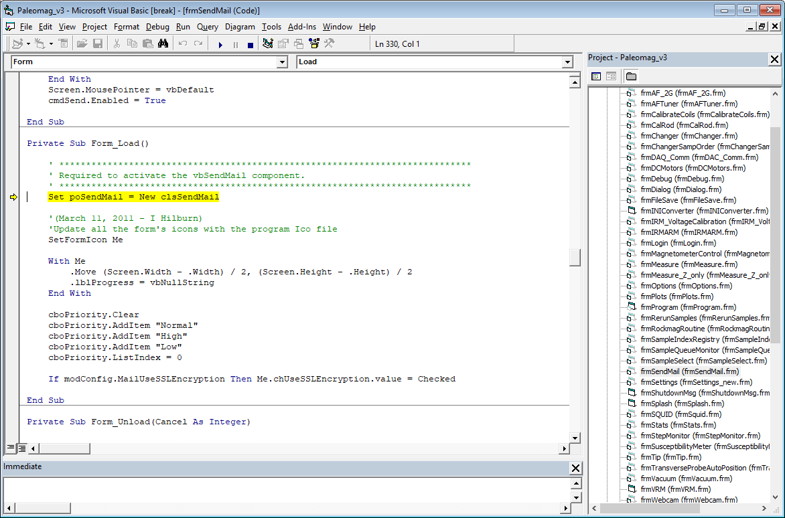 149
6) Your Windows 10 RAPID PC should now be fully functional. 152
7) Addendum 153
a) Comments from Yiming Zhang at Berkeley post-upgrade 153

Caution!
During the process of upgrading the Caltech Lowenstam RAPID system from Windows 10 to Windows 11, I was forced to install the Windows 11 Home edition, release version 24H2 for my new Windows 11 operating system. Windows 11 Home edition makes certain tweaks and fixes much harder than what I think Windows 11 Professional and Enterprise editions will do for / to you. Also, future release versions of Windows 11 may break this upgrade / install process even more. User beware!

Security Disclaimer
A lot of security features in Windows 11 need to be disabled for the install to work. If this is not allowed by your IT admins, then some other arrangement will need to be made (e.g. disconnecting the Windows 10 RAPID PC from the network, etc.).
NOTE: Do NOT install Visual Studio, yet. Read through ALL the directions and follow them in order. I’ve placed a discussion of the various Windows 11 security feature changes needed at the front of this documentation, as making these security settings changes may be forbidden by your organization / University.
List of Security Features that need to be Disabled or changed:

Core Isolation: Disabling Memory Integrity
  - The Memory Integrity feature under Core Isolation needs to be disabled
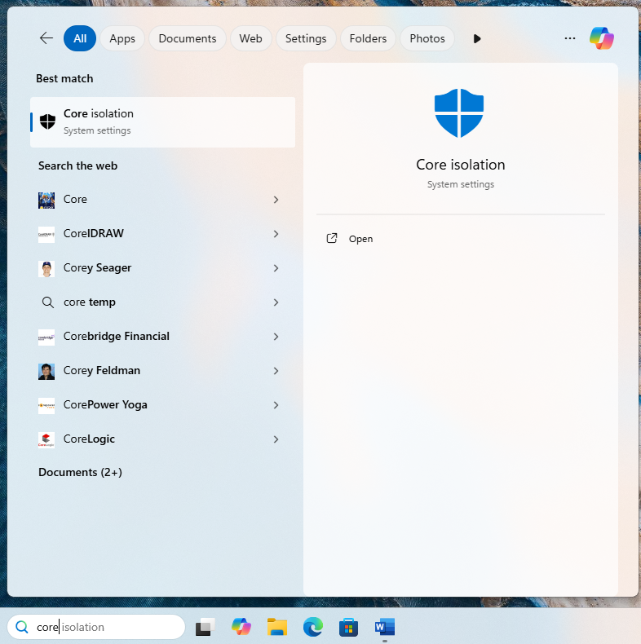
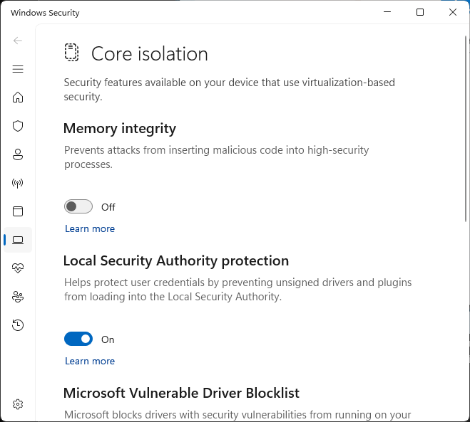
  - Blocks many 3rd party hardware drivers from running, including several of the hardware drivers needed to control the motors and DAQ devices that are needed for the RAPID system
  - Also blocks several of the drivers needed for VB6 to run.
  - This is Microsoft’s attempt to protect your PC from security exploits that target the memory cache in Intel and AMD x86 CPUs to gain access to processes / info that should remain secure.
  - It is designed to also reduce the likelihood of ransomware attacks
  - As a funny aside, it also blocks the new (as of winter 2025) Nvidia drivers needed for the graphics card in the Lowenstam RAPID PC. Yay!

Disabling Smart App Control
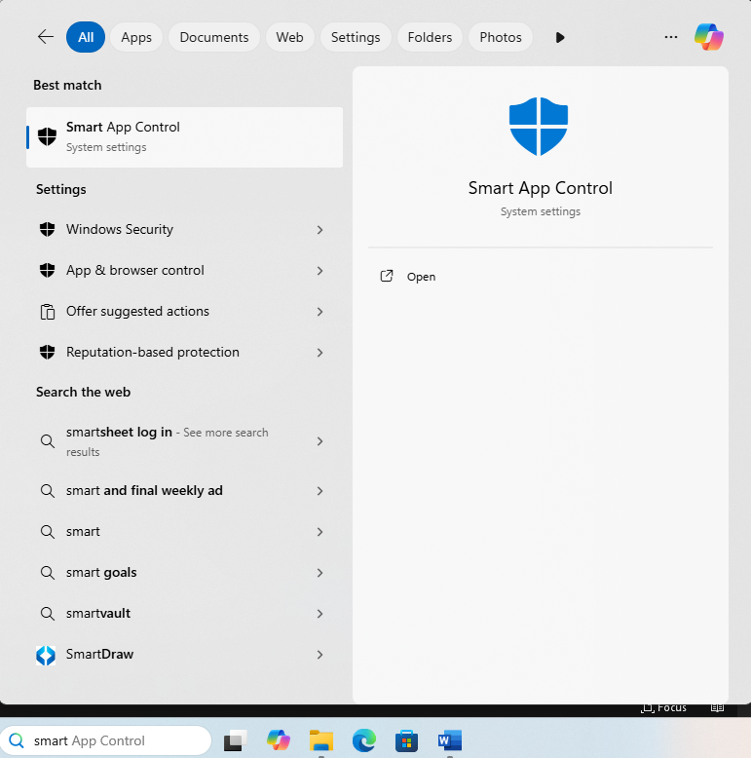
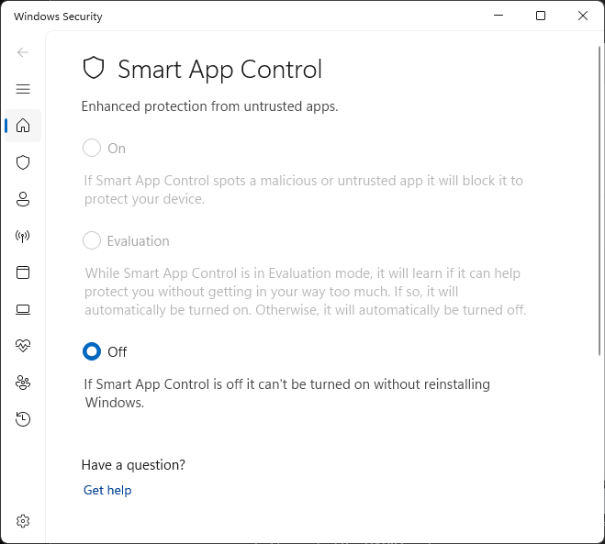
  - Needs to be disabled to install Visual Studio 6.0 and other 3rd party software needed to control the RAPID system
  - Will block installers from opening
  - Will block applications from running
  - May even block some installers / apps from being downloaded online
  - Turning off Smart App Control is a non-reversible action. You have to reinstall (?!?!?!!!!) Windows 11 to turn it back on again.

Controlled Folders: Disable or Allow Exceptions
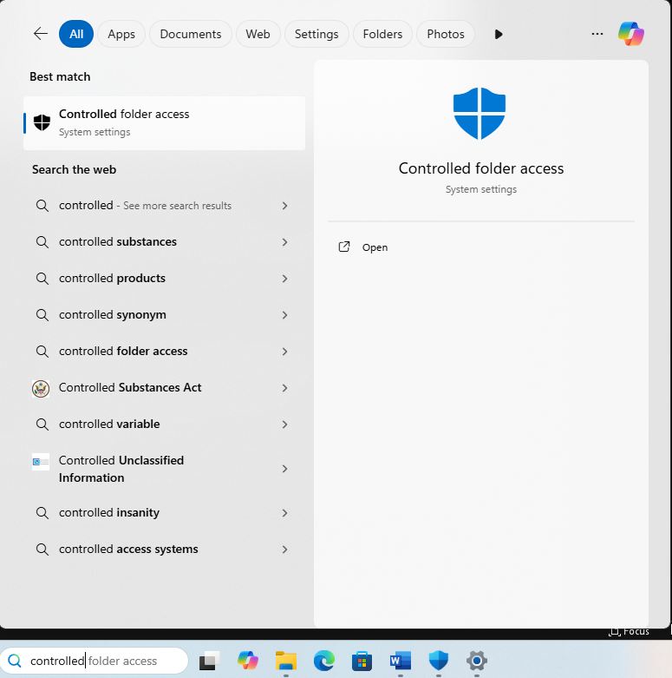
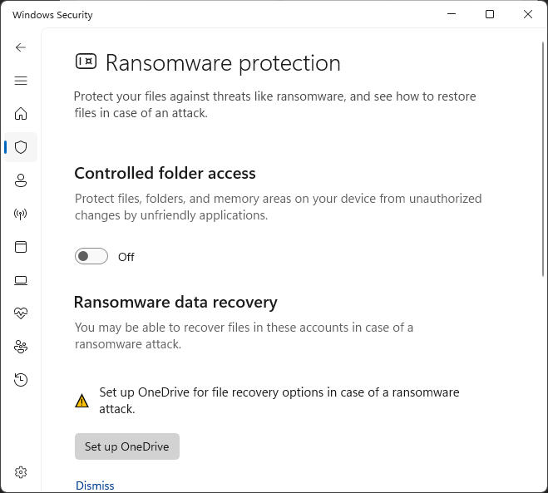

  - Need to add Visual Basic 6.0 to apps allowed to access “Controlled Folders” on your PC. Otherwise, the RAPID VB6 code will not have the file access needed to open settings files, save data, etc.
  - May need to add additional apps to the allow-list over time
  - Alternatively, you can turn off “Controlled Folders” entirely, to avoid any app conflicts.
- May need to tinker with Windows Update settings to prevent update restarts from happening while samples are running.
  - Can be set using a Group Policy by your IT Admin if you have Windows 11 Pro or Enterprise installed.
  - For Windows Home, there are possible workarounds, though I have not yet found one that works reliably
  - There will be Updates on this going forward
If any of these security settings changes are things that your organization’s IT Admins won’t allow, then I suggest sticking with Windows 10 for now.

Pre-Installation Backups / Preparations
The upgrade process from Windows 10 to Windows 11 is more complicated than the process was for Windows 7 to Windows 10. There is a higher chance of failure for your system. I strongly suggest a robust backup of your Windows 10 RAPID system prior to trying to upgrade to Windows 11.

Back-Up strategies
- Use a brand new computer for your Windows 11 system, so that if you need to abandon the upgrade, you can fall back to your original Windows 10 RAPID computer system
- Buy a new solid state drive (SSD) for your PC to install Windows 11 onto the new drive without affecting the old drive with your Windows 10 system.
  - Both Windows 11 and Windows 10 rely on the same UEFI BIOS to boot up, so you can pull the current drive that contains your Windows 10 system and replace it with a brand new solid state drive to install Windows 11 onto.
  - SATA and NVMe SSDs are super cheap right now
  - You likely won’t need more than 500 GB on your RAPID PC
  - Make sure to purchase an SSD that is compatible with your PC
- Image backups are going to be complicated to do a restore from.
- Talk to your IT admins for suggestions on how to back-up your system

Files and Folders to Copy to a portable / network drive
- You will need to make copies onto a thumb-drive / network share / etc. of your RAPID Paleomag code and settings folders, your AF and IRM data files, motor settings files, vbSendMail folder, etc.
- A list of what to save to a portable location is given in the instructions for upgrading from Windows 7 to Windows 10 in-place: Backup ALL of Paleomag files
  - These instructions are located in: APPENDIX A – Noted for Upgrading to Windows 10 in place, at the end of this document

Get an Installer for Windows 11
- Suggest downloading a .ISO file containing Windows 11 installer
- Can then use a tool, like rufus.exe, to create a bootable usb thumb-driver with the Windows 11 installer loaded onto it
- Strongly suggest you have installation media for Windows 11, even if you are doing an install in place. There is a much higher chance that the upgrade will go wrong and you will need to restart from scratch. As of this writing, on April 17, 2025, I am on my 3rd attempt. Installing VB6 on Windows 11 is not too hard. But, getting the Paleomag VB6 code and all the 3rd party hardware / software to run stably, is much trickier.

Document Device Configurations for your Windows 10 system
- Open Windows Device Manager and take screen shots of your current serial com port settings and assignments
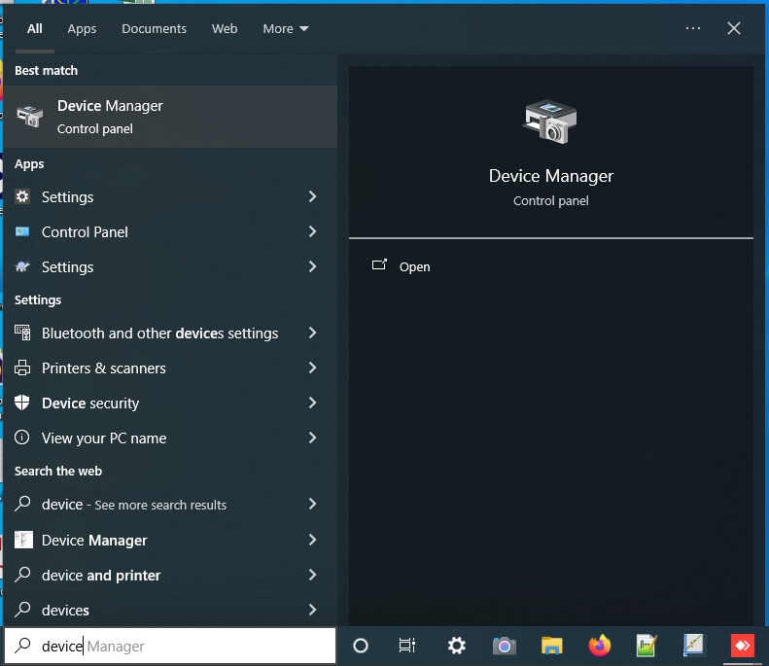
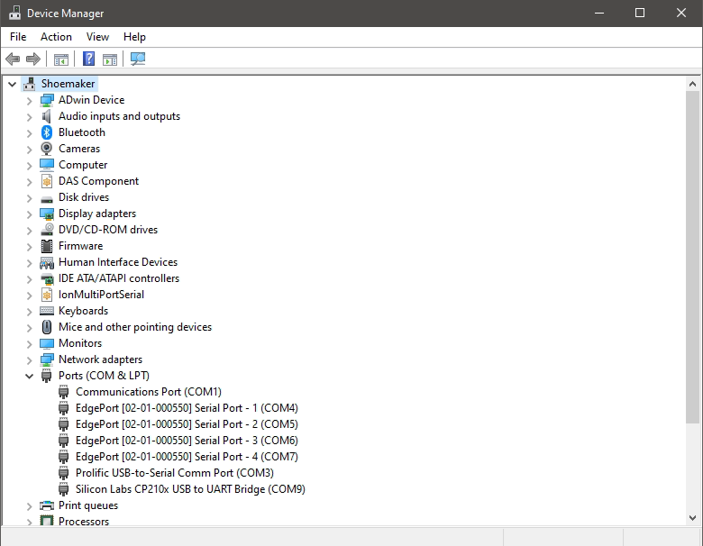

  - This includes the settings for each individual com port (baud rate, stop bits, data bits, parity, etc.). These settings can be accessed by right-clicking one of list COM ports and selecting the “Properties” from the drop-down menu.
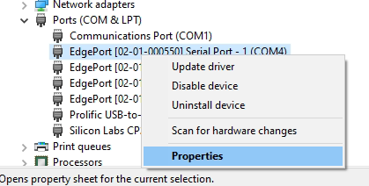
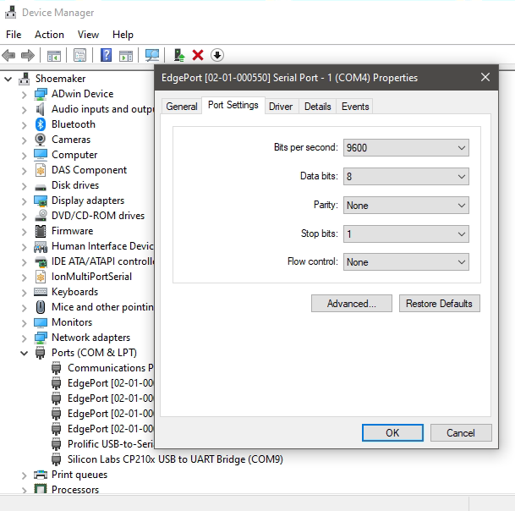

  - Also, which comm port name (e.g. “COM-1”) in Device Manager corresponds to which physical comm port for your USB -> comm port adapter
    - To do this, you will need to look at the labels on your USB Serial Com port adapter device and compare those labels to the port description under the list of Ports in the Windows Device Manager.
- ADwin DAQ system
  - Run Adconfig
    - Inside Adconfig, find out the device and boot ID for your ADwin system
    - If the Device No. for your ADwin-light-16 DAQ device changes after the upgrade (e.g. from “Device No. 1” to “Device No. 2”), then the Paleomag .INI settings file will need to be manually changed so that the Paleomag VB6 can boot and control the ADwin-light-16 DAQ device.
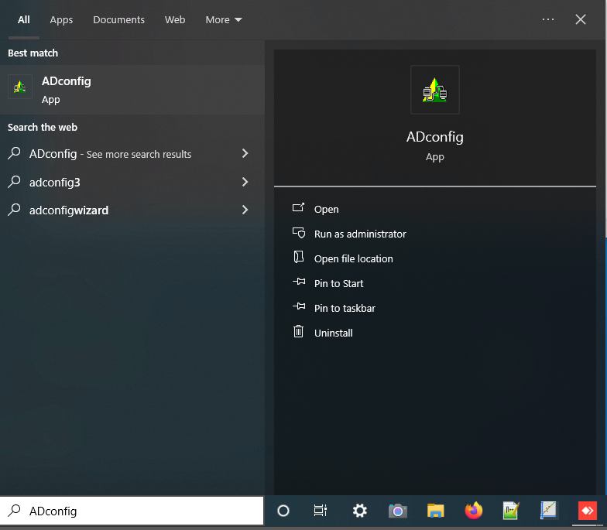
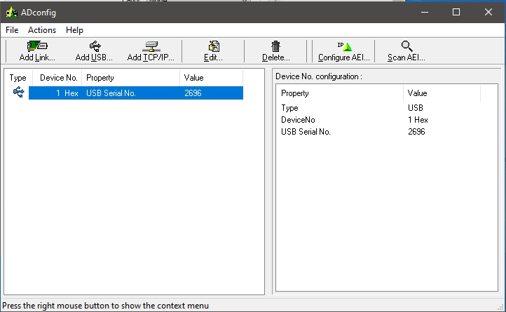
- Measurement Computing DAQ system
  - Run InstaCal
    - Inside InstaCal, find out the board number for the Measurement Computing DAQ devices on your RAPID system
    - If the Board# assigned in InstaCal for your Measurement Computing DAQ device changes after the upgrade, then manual changes will need to be made to your Paleomag .INI settings file, otherwise, the Paleomag VB6 code won’t be able to “find” the DAQ device.
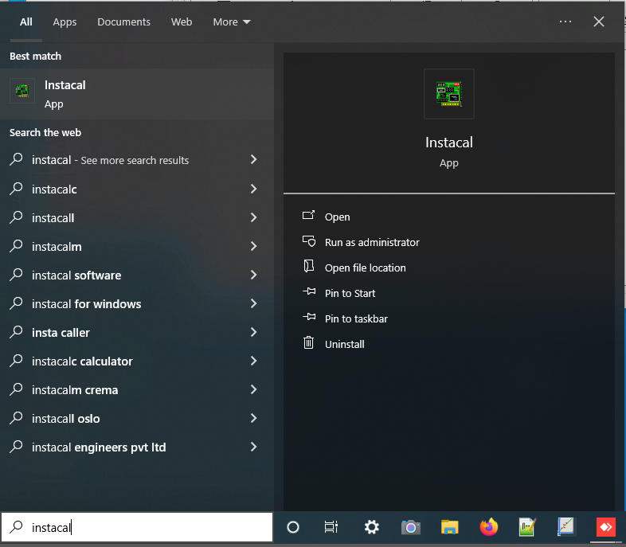
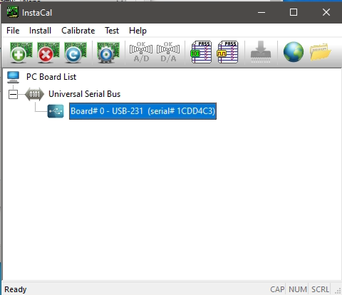

What else am I forgetting…?
- I probably am forgetting something. During the Windows 11 upgrade process in your lab, you may discover what it is that I am forgetting. Hopefully, it’s not important.

Installing Windows 11

Installing Windows 11 with a local user account
During the normal Windows 11 installation process, Microsoft will try and force you to sign in using a Microsoft User account in order for the installation process to continue. This may be highly undesireable for a computer that many different lab members and visitors will have access to. If the Windows 11 is signed in with your microsoft account, for instance, Outlook 365 will be automatically logged in to your email account. Likewise, any Office 365 product may open up automatically logged in and will have access to your OneDrive shared files, Outlook emails, etc., etc.
There are ways to get around this.
Fancy way:
- Your organization IT admins run the install, install Windows Pro or Enterprise and sets up all the account stuff by pushing group policies to the new Windows 11 PC or by some other sneaky / fancy method
Crude way:
- You disconnect your PC from the internet during install and use a hack to enable the installation to continue without an internet connection
  - How to Set Up Windows 11 Without a Microsoft Account

Disable Microsoft Copilot
- If you wish to prevent Microsoft’s attempt at user-friendly AI from using up computer resources and possibly gathering all sorts of user data and sending it off to cloud, you can hide and/or disable Microsoft Copilot
- If you search online using the phrase “Windows 11 turn off Microsoft copilot”, you can find a lot of guides for how to disable Microsoft Copilot
  - Be very careful when making any changes to your Windows 11 system registry, as suggested in some of the online guides
  - Some of the registry tweaks I have tried in the past for Windows 11 have not worked
  - After disabling Copilot on the Caltech RAPID PC, the computer failed to restart after the first try. I had to power cycle the PC a few times before Windows loaded up normally.

Other software to Install
- Prior to installing anything you download from the internet, I strongly suggest uploading the installer to an online anti-virus meta scanner, such as Virustotal.com
  - VirusTotal - Home
  - This will save you from installing mal-ware, ransom-ware, etc. on your new Windows 11 system from the start.
  - I scan every installer than I download / user with VirusTotal before running it
  - You’re not paranoid if they are trying to encrypt all your data files and ransom the decrypt key back to you.
  - This will not save your system from being hacked via other means, e.g. someone logging into their email account and opening an attachment that they shouldn’t, etc.

- Install only the software that you need on the RAPID PC.
  - Suggest analyzing the data on a different PC
  - The smaller the amount of 3rd party software installed, the less the likelihood of Visual Studio 6.0 / VB6 having a conflict with another piece of software on your RAPID PC
- Change your Folder / File view settings in Windows Explorer to show the file extension. This will help during later steps during the upgrade process and is a helpful way to prevent from running malicious programs or installer files that are pretending to be something else.
  - Open File Explorer
  - In File Explorer, open any folder, then click the “…” option in the menu row near the top of the window. This will open a pop-up menu.
  - In this pop-up menu, select “Options” 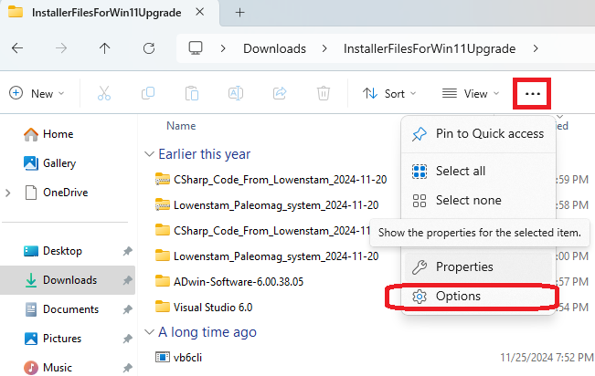
  - A “Folder Options” window will open. Click the “View” tab.
  - Under Advanced Settings, uncheck the box next to “Hide extensions for known file types”
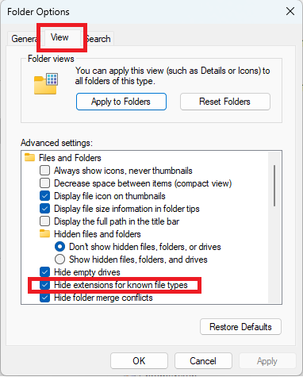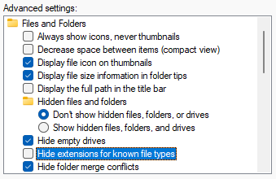
  - Finally, click the “Apply to Folders” button
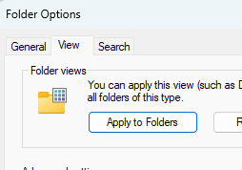

  - A confirmation message will pop-up, click “Yes” 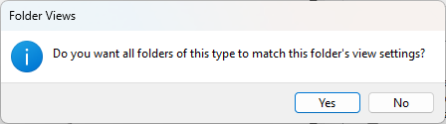

- Suggest installing the following software before installing any of the RAPID related software
  - Adobe Acrobat Reader
    - Be careful during download process to un-check also downloading McAfee Antivirus installer along with the Adobe Reader installer
    - Install just Adobe Reader and not Acrobat. Prior versions of Adobe Acrobat have created conflicts with the ActiveX user controls that the Paleomag VB6 code uses.
  - MS Office 365 or open-source equivalent
    - If possible, install only what you need, such as Word, Excel, PowerPoint, etc.
    - Excel can be useful for viewing AF ramp and IRM DC pulse debug files and diagnosing issues with those two hardware components.
  - NotePad++
    - Downloads | Notepad++
  - AnyDesk (or non-TeamViewer equivalent)
    - For remote support from other RAPID consortium members
    - Has pro version that is much cheaper than TeamViewer
    - The Fast Remote Desktop Application – AnyDesk
  - 7zip
    - Tends to be faster and more reliable than the built in Windows file compression / decompression app
    - You can search online to find a 7-zip installer for Windows 11
  - Web browser of choice
    - I prefer to use the default Windows 11 web browser, Microsoft Edge
    - Downloading other browsers involves installing more drivers, etc., onto your RAPID PC
    - In the future, some of these web browser drivers may come into conflict with the ActiveX controls and drivers that VB6 and Visual Studio 6.0 use and upon which the Paleomag VB6 relies.
    - Chrome is particularly notorious for creating conflicts with VB6 ActiveX controls. I’ve had to uninstall it from a few RAPID PC’s in the past.
  - Zoom
    - Suggested video chat software for connecting to other members of the RAPID consortium to get help.
    - Other options are available
    - Do NOT install Skype For Business – in the past, this app has had conflicts with Visual Studio 6.0 and with the Paleomag VB6 code

3rd-Party RAPID software installs
I recommend installing Visual Studio 6.0 last during the upgrade process. This way, you can create a system restore point using the Windows 11 settings->System->Restore interface so that you do not lose your work up to that point. Installing Visual Studio 6.0 and applying the necessary fixes for RAPID code to load and run can be complicated, and mistakes are likely. Furthermore, I am apprehensive that Microsoft may alter subsequent versions of Windows 11 in such a way that could lead to new and unexpected complications.

Creating a Windows 11 Restore Point
- Use the Windows 11 search bar to search “restore” and click the Best Match option “Create a restore point”
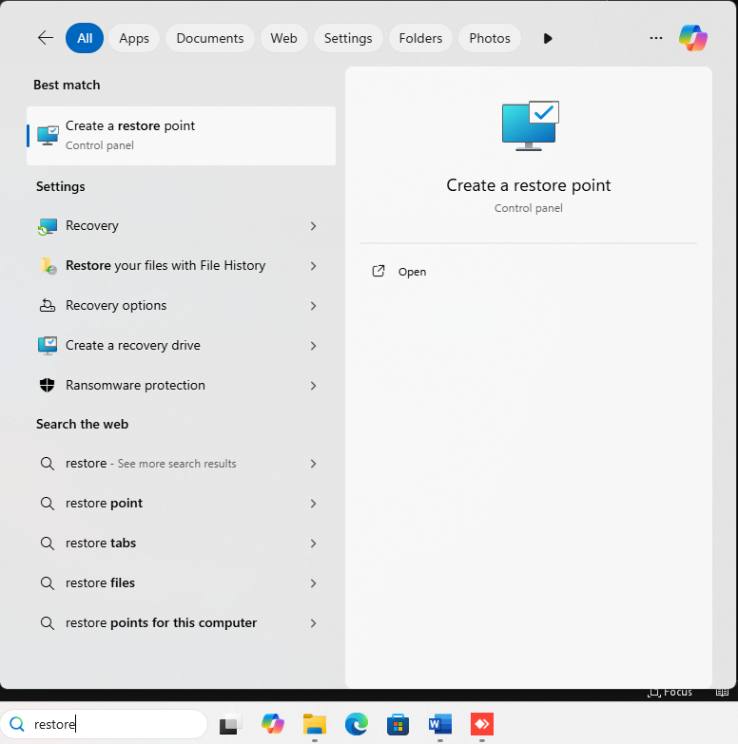
- A new System Properties window will open to the System Protection tab.
- You can create a new Restore point using the “Create” button near the bottom of this window
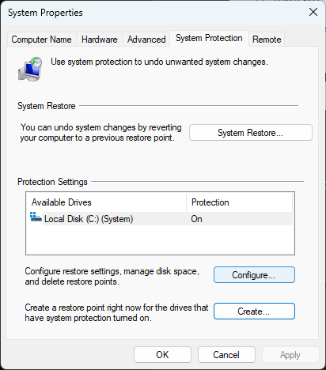
- Name the new Restore point something that corresponds to where you are in the installation process.
- I have created two restore points
  - After installing the non-RAPID related software onto Windows 11
  - After installing all of the RAPID related software, but BEFORE installing Visual Studio 6.0
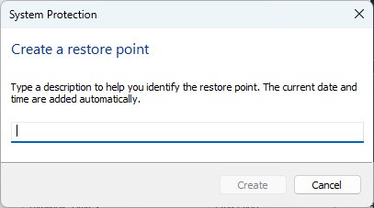

ADwin Software
- ADwin - Download - Windows Software Package
- In particular, you want to download the most recent version of the: ADwin software package
- Windows Smart App Control may block the process of downloading, extracting, or installing the ADwin software package. Follow the instructions from the Security Disclaimers portion of this document to turn off Smart App Control: Disabling Smart App Control
- Virus scan the downloaded .zip file
- Extract the .zip compressed files
- Pre-install, either disconnect your ADwin-light-16 device from your PC or turn off the ADwin-light-16 device power using the pull-then-toggle switch (be careful – you have to pull gently out on this switch before you can toggle it on or off – it is easy to break)
- Run install by double-clicking the Setup.exe file inside the ADwin software folder
  - Follow the installer directions
  - Install the application for: Anyone who uses this computer (all users)
  - Chose to do a “Complete” install
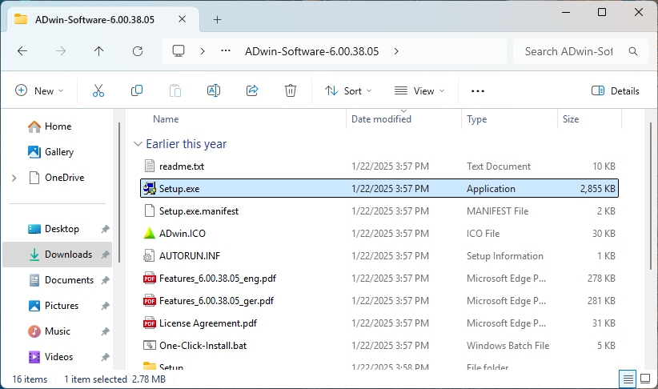
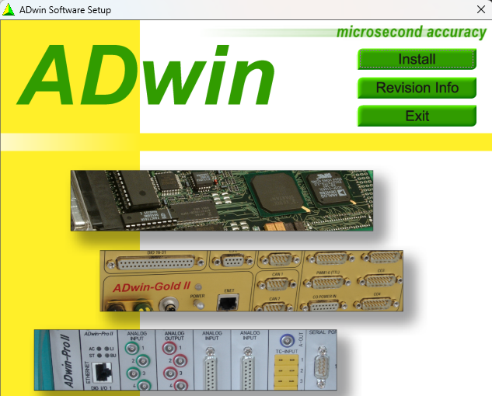
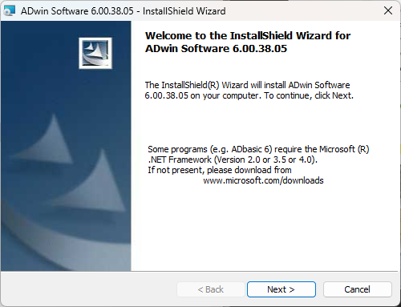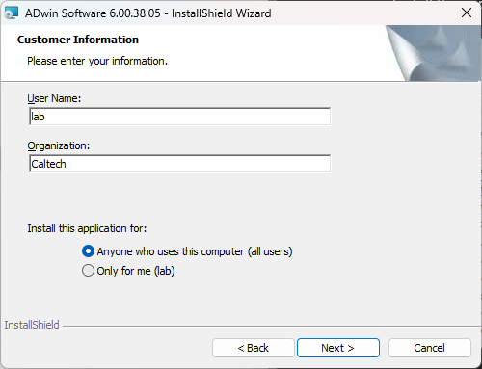
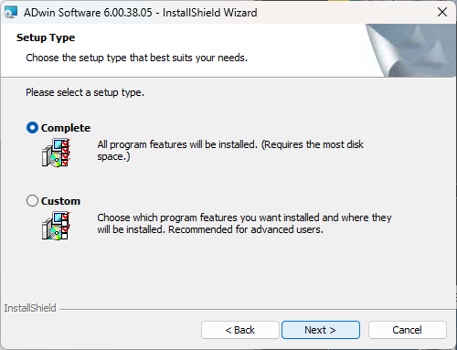

- Connect via USB your ADwin-light-16 DAQ device to your RAPID PC, turn on the ADwin device’s power (remember to gently pull out on the power toggle switch, first – it is easy to break).
- Wait for your system to detect the new USB device and finish “setting it up”
  - At this point, if you have not turned off the Memory Integrity security feature in Windows Core Isolation, you will have received a notification from Windows Security that one or more ADwin driver have been disabled because they are incompatible with the Memory Integrity security feature. The drivers, so far, that I’ve found to be incompatible are:
Driver Name | Developer
ADldr2_64.sys | Jaeger GmbH
ADldr_64.sys | Jaeger GmbH
ADusb_64.sys | Jaeger GmbH

  - Some drivers may be listed twice with different capitalizations
  - To resolve this, you must turn off the Memory Integrity security feature: Core Isolation: Disabling Memory Integrity
    - You will need to restart the RAPID PC to complete this process
- Run ADconfig
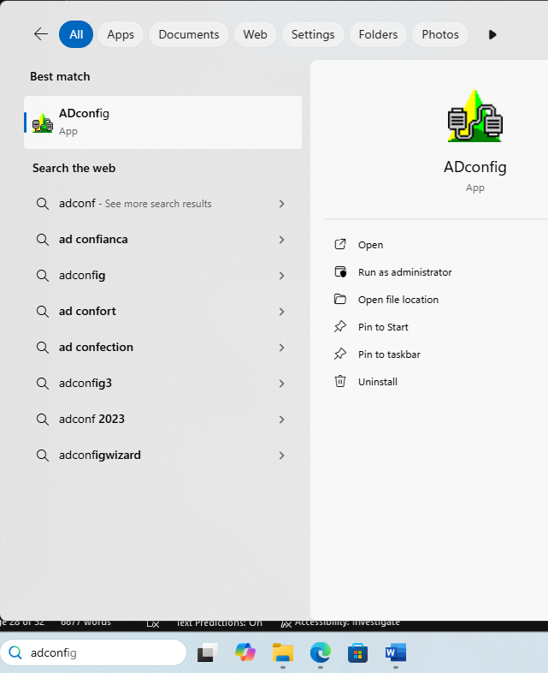
  - ADConfig Should detect ADwin-light-16 device and assign it a boot number
  - If not, click the “Add USB…” button
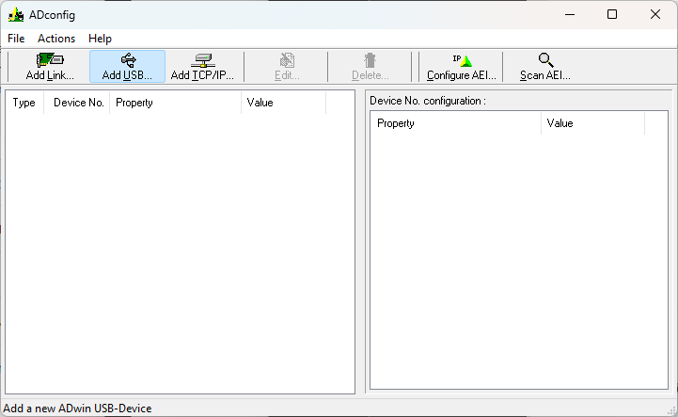
    - In the resulting pop-up window, click the USB Serial No. drop-down box, and the serial number corresponding to your connected ADwin-light-16 device should be the only option
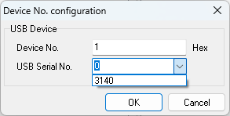
    - Select this Serial Number, then click the OK button
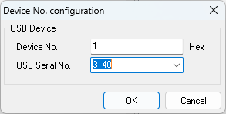
  - Now, the ADwin-light-16 device should be listed in the main ADconfig program window
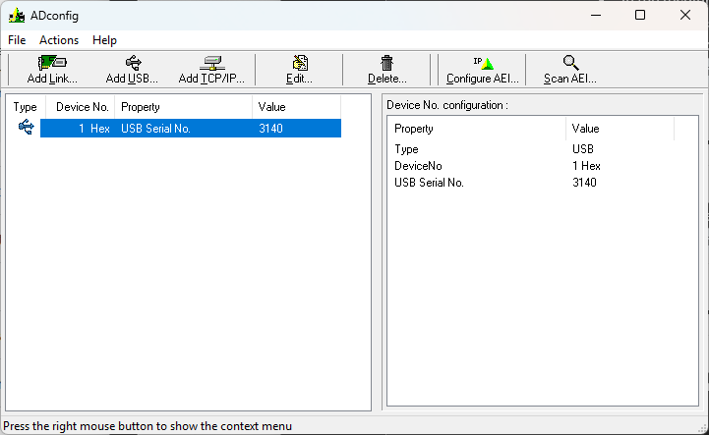
- Once this is done, Run ADtest
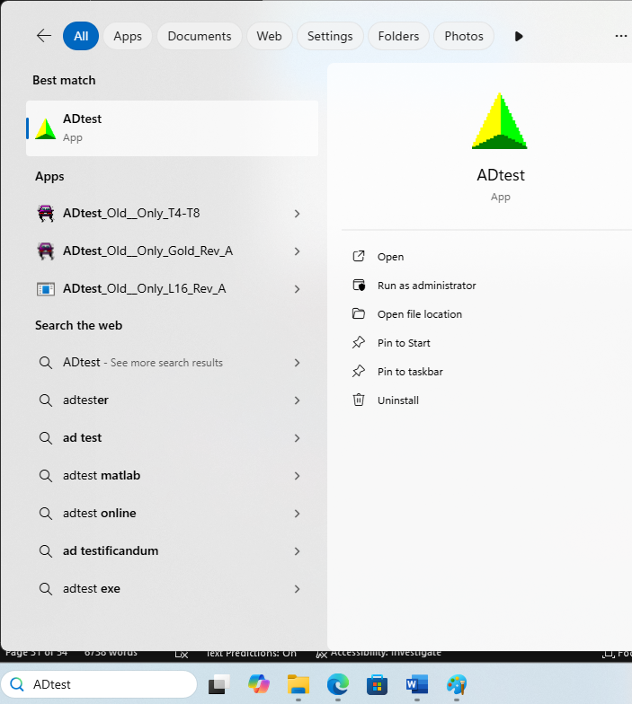

  - When ADtest loads, click “OK” to proceed through the first pop-up window
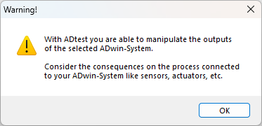

  - When the ADtest – Boot window pops-ups, for Step 1, select the option for “light-16”. For Step 2, select the Device Number that corresponds to your ADwin-light-16 system.
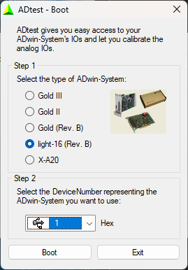
    - If your device number does not show up in the drop-down list in Step 2, or there are no devices to select from, then something may have gone wrong. You may want to check the USB cable and connection between your PC and the computer. You may likewise want to check the DC power supply that you are using to power your ADwin device, etc.
  - Otherwise, click the “Boot” button
  - Click to Agree to reboot the device, if a message window pops-up prompting you to to this.
  - Test ADwin device functionality in Adtest
    - Analog Input
      - The analog input channel that is connected to the green Pearson electronics ammeter donut in the AF capacitor box (a.k.a. the AF auxiliary degausser box) should be reading in a static value close to zero.
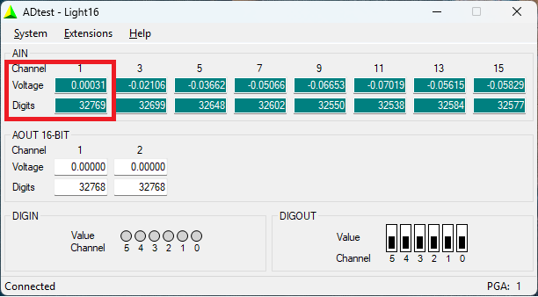

    - Digital Output
      - The first three digital outputs (Channels 0, 1, and 2) control the three AF and IRM relays in the AF capacitor box (a.k.a. auxiliary degausser box).
      - You should hear two different click noises when you toggle the values for these channels, a softer “click” noise when you toggle the values for Channels 0, 1, or 2 from Lo to Hi, and a slightly louder “click” noise when you toggle the values from Hi to Lo.
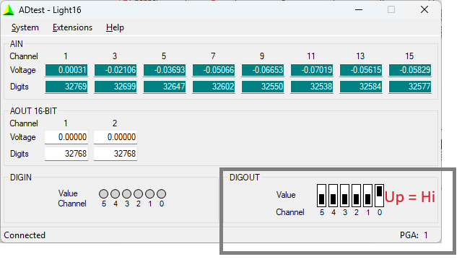
    - If you experience issues with either the Analog Input or Digital Output readings / behavior, then contact other members of the RAPID consortium to get help. Sometimes, though, the issue can be as simple as an unplugged power cable, or a power switch set to off. (I tend to leave the AF and IRM hardware unplugged when not in use. The number of times that I have forgotten about this when trying to debug the ADwin system is embarrassingly high).

Digilent / Measurement Computing DAQ software
- Recently, National Instruments (NI) reorganized all of the Measurement Computing DAQ products under the umbrella of Digilent, so all the links for finding the Measurement Computing software downloads and support manuals have changed since ~2023. Given how sneaky NI is, the links are liable to change again in the future.
  - Link to Measurement Computing support page under Digilent’s webpage:
    - Current link, as of Jan 22, 2025: Software - Digilent Reference
    - On this webpage, choose the link for MCCDAQ Software CD:
      - https://digilent.com/reference/software/mccdaq-cd/start
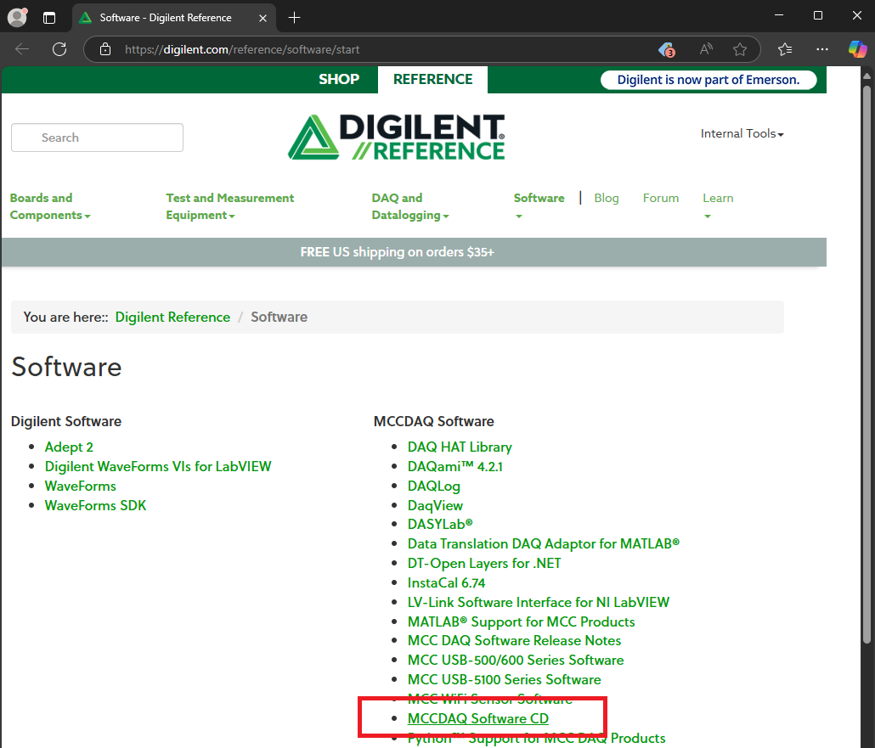
- In order to download the Measurement Computing software, you will need to create a Digilent user account and sign in. This account is free and yet another fun way to expose your personal data online and subject your email inbox to more sales spam.
  - Some user support forums, online, have reported issues registering as a new user on the Digilent website when using the Chrome and Safari browsers. Microsoft Edge is the browser recommended, instead.
- Windows Smart App Control may block the process of downloading, extracting, or installing the MCCDAQ software package. Follow the instructions from the Security Disclaimers portion of this document to turn off Smart App Control: Disabling Smart App Control
- Once you download and virus scan the MCC DAQ software CD, just double-click the mccdaq.exe application file. It will run WinZip self extractor and open a small window from which a sequence of other installers will be run
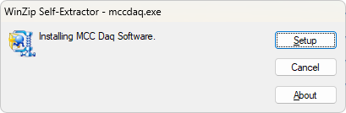
- Click the “Setup” button to start unzipping the installers. I suggest installing the minimum amount of software from Measurement Computing – just the option for InstaCal & Universal Library. Nothing more than this is necessary for a RAPID PC. To avoid future 3rd party application / driver issues, it is advisable to install the minimum. Exceptions to this are the example code files for Universal Library – you can install all of those files without causing any compatibility issues.
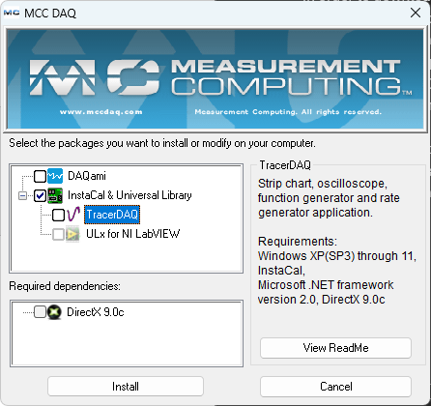
  - Installing TracerDAQ is not needed for running or debugging the RAPID system. I like to use it for other tasks / hardware diagnostic tasks not related to the RAPID system (especially debugging issues related to the Caltech scanning SQUID microscope).
- Configure MCC DAQ device(s) for the RAPID system:
  - If you have a USB measurement computing (MCC) DAQ device, make sure it is connected to the PC via USB at this point
  - If you have a PCI or PCI-E MCC DAQ device, it should (hopefully) already be connected to the computer.
  - Once the MCC DAQ software installation process is complete, search “InstaCal” in the Windows search bar and open the InstaCal app
  - When the app opens for the first time, it should detect your Measurement Computing DAQ device. However, this may be for USB MCC DAQ devices and not for the older PCI or PCI-e MCC DAQ devices.
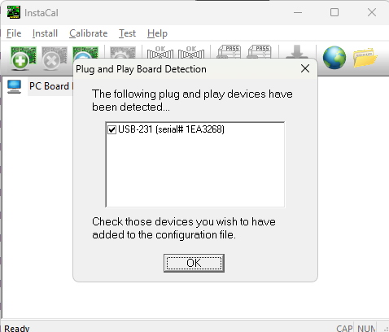
    - Click “OK” to direct InstaCal to add your Measurement Computing DAQ device to the InstaCal configuration file. This process is necessary to enable the MCC DAQ device to be accessible in Windows to other applications and programs (such as the Paleomag VB6 code).
    - InstaCal only works for measurement computing (MCC) DAQ devices
  - If your Measurement Computing DAQ device is not detected and loaded into InstaCal, then you will need to check the Measurement Computing troubleshooting and support. A good starting place for this is: Data Acquisition (DAQ) & Data Logging - Digilent Forum
    - Also suggested: emailing the RAPID consortium group email list and asking if anyone else has had an issue with this.
    - One common solution when having issues in InstaCal with Windows 11 is to ensure that you are installing the latest version of the MCC DAQ software / InstaCal / Universal Library. The forums in particular mention needing InstaCal version 6.74 or later for Windows 11.
    - There are known compatibility issues between Windows 11 and older Measurement Computing DAQ devices, particularly the PCI DAS6000 series devices. However, I think that these issues have been resolved with the newest versions of InstaCal and Universal Library (as of April 2025)
  - Once you click “OK” to add the MCC DAQ device in InstaCal, the MCC DAQ device will show up in the PC Board List.
    - For USB devices, they will be listed under the Universal Serial Bus
    - For PCI or PCI-e devices, they will be listed under those interfaces
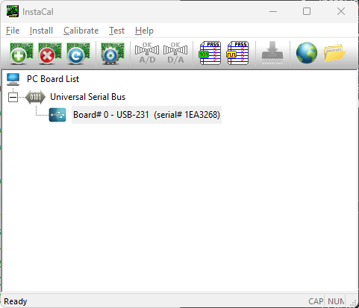

  - Make a note of the Board# assigned to the MCC DAQ device. In the example above, the device has been added as Board# 0. This Measurement Computing board number assignment is used by the Paleomag VB6 code to access the MCC DAQ device (or “board”). The default Measurement Computing Board# is 0. Further along in this document, I will go over the Paleomag .INI settings file, its structure, and how to verify that the MCC DAQ board number in the Paleomag .INI file matches that of the correct MCC DAQ device in InstaCal.
- Finally, we need to configure the Analog Input settings for the MCC DAQ board in InstaCal. This is key.
  - Measurement Computing (MCC) devices can be configured for a few different types of analog input wiring schemes. The scheme used in the RAPID consortium, and the one currently being used for new 2G / APS RAPID vertical SRM systems (as of April 2025) is “Single-ended”, which basically means all the analog inputs share a common ground and the active (“+” or “hot”) wire for the analog input is connected to one of Analog Input channel terminals on the MCC DAQ.
  - In InstaCal, right click the listing for your MCC DAQ board / device and select the “Configure … “ option from the pop-up menu.
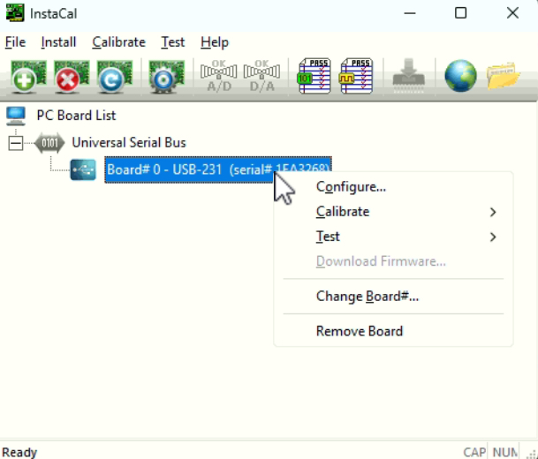

  - A new Board Configuration windows will open. The options / contents of this window will be different depending on the MCC DAQ board / device that you are using.
    - In this window, search for a setting labelled “Input Mode:” or “Analog Input Mode:”. This setting should have a drop-down selector associated with it.
    - In the drop-down selector, change the setting to: “Single-Ended (8 ch)”. Depending on your MCC DAQ board / device, this might just be listed as “Single-Ended” or “Single Ended (16 ch)”, etc.
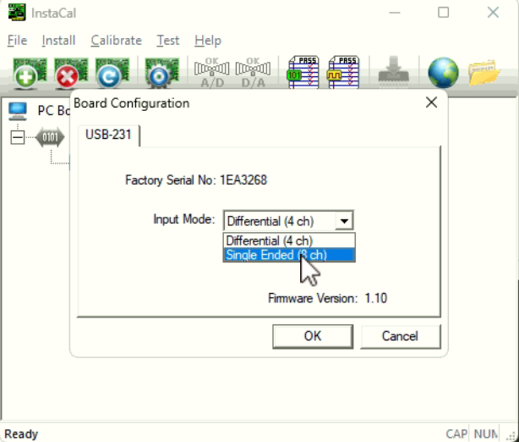
- Add your MCC DAQ board / device in InstaCal and changing the Analog Input Mode setting to Single-Endded must be performed in InstaCal everytime the following happens:
  - You update InstaCal or your MCC software
  - InstaCal / the MCC software / Windows 11 drops and re-adds the MCC board / device in InstaCal. This can happen, say, if you connect a USB MCC DAQ board / device in a new way to your RAPID PC, such as via a new USB hub.
  - Symptoms that this step needs to be redone in InstaCal:
    - Paleomag VB6 code throws an error when trying to connect to and use the Measurement Computing DAQ board / device. This generally indicates some communication and control issue between the Paleomag VB6 code and the MCC computing DAQ board / device drivers (e.g. that the DAQ board needs to be setup in InstaCal again)
      - For almost all RAPID systems, the Paleomag VB6 code uses the MCC DAQ board / device to:
        - Control the Vacuum and degausser cooling valves, using digital output channels on the MCC DAQ board / device
        - Control the ARM box, including an analog output channel to set the ARM bias coil DC current level / magnetic field output, and a digital output channel to open and close the Set Bias relay that connects the ARM bias coil to the DC power-supply that energizes it, etc.
      - For some systems with a Caltech / ASC / Matsusada / B&K Precision powered IRM device, the MCC DAQ board / device is also used to:
        - Control the IRM box, including digital outputs that set the IRM capacitor trim relay, set the IRM Fire relay, an analog output that sets the voltage for the capacitor charge level (i.e. the DC pulse magnetic field flux density to charge up to and fire at), and an analog input that reads back the voltage or current level (depending on your IRM device) currently in your DC capacitors.
    - Incorrect Analog Input values being read from the MCC DAQ board / device, usually this can show up as an issue when trying to do an IRM
      - If your RAPID system has a Caltech / ASC / Matsusada / B&K precision powered IRM devce, the analog input values coming back from the IRM box are incorrect / floating / not changing correctly as the IRM capacitors are being charged.
      - Means that the “Input Mode:” settings for the MCC DAQ board / device are likely incorrect and need to be changed to “Single Ended” mode.
      - Could also genuinely be an issue with your IRM device hardware. WARNING: don’t try to debug your IRM hardware without advice from other members of the RAPID consortium and someone with experience working with a high-voltage electronic device. An electrical discharge from the capacitor banks – or anything connected to the capacitors -- in your IRM box / device into your body can be lethal.

QuickSilver Controls software
- Next up is QuickControl, from QuickSilver Controls, the maker of the DC servomotors that are used to control the RAPID pick-and-put sample handler system (both the snake-chain and the XY stage variants).
- Prior to downloading and installing the QuickControl software, it is a good idea to make sure that whatever USB to RS232 comm port adapter that you re using with your RAPID system is being recognized by Windows 11 and that the comm ports show up in Windows Device Manager
  - For more information on this, please read in APPENDIX A, below: Hardware compatibility
  - Some USB to RS232 adapters that are compatible with Windows 10 are not compatible with Windows 11. The 4 and 8 port Edgeport USB adapters appear to work well, so far, as of April 2025.
- QuickControl software can be downloaded from the QuickSilver Controls website: Downloads - QuickSilver Controls Inc
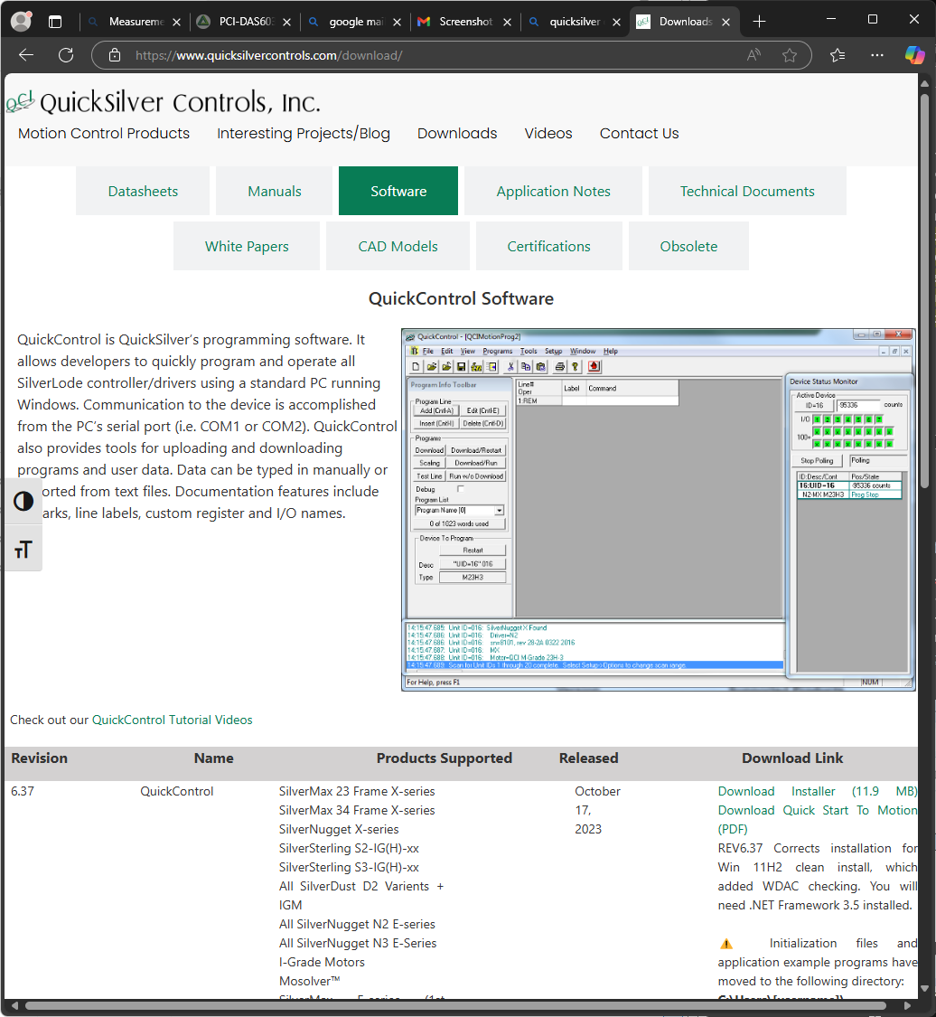
- Suggest downloading the newest Revision version of the QuickControl software. As of April 2025, this is Revision 6.37
- Downloads portion of QuickSilver controls website also contains a large amount of user manuals, motor control / programming guides, technical papers about you the motors work, etc. The general level of technical support is awesome. The RAPID system barely uses any of the full functionality of the QuickSilver DC servo motors. If you are interested in automation and control applications, embedded software / hardware, etc., I strongly recommend reading through some of the support documentation on the QuickSilver Controls downloads website.
- Once you have downloaded the QuickControl installer and virus-scanned it (e.g. using VirusTotal online), extract the installer from the downloaded .zip file and open “setup.exe” to start the installer process. Follow the installer’s directions and click finish once the installation is complete
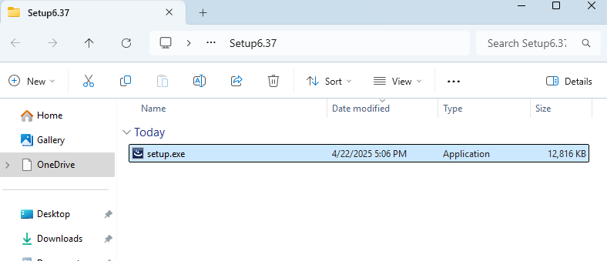
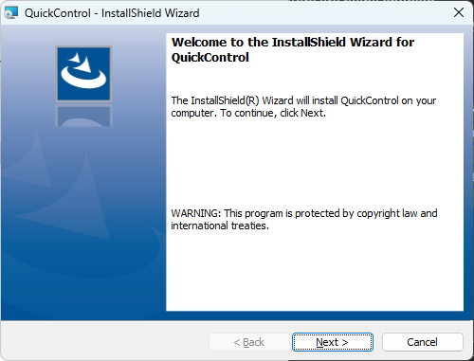
- Once the installation is complete, type “QuickControl” into the Windows search bar and then open the QuickControl app.
- The first time you open QuickControl, a couple message windows will pop up, offering you a tutorial on how to use QuickControl (worth it if you have the time), and then a second windows will notify you how to setup the comm port settings within QuickControl to connect to a motor system
- The DC servo motors consist of two parts:
  - The motor
    - Has rotary position encoder wheel attached to the motor shaft. As the shaft rotates, an optical sensor detects position change on the encoder wheel, allowing the motor to read and report its own position. Can be powered on and off separately from the motor controller.
  - The motor controller
    - Connects to and controls the motor. Keeps track of the state that the motor is in (e.g. target and current motor position, motor speed, acceleration, motor error status, etc.)
    - Handles RS232 serial communication with the RAPID PC, and receives, acts upon, and responds to commands from the RAPID PC
    - Capable of multiple reset options – including soft and hard resets of the motor and the controller, itself
  - Many QuickSilver Control motor issues can result from communication / connection issues between the Motor and Motor Controller. Namely, the communication cables that connect the two have a finite number of times they can flex (bend) before one or more of the wires in the connection cable shorts or breaks. This can be an issue for the RAPID turning motor and Y stage motor. Due to their location, these two motors are moved by the sample changer system whenever the up-down or X stage moves (respectively). Thus, the cables connecting the turning and Y motors to their motor controllers experience flex (bending) regularly.
  - There are ways to diagnose communication / control issues between a motor and its motor controller from within the QuickControl software
- The motor controllers each talk to the RAPID PC over their own RS232 serial comm port
  - Comm port settings used for communicating with the QuickSilver Controls motor controllers:
    - Baud Rate: 57,600 (57.6K)
    - Data Bits: 8
    - Stop Bits: 2
    - Parity: None
- Using the screen captured RS-232 comm port configuration that was documented for your prior Windows 10 system, go to Device Manager, now, in Windows 11 by searching “Device Manager” in the windows search bar and opening the Device Manager under the Best Match search result.

- In the Device Manager window, scroll down the list of Device categories to the “Ports (COM & LPT)” category. Click the heading for this category to list its contents. 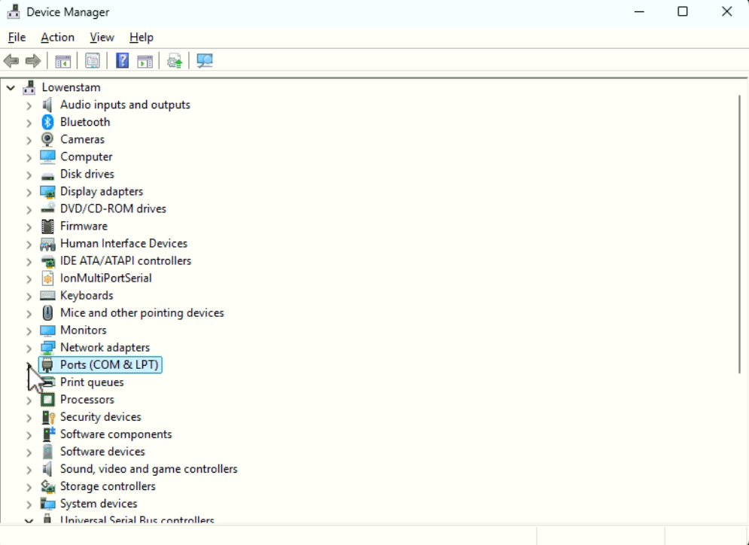
- Compare the list of COM port devices to the screen-shots from your Windows 10 system
- Missing COM port devices / adapters might be hidden under the “Other devices” device category. For an example of this, see the section below on the B&K precision DC power supply USB communications drivers: B&K Precision DC power supply USB communications drivers for Caltech / ASC IRM systems
- If you are missing COM ports, you may need to find Windows 11 compatible drivers for the various com port adapters that your are using with your RAPID system
  - General note, the Edgeport USB to RS-232 comm port adapters – both the 4 and 8 port variants, appear to have no issues in the Windows 10 -> 11 transition.
  - Not sure is this is so for other brands of adapters. Some of the cheaper USB to RS232 com port adapters, particularly the single-port adapters, are not Windows 11 compatible.
  - In general, it is a good idea to avoid assigning COM port binding smaller than or equal to COM3. Usually, windows will assign the built-in com-port attached to the desktop PC motherboard as COM1. COM2 and COM3 used to be “quietly” assigned by older Windows OS’s to other things.
    - Example from the Lowenstam RAPID system at Caltech:
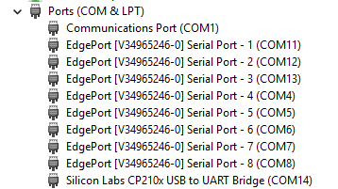
      - COM11,12,13, and 4 – 8 are assigned in Device manager to the eight RS-232 serial ports on our eight port Edgeport USB to RS-232 adapter. COM14 is a virtual comm port for for USB communications with our B&K Precision 9185b DC power supply. We use this computer controlled power supply to power the Lowenstam IRM pulse magnetizer box (a modified ASC Model IM-10 pulse magnetizer).
- Once you have installed all the needed device drivers for your missing com ports and they are listed under the “Ports (COM & LPT)” section in Device Manager, then you need to check the properties for each of these com ports to verify that they match the properties under your prior Windows 10 system.

- For now, we will go over the COM port settings for the 3 or 4 QuickSilver controls motors that are part of the RAPID sample changer system (3 motors for the older snake chain systems, 4 motors for the XY tray systems).
  - First, we need to verify that the com port numbers assigned by Windows 11 to each physical com port in your adapter have not been scrambled
    - For EdgePort USB to RS-232 serial com port adapters, this is easy as the listings in Device Manager should specify the physical com port on the EdgePort adapter (e.g. EdgePort [V34965246-0] Serial Port – 1, and so on)
  - If the com port numbers have been scrambled, then we will need to adjust them one by one back to the correct values.
    - Note: Two com ports cannot be given the same com port number assignment, so you may need to temporarily assign one com port number to a high, temporary value to free up the old number for another com port.
    - To Change the number associated with a com port, right click the target com port in Device Manager, and in the pop-up menu, select the “Properties” menu item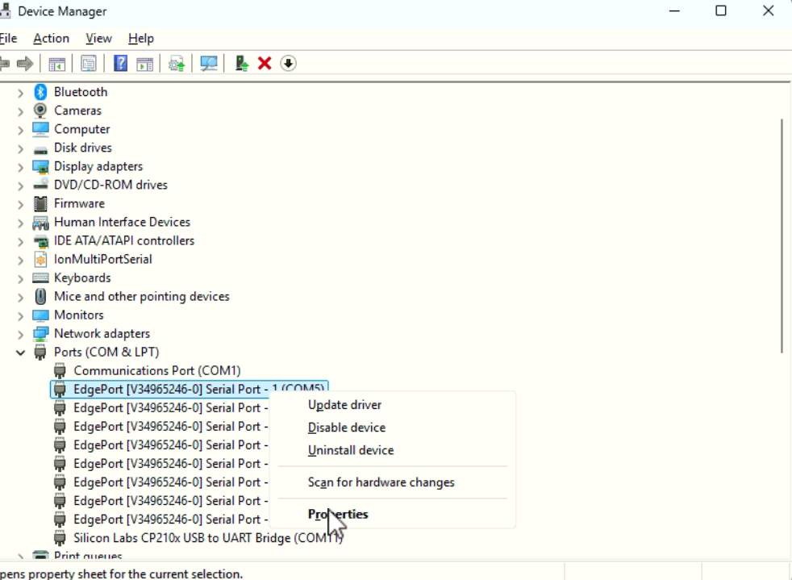
    - Click the “Port Settings” tab to short the com port settings values
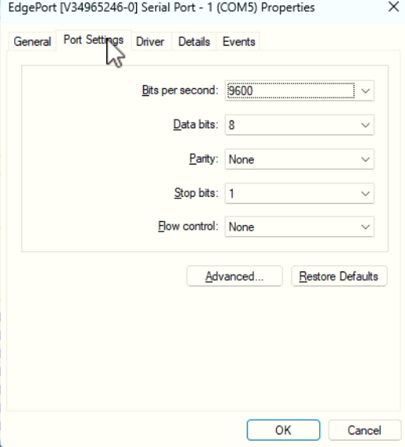
    - Then, click the “Advanced…” button to open the Advanced Settings window
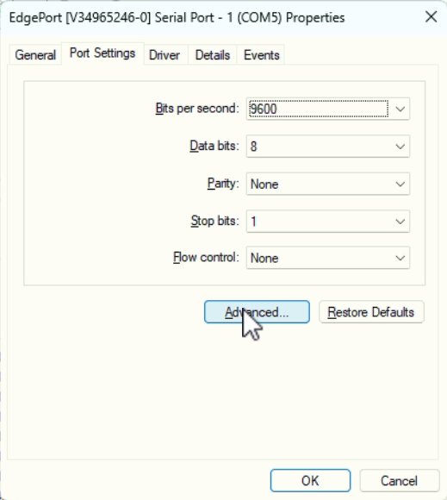
    - At the bottom of this window, click the drop-down item labelled “COM Port Number:”
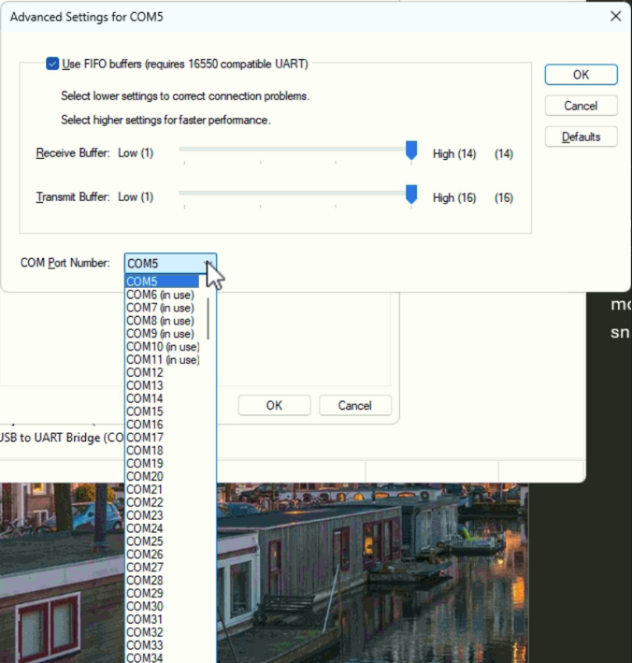
    - Select the new desired com port number. Again, note that you can only one com port can be assigned a given number at anyone time. If the com port number is in use by another com port, then you will need to close the advanced properties, and then the properties window for the current com port and then you will need to go to the com port currently using that number, assign it a different number, and then return to this com port to assign it the number that had been taken.
      - Embrace the logic puzzle! Is there an order to changing the com port numbers that minimizes the number of ports that need to be assigned temporary values?
      - Again, I suggest not using COM1, COM2, or COM3 as a new com port binding. Instead, I generally name the first three ports on a multi-port USB to RS 232 adapter to COM11, COM12, and COM13.
      - Some com port assignments may be mapped to “ghost” ports that no longer exist. The assignments show in the the list as being in use, but the “ghost” ports they are assigned to do not show up under the Ports (COM & LPT) list of ports under Device Manager. You may need to go to the View menu in Device Manager and select to “Show hidden devices” to see these “ghost” ports. 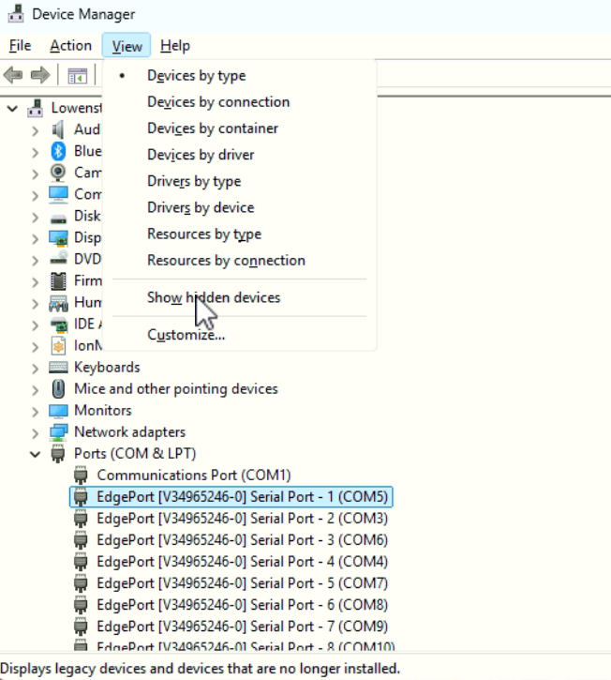
        - Then you can right-click each ghost-port (the font text for a missing port with be colored in light-gray), and select to delete the port. AVOID doing this to actual, real ports connected to your PC (will be listed in black text). In the image above, there are no ghost-ports.
- Once all the com port numbers have been remapped to how they were under your prior Windows system, we need to check the Paleomag .INI settings file for your RAPID system to determine which com ports correspond to each motor for your sample changer system. Make note of any com port number assignments that you had to change in Windows 11 vs your prior configuration, you will need to update these values in your Paleomag INI file.
- This is a good time to copy over all of the files that you backed up from your prior system to the downloads folder of your new Windows 11 system.
- If you have not already, I suggest downloading and installing NotePad++ from the internet. It is a useful text editor for parsing through the Paleomag .INI file and other large, formatted text-files (such as .INI and .csv files).
  - Remember to virus scan the downloaded NotePad++ installer file before running it
- Navigate to the downloaded copy of the folder that contains your most recent Paleomag .INI file. In the example, above, this is in the “Settings” folder under the downloaded copy of the main RAPID system folder. This folder may also contain a lot of files ending in the “.bak” file extension. (If you have not done so already, you will want to Show extensions for known file types, see the Other software to Install section, above. 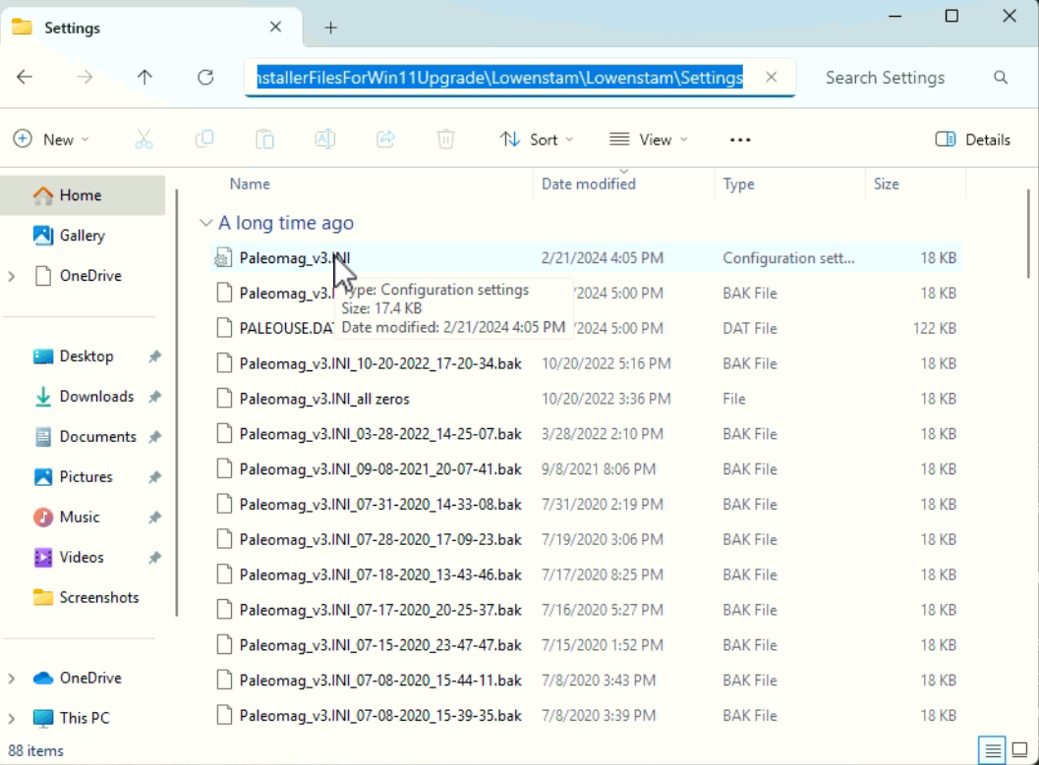
  - Make sure you find the most recently modified / created Paleomag .INI file
    - For XY tray RAPID systems, the default name of your .INI file is Paleomag_v3.INI
    - For snake chain RAPID systems, the default name of your .INI file is likely Paleomag_v2-4.INI, but could be different.
    - Note: for your RAPID system, someone may have decided to rename the .INI file to something like [Name of your university / SRM system].INI, such as Shoemaker.INI (for the Shoemaker RAPID system at Caltech).
    - EVERYTIME the Paleomag settings are changed in the Paleomag VB6 program (note: in the Settings or Options window in the program, not in NotePad++), a back-up copy of the prior Paleomag settings .INI file is created with the naming scheme: [old file name.INI]_MM-DD-YYYY_HH-mm-SS.bak, where MM = two digit month, DD = two digit day number, YYYY = 4 digit year, HH = two digit hour in 24-hour clock notation, mm = two digit minute, and ss = two digit seconds, corresponding to when the backup file was created. For example: Paleomag_v3.INI_02-20-2024_17-04-41.bak was created on February 20, 2024 at 5:04 PM and 41 seconds.
- Right click the Paleomag .INI file, and in the pop-up menu, select the option “Edit in NotePad++”, this may be a ways down the menu, but should be there IF you have installed NotePad++. If you haven’t, please take the time to install NotePad++.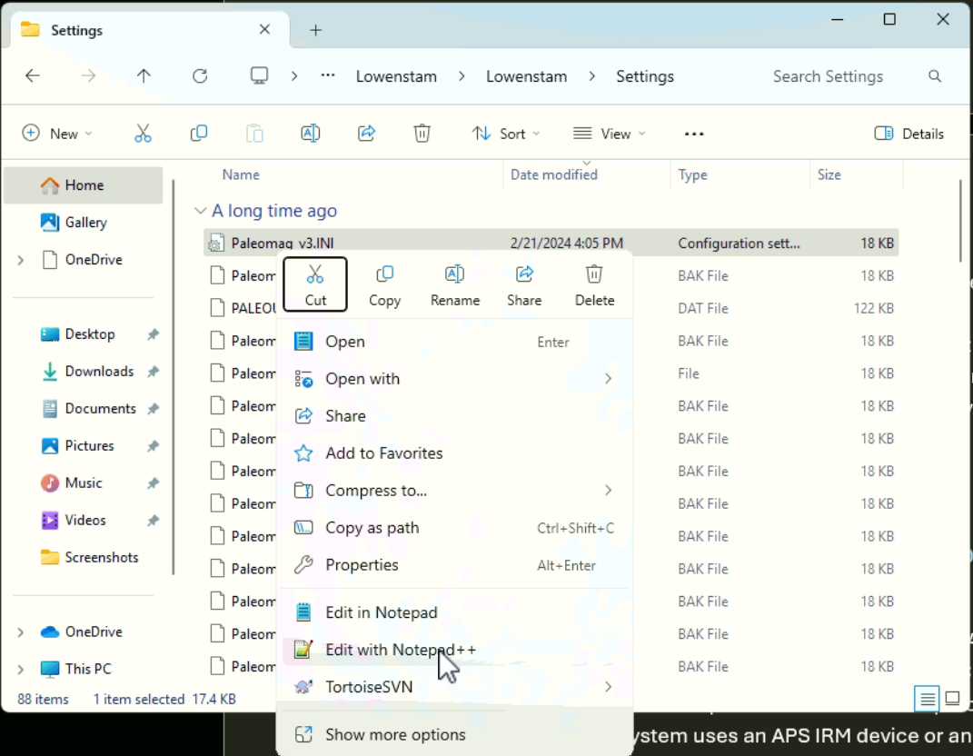
- In NotePad++, the .INI file should open. Press the Control and F key on your keyboard to search the contents of the .INI file in NotePad++. Type in “COMPorts” in the Find What: text box and then the “Find Next” button to locate the “[COMPorts]” section header in the .INI file. 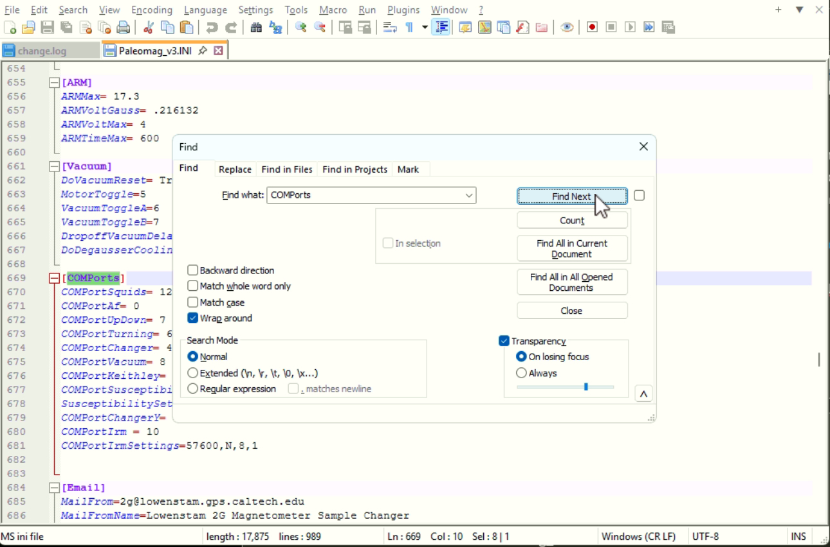
- Read the comm port assignments in the .INI file to find the 3 (or 4) comm ports assigned to your QuickSilver Control motors. Make sure that you that the assigned com-port numbers that you verified and perhaps reassigned in the Windows 11 Device manager match the values in your INI file. If necessary, adjust the values in the INI file to match the values in the Windows 11 Device Manager, if you had to make any changes.
- Next, in Device Manager, we need to verify that the comm port settings for each quick control motor system are correct.
  - Right-click one of the com ports under the “Ports (COM & LPT)” section in Device Manager, and in the pop-up menu, select the “Properties” menu item
  - In the Comm Port properties window that will then open, select the “Port Settings” menu.
  - Change the values for the comm port so that they are:
    - Bits per second: 57,600
    - Data bits: 8
    - Parity: None
    - Stop bits: 2
    - Flow control: None
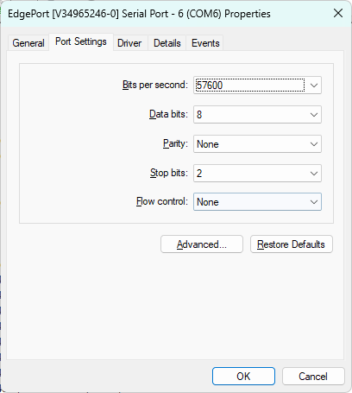
  - Then, click the “OK” button to close the Com port properties window.
  - Repeat this for each of the other com ports that are listed in the Paleomag .INI file as being connected to one of your QuickSilver Controls motors / motor controllers
    - 3 motors for snake change sample changer systems
    - 4 motors for XY tray sample changer systems – as of April 2025, all APS / 2G manufactured RAPID sample changer systems use the XY tray sample changer configuration
- While we have Device Manager open, we should probably configure the RS-232 com port settings for all of the other hardware systems connected via RS-232 serial to your RAPID PC
  - Check the screenshots from your Device Manager for your prior RAPID PC Windows operating system. Go with the values in those screenshots, but make sure you have fixed any scrambled com port assignments, first.
  - Com settings for communicating with the Bartington susceptibility meter should match those set on the meter, itself. Make sure to update the com settings not only in Device Manager to match, but also in the Paleomag VB6 program Options -> Com Ports window
  - Com settings for the SQUID fluxmeter boxes should match the values provided by 2G in your support manuals.
    - Need to make sure that the settings for this inside the Paleomag VB6 program match these values, as well.
- Now, we can return to the QuickControl program, go to the “Setup” menu and select “Comm Port” menu item
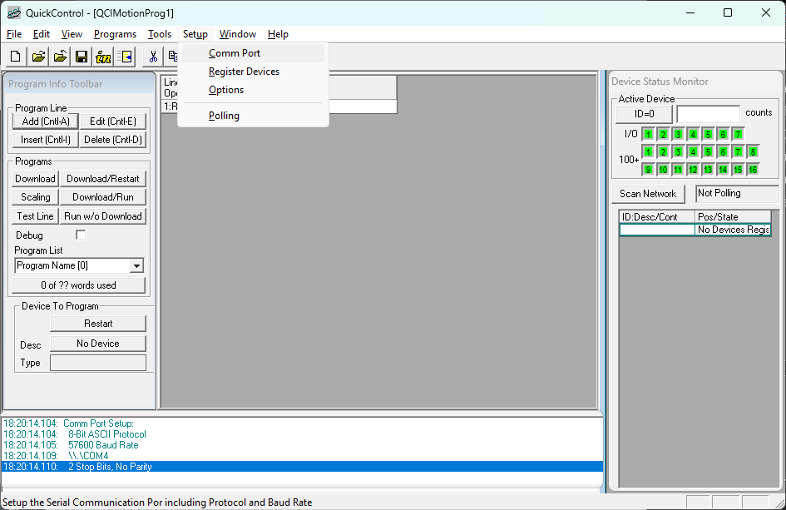
  - This will open the Setup Communication Port window in QuickControl
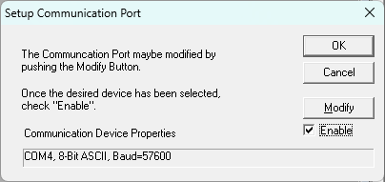
  - Click the “Modify” button to change the selected comm port, this will open the Comm Properties menu in Quick Control
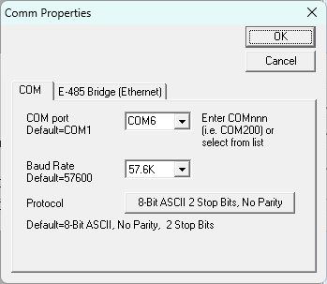
  - In this window, change the COM port value to the desired value (in the example above, COM6, which is the RS-232 com port connected to the turning motor on the Lowenstam RAPID system at Caltech).
  - If the desired COM number is not listed in drop down selector, you will need to close out of QuickControl entirely and then do the following:
    - Type in “QuickControl” in the Windows 11 Search bar
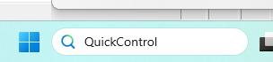
    - In the list of results, right click the QuickControl app result under “Best Match”, and from the pop-up menu, select “Open file location”
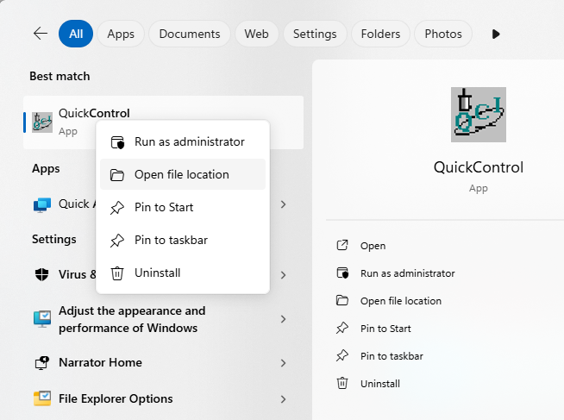
    - A new Windows File explorer window will open with a shortcut to QuickControl highlighted
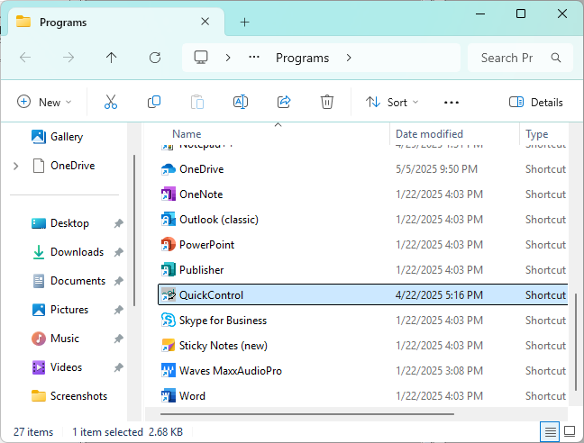
    - Right-click the QuickControl short-cut, and in the resulting pop-up menu, select: “Properties”.
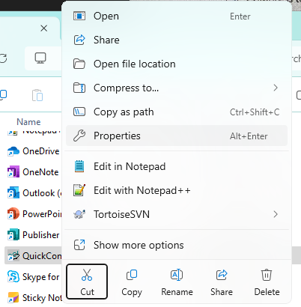

    - In the new QuickControl Properties window, select the Compatibility tab
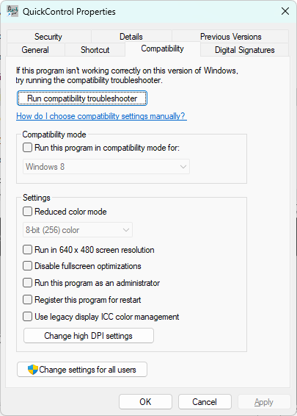
    - In the Settings group pane in the bottom middle of the QuickControl properties window, check the option “Run this program as an administrator”, then click the “OK” button.
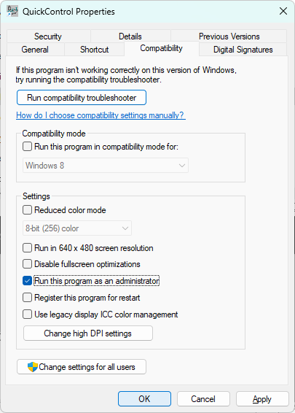
    - Now, re-open QuickControl, (click Yes when prompted to allow the QuickControl program to run with Admin privileges), then click the “Setup” menu, select “Comm Port”, and finally click the “Modify” button, and a full listing of Com ports should be listed in the COM port drop-down
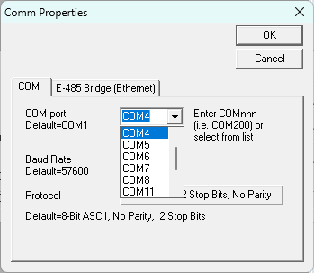
  - Once you’ve selected the com port, then you may need to also select the needed Port Settings. (NOTE: this does not change / alter the Windows 11 com port settings changes that you have already made in the Windows 11 Device Manager. The changes made inside the QuickControl program only change how QuickControl will try to communicate via RS-232 over the selected com port to the motor controller / motor).
    - In the QuickControl Comm Properties window, set the Baud Rate to 57.6K in the Baud Rate drop-down menu. (This is the default value, and may already be set to this value).
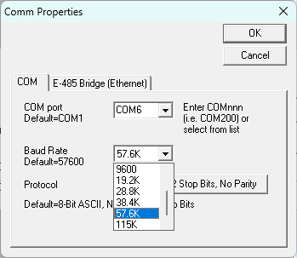
    - The comm port Protocol should be set to: 8-Bit ASCII 2 Stop Bits, No Parity (the default value). If this is not so, click the button to the right of Protocol that lists the current comm protocol settings.
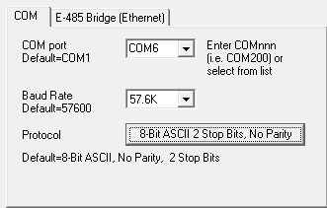
    - A new window will pop-up.
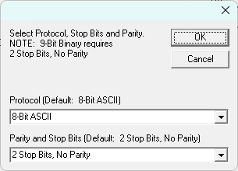
      - Use the first drop-down to select the option for 8-bit ASCII (for Protocol)
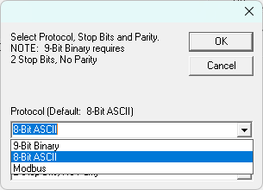
      - Use the second drop-down to select the option for 2 Stop Bits, No Parity (for Parity and Stop Bits)
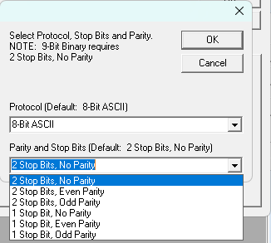
      - Then click the “OK” button to return to the QuickControl “Comm Properties” window
      - Click “OK” in the QuickControl “Comm Properties” window to return to the QuickControl “Setup Communication Port” window.
      - Make sure that the Enable check-box is CHECKED.
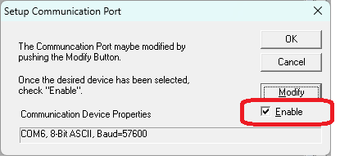
      - Then, click “OK”
    - QuickControl may then pop-up a new window to help you initialize your device. Click the “Cancel” button to cancel out of this. Your QuickSilver Controls DC servor motor + motor controller should already be initialized by whomever setup your RAPID sample changer system in the past. You do not want to alter the motor controller / motor settings.
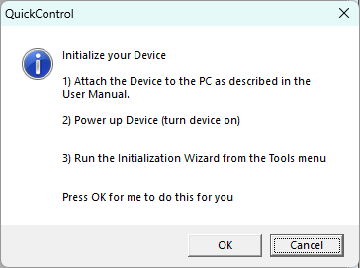
  - Your QuickControl program window should now look something like the example image, below. Note the communications log in the lower left portion of the QuickControl program window. This shows that the comm port has been setup to communicate with \\.\COM6, in the example below
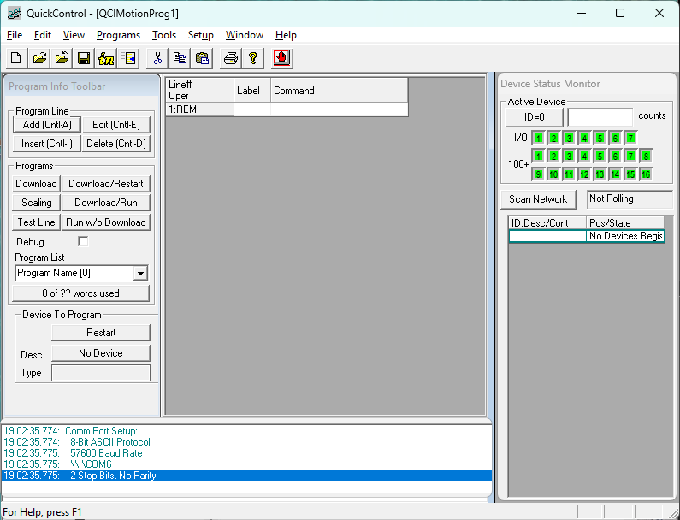
  - You can click the “Scan Network” button in the “Device Status Monitor” sub-window on the right hand side of the QuickControl program window to connect to the motor controller / motor.
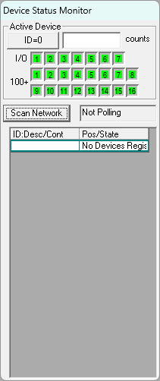
  - If all is connected correctly, and your Windows 11 com port settings are correct then the communications log in the lower left portion of the QuickControl program window will update with information about your motor controller, its driver, serial number (sn), and revision (rev). Below that, information about the motor attached to the motor controller will be listed. In the example below for the Lowenstam turning motor controller / motor, the motor controller is a SilverDust controller, with a D2 driver, a serial number of 10752, and firmware revision 59-11, and the motor controller firmware was last updated on: 0226 2013 (Feb. 26, 2013).
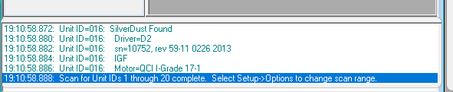
  - In the Device Status Monitor, the motor controller and motor status should update. The current motor position will be shown next to the motor controller ID. NOTE: For the Lowenstam turning motor controller / motor, and all RAPID systems, the Active Device ID should be 16. If it is a different value, then the Paleomag VB6 code will have problems correctly sending commands to the motor controller / motor.
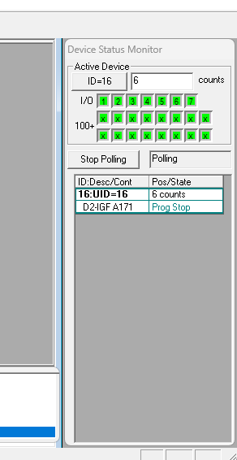
  - You can then click the “Stop Polling” button in the Device Status Monitor sub-window, and then use the Setup -> Comm Port window to connect QuickControl to a different motor controller / motor on your RAPID system and check the status / connectivity of that motor system. QuickControl can only connect to a single motor controller / motor at a time.

B&K Precision DC power supply USB communications drivers for Caltech / ASC IRM systems
- RAPID Systems with the newest iteration of the Caltech / ASC IRM device that is powered by a digitally controlled B&K Precision 9185B DC power supply will need to update the USB virtual comm port drivers for the B&K precision power supply.
  - If your RAPID system uses an APS IRM device or an older Caltech / ASC IRM device with an analog DC power supply (e.g. a Matsusada DC power supply), please ignore this section!
  - The B&K precision 9185B power supply uses the Silicon Labs CP21x USB to UART bridge VCP driver to implement serial communications between power supply and the RAPID PC
  - Need to download latest drivers from Silicon Lab’s website: CP210x USB to UART Bridge VCP Drivers - Silicon Labs
  - Navigate to the “Downloads” tab, and select the most recent Universal Windows driver download. As of April 2025, this is v11.4.0, released on 12/18/2024

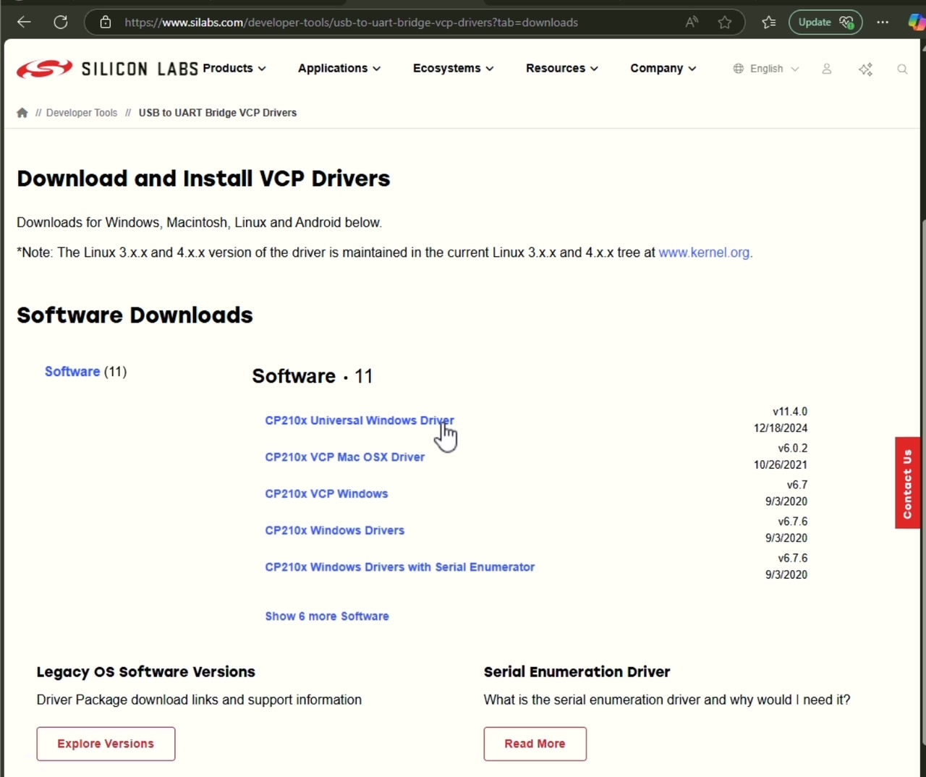
  - Virus-scan the downloaded file (e.g. using VirusTotal.com)
  - If the downloaded file is virus-free, extract the contents
  - You will then need to open the Windows Device Manager settings page by typing “Device Manager” in the Windows search bar and selecting Device Manager from the Best Match search results.
  - In Device Manager, check for a device category of “Other devices”
    - Expand this category and search for: CP2102 USB to UART Bridge Controller, or something similar to this.
    - Right-click this device listing and in the resulting pop-up menu select the “Update driver” option
    - An Update Drivers window should open up
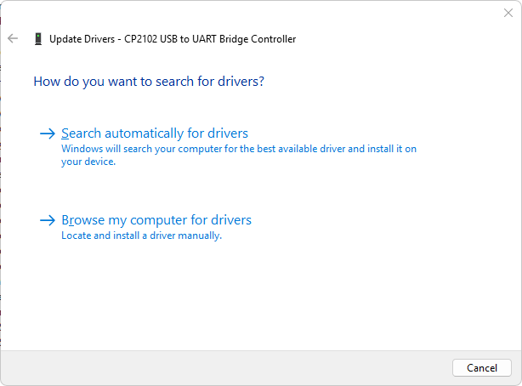
    - Select the “-> Browse my computer for drivers” option, and a folder browser should appear in the Update Drivers windows.

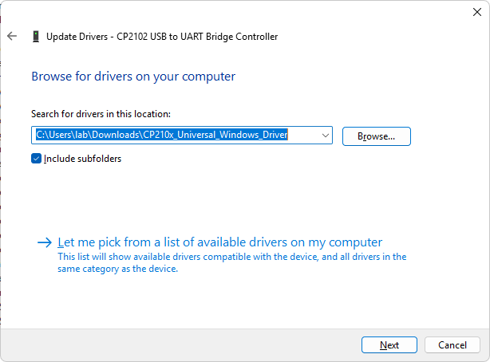
    - Browse to the folder that you created, above, from the downloaded Silicon Labs CP210x driver .zip file, then click “Next”
    - The folder will be scanned for the correct driver, and you should receive confirmation that the driver has been installed
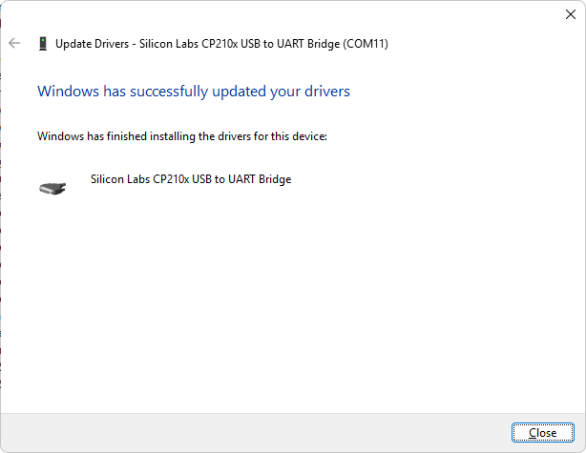
- Device Manager should automatically refresh it’s list of devices (if not, you can manually do this via by clicking on the Action menu at the top menu bar of Device Manager, and then selecting the “Scan for hardware changes” menu item.
- The Silicon Labs CP210x USB to UART bridge should now show up under the list of Ports (COM & LPT) under Device Manager
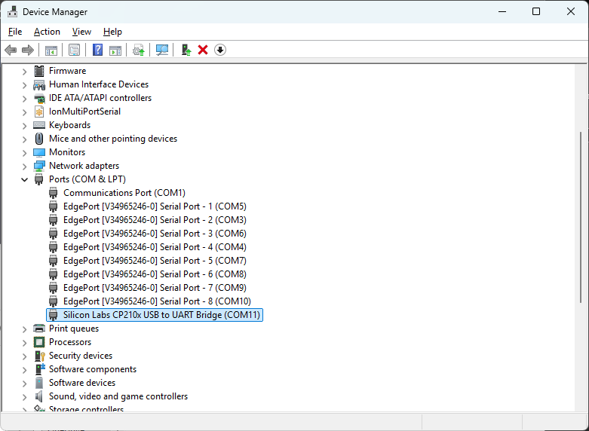
- Make a note of the new com port binding (e.g. COM11 in the example above)
- Right-click the listing for the Silicon Labs com port, and in the pop-up menu select the “Properties” menu item
- In the Com port properties window that will open, select the “Port Settings” tab.
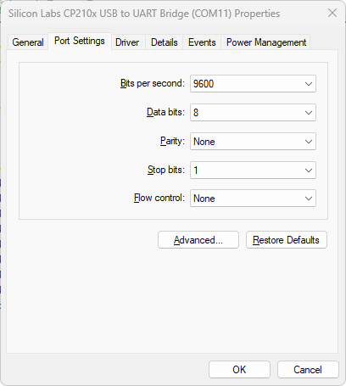
  - The settings should be:
    - Baud Rate: 9600
    - Data Bits 8
    - Parity: None
    - Stop Bits: 1
    - Flow control: None
  - If not, adjust the com port settings to match these values, and then click the “OK” button in the lower right of the windows to close it.
- It may be necessary to adjust the settings in the RAPID Paleomag VB6 code so that the com port setting for your IRM system matches the Silicon labs virtual USB to UART bridge com port
  - AGAIN: this is only needed if you are using the Caltech / ASC IRM device with a B&K Precision digitally controlled DC power supply
  - If you are using an APS IRM device, or an older Caltech / ASC IRM device with an analog controlled DC power supply (e.g. a Matsusada DC power supply), then this whole section should be IGNORED.

GM0 Gaussmeter Drivers
- WARNING!!!!!! Avoid the most recent version of the GM0 gaussmeter drivers. This version is intended for the Visual Studio .NET coding development environment. Installing this newest version of the drivers will BLOCK the Paleomag VB6 code from being able to run correctly on your RAPID PC. If you accidentally install the wrong, newer version of the GM0 gaussmeter drivers, you will need to do a complete and clean reinstallation of Windows 11 on your target RAPID PC. This is the only solution that we have been able to find.
  - The correct driver file that you NEED to download is: gaussmeter-drivers-20090803-2.exe and is ~2.5 MB in size
- This section describes how to download and install the drivers that enable the Paleomag VB6 code to automatically connect to and control your Hirst / Magnetic Instruments 908A gaussmeter. This automation may come in handy when calibrating your AF demagnetization system. Do NOT use the 908A gaussmeter to calibrate your IRM system. The 908A is not accurate / fast enough to correctly capture the DC peak field of a single DC magnetic field pulse (as used in IRM), while it can capture the repeated maximum DC peaks of an AF demagnetization ramp.
- This is optional. You only need to download these drivers if you intend to computer control a USB-connected 908A gaussmeter from within the Paleomag VB6 program at some point in the future.
- In a web browser, navigate to: GM0 Gaussmeter drivers and apps download | SourceForge.net (https://sourceforge.net/projects/gm05)
- In the row of menu items (e.g. Summary, Files, Reviews, Support, etc.) on the SourceForge page for GM0 Gaussmeter drivers and apps, click the “Files” menu. Note, this row of menu items may be part-way down the page below a bunch of banner ads, etc. In the web-site screen capture, below, a have highlighted the location of the “Files” menu using two red, nested, smoothed rectangles.
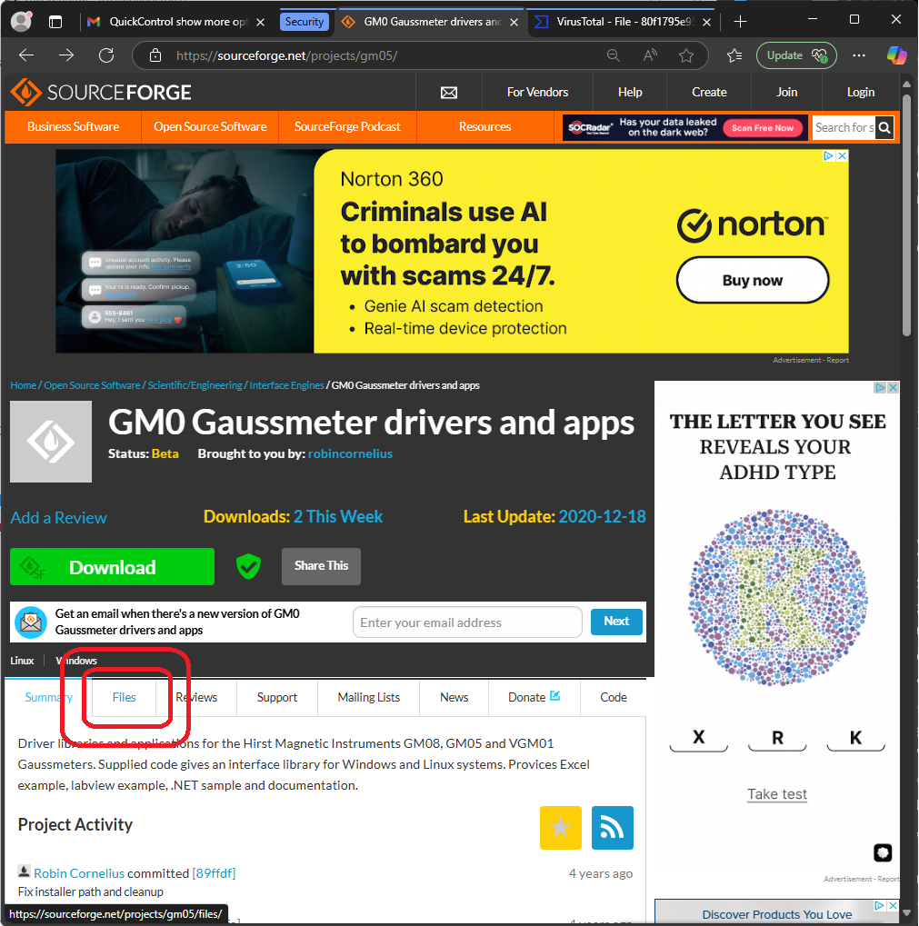
      - Are the ads showing on your source forge window as banal as those showing in the example, above? If the ads are particularly droll, please share them with us. As of now (May 2025), we foolish / barbaric Americans could definitely use a good laugh and / or source of mirth. In the future, this dose of amusement may no longer be required. One can hope.
- Under the files window, click on the link to the file: gaussmeter-drivers-20090803-2.exe, this should trigger the file to download onto your system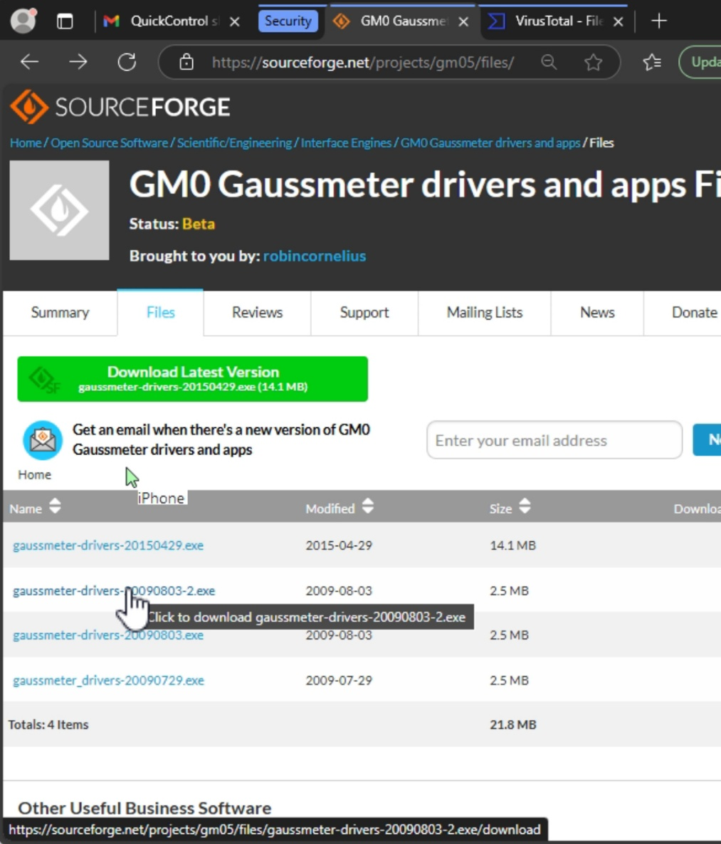
- Direct link to file (might fail): https://sourceforge.net/projects/gm05/files/gaussmeter-drivers-20090803-2.exe/download
- Once downloaded, scan the downloaded file for viruses. (Again, I suggest uploading the file to VirusTotal.com).
  - If you scan the file on VirusTotal.com it may show up flagged as by one of the anti-virus engines. This is likely a false positive. If you do not want to take the risk, installing the GM0 gaussmeter driver is optional and can be skipped.
- Once scanned, and potential virus risk assessed and accepted (if so chosen), double click the downloaded installer file to start the install. An installer window will pop-up
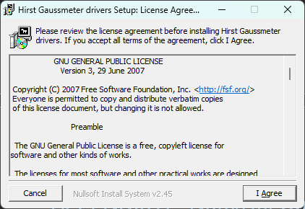
  - Accept the license agreement to proceed, and then follow the installer instructions till the end. The installer will need to add some Microsoft visual studio redistributable run-time files to support the driver and the GM05 gaussmeter control app.
  - If prompted to overwrite existing Docs, Source, and Examples, click “Yes”
  - Once the installer has completed, click the “Close” button to end the installation.
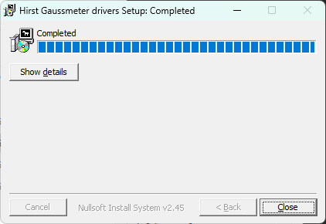

Installing Visual Basic 6.0
- This section describes the steps needed to install Visual Basic 6.0 on Windows 11
- I strongly recommend installing all of the other software listed in the sections above before installing VB6.
- I also strongly recommend making a back-up of your Windows 11 system prior to installing VB6 in case it all goes horribly wrong.
  - On this note: do not use a Windows 11 System restore point to backup your system. We tried this at Yale, and the restore process failed due to a clash between the Windows System Restore application and Microsoft Defender (the anti-virus agent, written by Microsoft, and the default anti-virus software provided on Windows 11). Oh Microsoft, never change.
- You will need to obtain a Visual Basic 6.0 installer to proceed here. If needed, I have one and can send you a download link.
- To install the Visual Basic 6.0 under Windows 11, we will be using some of the instructions for installing Visual Studio 6.0 on Windows 10. In particular, the guide I like is on the CodeProject.com: https://www.codeproject.com/Articles/1191047/Install-Visual-Studio-6-0-on-Windows-10
  - The instructions on this website on how to clean up a failed VB6 install are particularly useful, and have worked for me during the process of writing this guide, twice so far.
  - Deviations from instructions:
    - We are installing Visual Basic 6 and some support tools, not all of Visual Studio 6.0.
    - When I have attempted to install Visual Studio C++ 6.0 as well as VB6, the installation process has either frozen part-way (once on the Lowenstam system and once more on the Yale University paleomag lab Windows 11 RAPID PC), or resulted in a chain of issues when trying to load and run the Paleomag VB6 code post install that I could not fix.
  - I will copy the instructions here, in case the CodeProject.com web-page is ever taken down

Clean-up Failed Visual Studio / Visual Basic 6.0 install
- How to clean up a failed Visal Basic 6.0 install (From the CodeProject.com web-page):
  - If you attempted to install Visual Studio 6.0 or Visual Basic 6.0 on this Windows 11 system, and failed, you will need to remove any installation folders from previous installation attempts, they are usually located under C:\Program Files (x86) folder for 64-Bit OS and C:\Program Files folder on 32-Bit OS. Note: If you have installed Visual Studio 2017, make sure you do not touch the C:\Program Files (x86)\Microsoft Visual Studio\2017 folder.
  - Delete the following folders and files, note the usage of “*” as a wild-card symbol, for example *.htm means to delete any .htm files in the specified path. Not all files / folders may be present – especially if a previous install attempt froze part-way thru. (If you have not done so already, you will want to Show extensions for known file types, see the Other software to Install section, above.
    - C:\Program Files (x86)\Microsoft Visual Studio\Common
    - C:\Program Files (x86)\Microsoft Visual Studio\MSDN
    - C:\Program Files (x86)\Microsoft Visual Studio\MSDN98
    - C:\Program Files (x86)\Microsoft Visual Studio\VB98
    - C:\Program Files (x86)\Microsoft Visual Studio\VC98
    - C:\Program Files (x86)\Microsoft Visual Studio\*.HTM
    - C:\Program Files (x86)\Microsoft Visual Studio\*.TXT
    - C:\Program Files (x86)\Common Files\Microsoft Shared\MSDesigners98
    - C:\Program Files (x86)\Common Files\Microsoft Shared\MSDN
    - C:\Program Files (x86)\Common Files\Microsoft Shared\VS98
    - C:\Program Files (x86)\Common Files\Microsoft Shared\Wizards98

  - Remove Registry Entries for the failed install attempt. To do this, type in regedit in the Windows search bar, then right-click on the best match (the RegEdit app), and select the option to “Run as administrator”
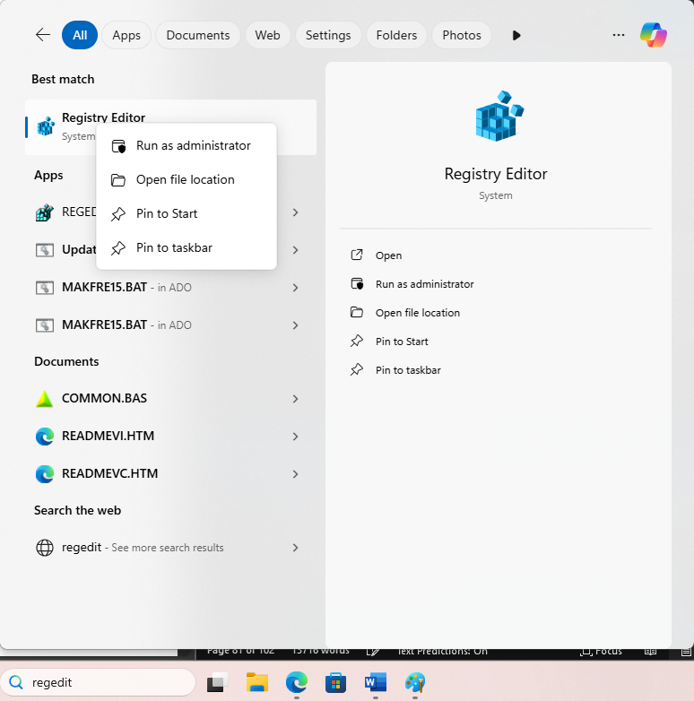
  - Click “Yes” when prompted to allow RegEdit to open with admin privileges
  - In Registry Editor, we will be searching for and removing folders in the Windows registry that were installed during the failed VS or VB 6.0 install attempt. We will be removing things in two main directories of the Windows Registry: HKEY_CURRENT_USER and HKEY_LOCAL_MACHINE. Some of the registry paths look also identical, but are just two similar paths each under one of these two main directories.
  - We need to remove the following folders / nodes in the registry. Note: depending on how far the VS6.0 / VB6 install proceeded before failing and also what edition of Visual Studio was being installed (Enterprise vs Pro), some of the registry nodes listed below may not be present. Do not worry.
    - HKEY_LOCAL_MACHINE\Software\Microsoft\DevStudio
    - HKEY_LOCAL_MACHINE\Software\Microsoft\HTML Help Collections
    - HKEY_LOCAL_MACHINE\Software\Microsoft\MSVSDG
    - HKEY_LOCAL_MACHINE\Software\Microsoft\Visual Basic\6.0
    - HKEY_LOCAL_MACHINE\Software\Microsoft\Visual Component Manager
    - HKEY_LOCAL_MACHINE\Software\Microsoft\Visual Modeler
    - HKEY_LOCAL_MACHINE\Software\Microsoft\VisualStudio\6.0
    - HKEY_LOCAL_MACHINE\Software\Wow6432Node\Microsoft\DevStudio
    - HKEY_LOCAL_MACHINE\Software\Wow6432Node\Microsoft\HTML Help Collections
    - HKEY_LOCAL_MACHINE\Software\Wow6432Node\Microsoft\MSVSDG
    - HKEY_LOCAL_MACHINE\Software\Wow6432Node\Microsoft\Visual Basic\6.0
    - HKEY_LOCAL_MACHINE\Software\Wow6432Node\Microsoft\Visual Component Manager
    - HKEY_LOCAL_MACHINE\Software\Wow6432Node\Microsoft\Visual Modeler
    - HKEY_LOCAL_MACHINE\Software\Wow6432Node\Microsoft\VisualStudio\6.0
    - HKEY_CURRENT_USER\Software\Microsoft\DevStudio
    - HKEY_CURRENT_USER\Software\Microsoft\MSVSDG
    - HKEY_CURRENT_USER\Software\Microsoft\Visual Basic\6.0
    - HKEY_CURRENT_USER\Software\Microsoft\Visual Modeler
    - HKEY_CURRENT_USER\Software\Microsoft\VisualFoxPro
    - HKEY_CURRENT_USER\Software\Microsoft\VisualStudio\6.0
  - When you find the registry node / folder that you wish to delete, right-click the folder icon that you wish to delete, and in the pop-up menu, select delete. A confirmation window will pop-up to confirm that you wish to delete the registry node. Be careful. Deleting the wrong registry node could corrupt your Windows 11 operating system, causing you to have to start over with a fresh Windows 11 installation.
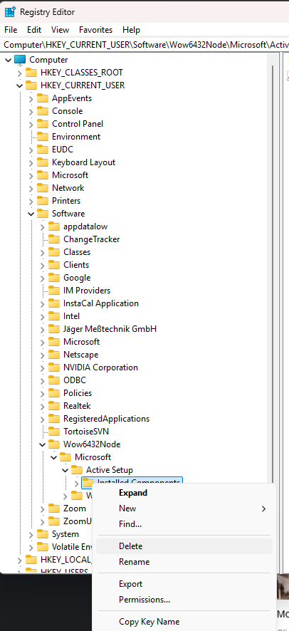
  - Restart your computer once you are done removing all traces of your prior, failed, Visual Studio or Visual Basic 6.0 installs.

Install Visual Basic 6.0
- Again, borrowing heavily from the VS 6.0 install directions on Install Visual Studio 6.0 on Windows 10 - CodeProject on CodeProject.com, we then need to edit the Visual Studio 6.0 installation files.
- If get your installation files from me, then they editing the installer files should be fairly easy. The files will be organized in a .zip archive with a folder for each installer CD
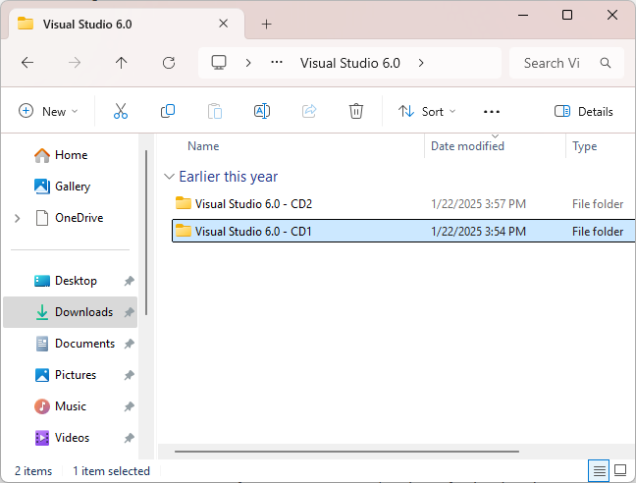
- If you have obtained your own physical or digital copy of the Visual Studio 6.0 installer, then you will need to create a folder either on your desktop or some other location that we can use to copy the installation files to. The reason for this is some of the files will need to be modified or edited. Let's create a folder in your Downloads folder and call it Visual Studio 6.0. Inside that folder create two sub-folders: one named Visual Studio 6.0 - CD1 and one named Visual Studio 6.0 - CD2. Go to your installation CDs and copy the contents to this folder, the files from the first CD into the …CD1 folder and the files from the second CD into the …CD2 folder.
- In the Visual Studio 6.0 - CD1 folder, find a file called SETUPWIZ.INI
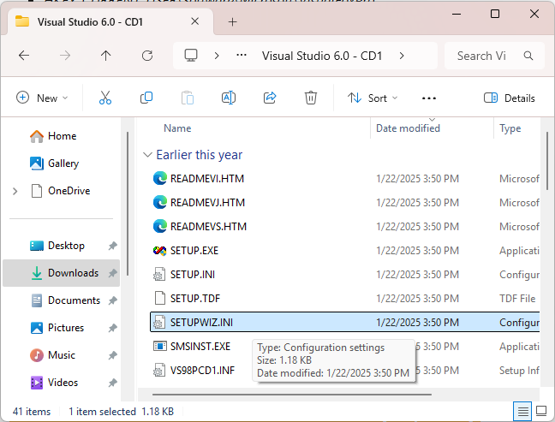
- Edit the file called SETUPWIZ.INI and under the section called [setup wizard], change the entry for VmPath=ie4\msjavx86.exe. If this entry does not exist, you can skip this step. We need to remove the value ie4\msjavx86.exe form this entry so it will create an empty environment variable during installation. This will stop the setup wizard from looking for and installing this very old version of MS Java on our system. After removing this entry, your INI file entry should now look like this:
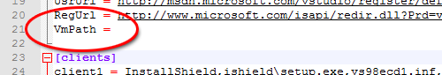
  - Note: If you are using the installer I provided, this edit to SETUPWIZ.INI may have already been made.
- In the Visual Studio 6.0 - CD1 folder, find a file called SETUP.EXE
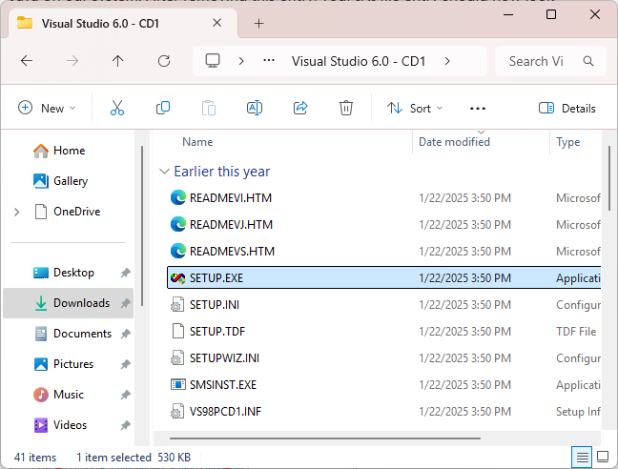
- Here, we will now need to deviate from the instructions on the CodeProject website, because Windows 11 makes it REALLY hard to change the compatibility settings for legacy applications. If you right-click the file, and then select “Properties” from the pop-up menu, in the SETUP.EXE Properties window, you may notice that the “Compatibility” tab is missing. This is Windows 11 fun attempt to block you from running legacy applications and installers. We need a work around
- In the Windows search bar, type: Run programs made for previous versions of Windows. Select the option in the search results with the matching name from the Windows control panel
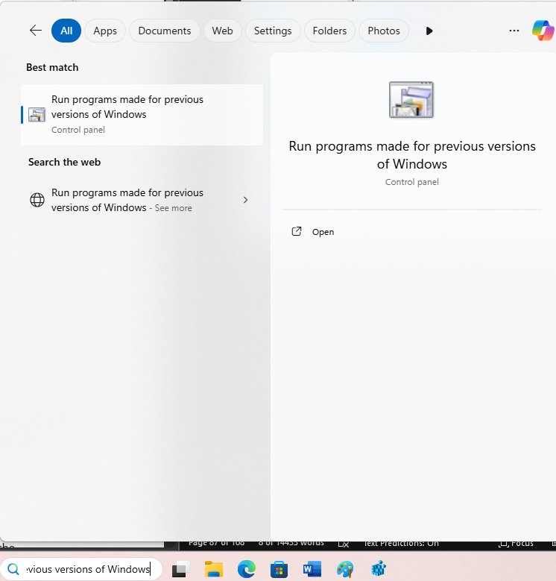
- The Program Compatibility Troubleshooter window should then open up
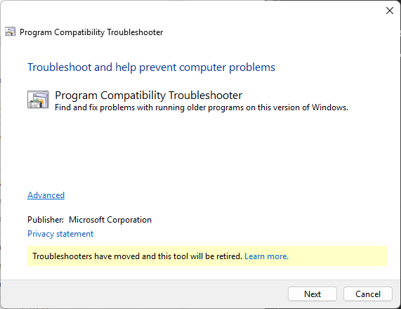
- Click the “Next” button.
- Once the window has finished scanning for programs that might have compatibility issues, select the “Not Listed” option at the top of the list of programs, and then press the “Next” button.
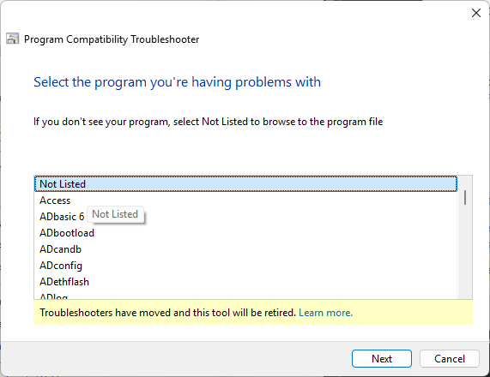
- Click the “Browse” button to open a file dialog window to find the SETUP.EXE file inside the Visual Studio 6.0/Visual Studio 6.0 – CD1 folder, and then click the “Open” button.
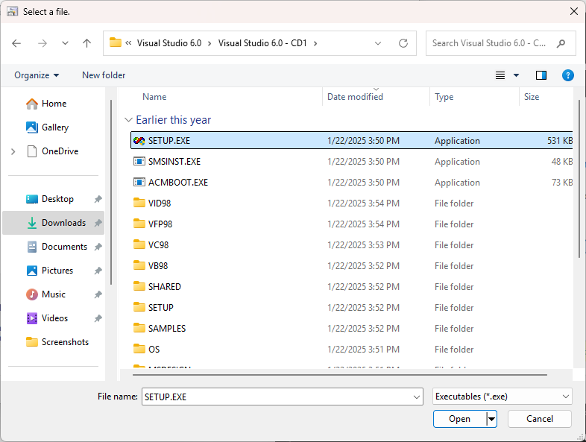
- This will put the path to the SETUP.EXE file into the Program Compatibility Troubleshooter window. Click the “Next” button
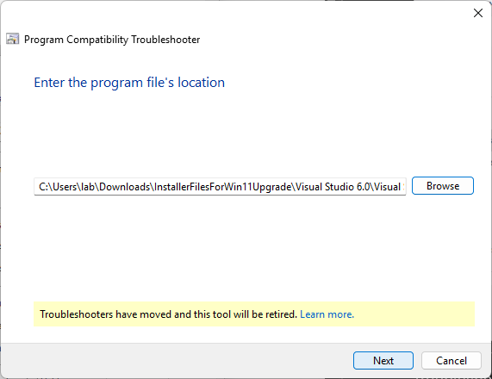
- In the subsequent “Select troubleshooting option” window, click the second option to “Troubleshoot program”
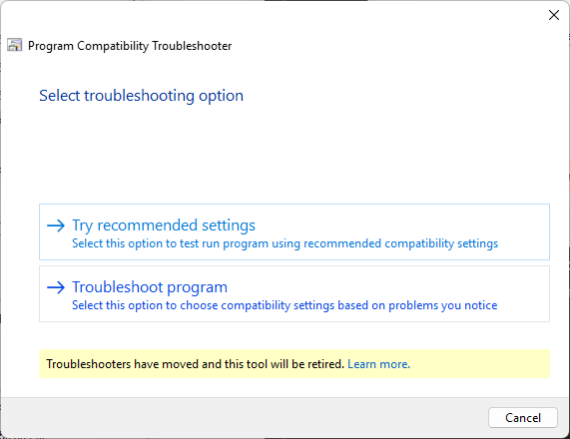
- In the “What problems do you notice?” window, select the options:
  - The program worked in earlier versions of Windows but won’t install or run now
  - The program requires additional permissions
  - I don’t see my problem listed
Then click the “Next” button
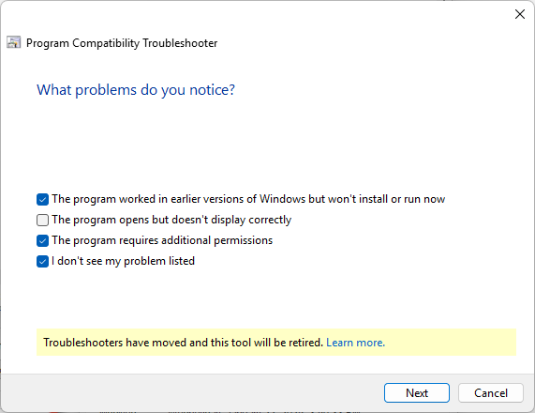
- In the next window, “Which version of Windows did this program work on before?”, select “Windows XP (Service Pack 3)”
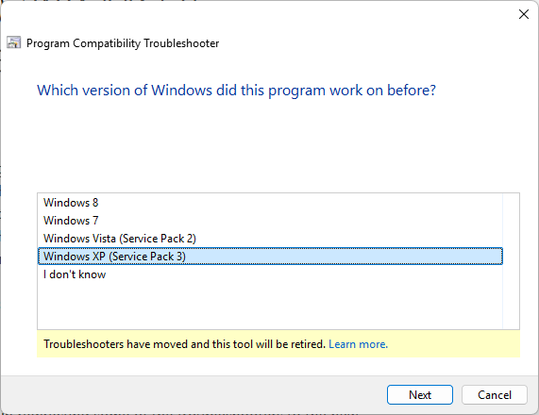
- In the next window, “Test compatibility settings for the program”, click the “Test the program…” button
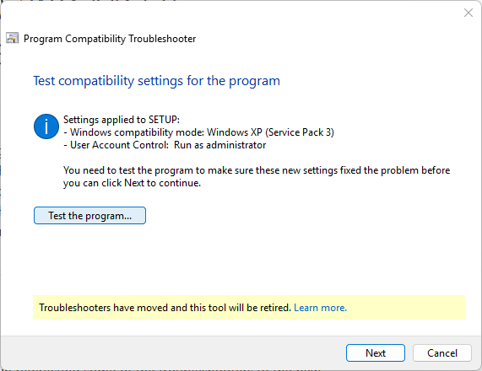
- This should open a window asking you if you want to run “SETUP.EXE” with admin privileges. If you do not see this window pop-up directly, if may be open in the background. Check your Windows 11 Task View bar to see if there is a new window waiting for your attention, it will likely be a subtly flashing blue and yellow shield icon. Click it to open the background window.
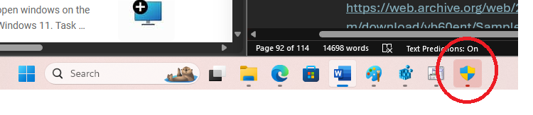
- Click “Yes” to authorize SETUP.EXE to open with admin privileges.
- The Visual Studio 6.0 Professional installer window should now appear
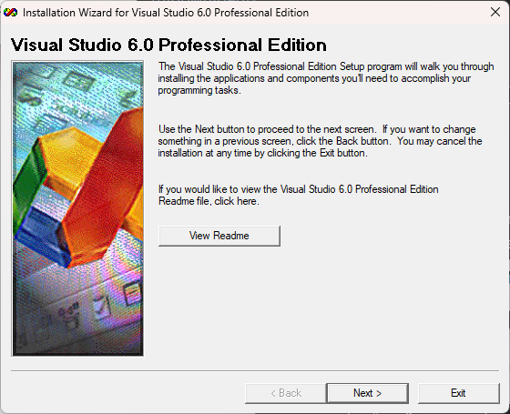
- Click the “Next >” button
- Accept the license agreement and then click the “Next >” button, again.
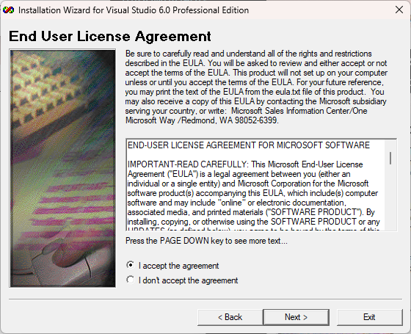
- In the Product Number and User ID window, if you do not have a Visual Studio product ID (what we would now call a “license number”), then you can just enter in the number zero repeatedly: 000 – 0000000.
  - Put in the user name and organization name you wish to use
  - Then click the “Next >” button
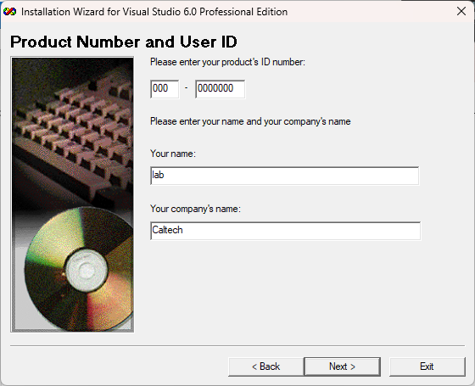
- In the next window, make sure to select the option for “Install Visual Studio 6.0 Professional Edition”, and then click the “Next >” button
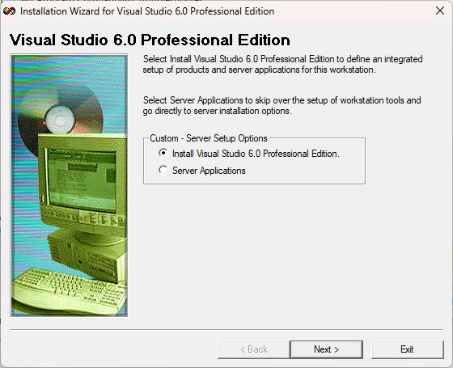
- In the next window, “Choose Common Install Folder”, go ahead and click the “Next >” button to accept the default option provided by the installer
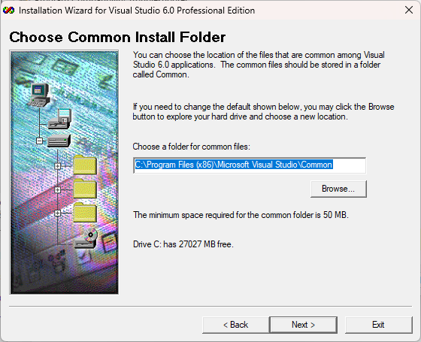
- The main Visual Studio 6.0 Professional Setup full screen window should then load and appear:
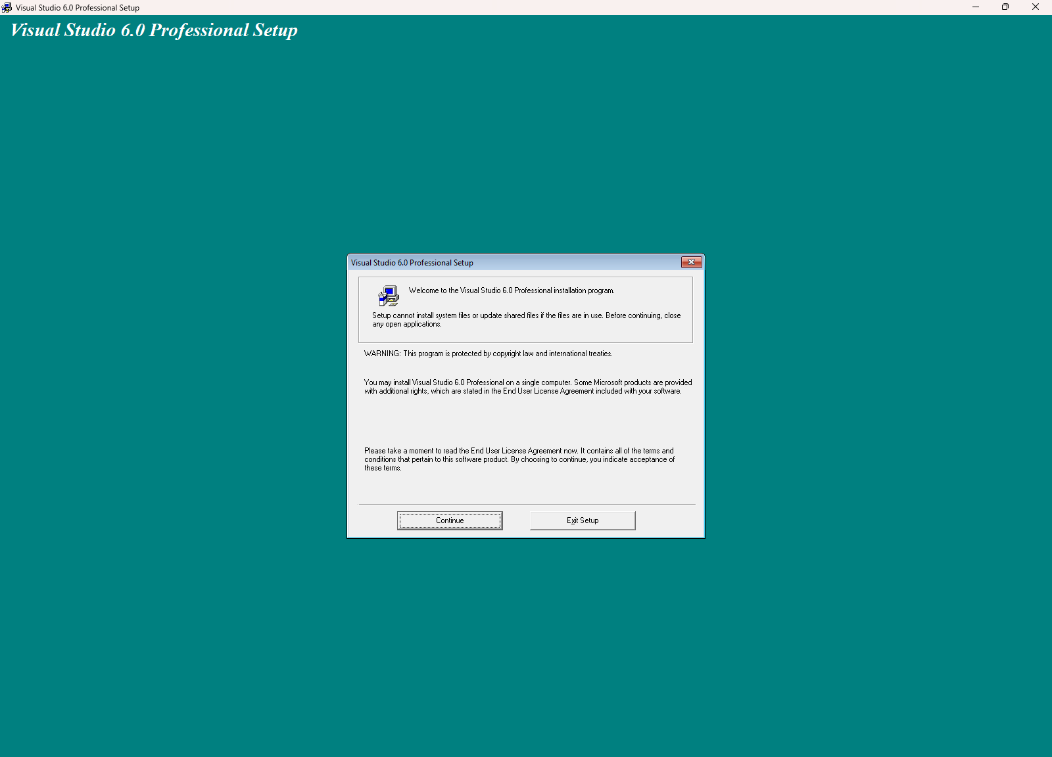
- Click the “Continue” button to proceed with the installation
- Click “OK” through the product ID confirmation window
- The installer will then search for installed components. If this is the first install attempt or you did a thorough job cleaning up past failed installs, this search should go quickly.
- Finally, the start installation window will show. Click the “Custom” button to configure the installation.
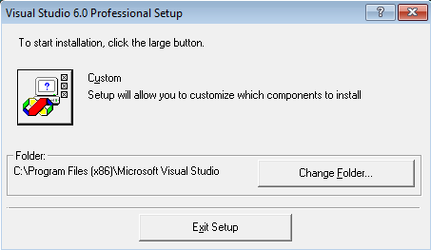
- IMPORTANT: this is were directions deviate from those on the CodeProjects.com webpage.
- In the custom install options, deselect EVERYTHING, but Microsoft Visual Basic 6.0, Data Access, Professional Tools, and Tools.
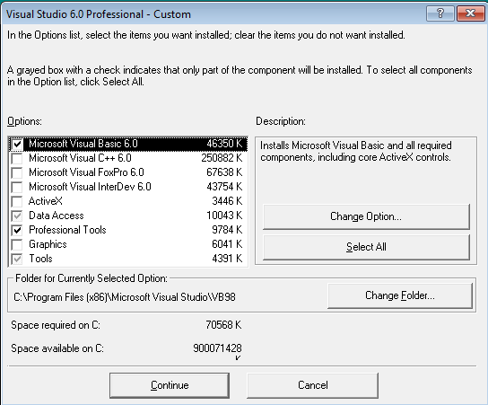
- Now, click on the “Data Access” option, and then click the “Change Option…” button.
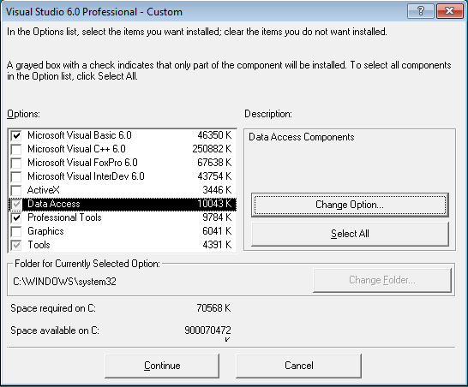
- In the sub-sequent “Visual Studio 6.0 Professional – Data Access” window, uncheck the “ADO, RDS, OLE DB Providers” option and click “OK” to ignore the warning.
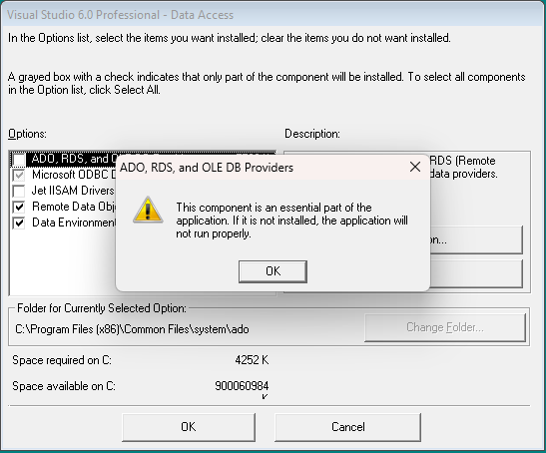
- Click “OK” to return to the “Visual Studio 6.0 Professional – Custom” options window
- If you are using the installer I provided, the Visual Studio 6.0 Professional Edition installer, you can now click the “OK” button to proceed with the install. HOWEVER, if you are using your own installer, and you are installing the Visual Studio 6.0 Enterprise Edition, you have an additional change to make, as detailed on the Install Visual Studio 6.0 on Windows 10 - CodeProject webpage:
  - Disable Visual Studio Analyzer
    - This is an option in the Enterprise Tools in the Enterprise edition, only
    - If you are using the Professional Edition installer, you can ignore this step
  - The last setting we need to disable is the Visual Studio Analyzer. Leaving this option checked will cause the installation to fail. To disable this, select the Enterprise Tools option and press the Change Option... button. Uncheck the option for Visual Studio Analyzer on the Enterprise Tools dialog and press the OK button to continue.
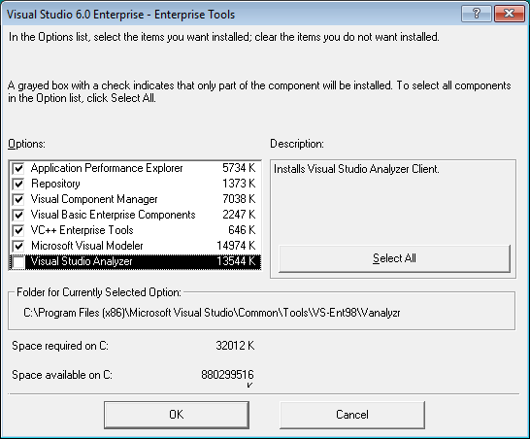
- We can now start the installation by clicking the “Continue” button in the Visual Studio 6.0 Professional – Custom window.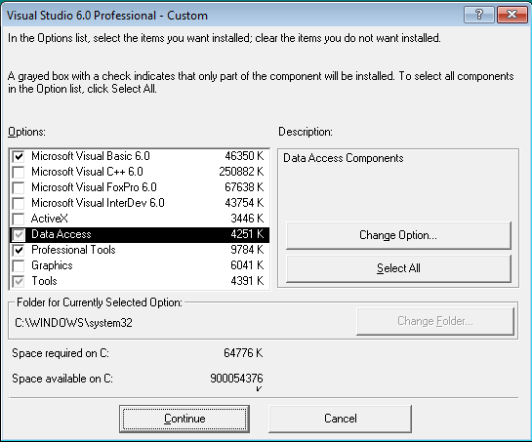
- The installer will then start and run
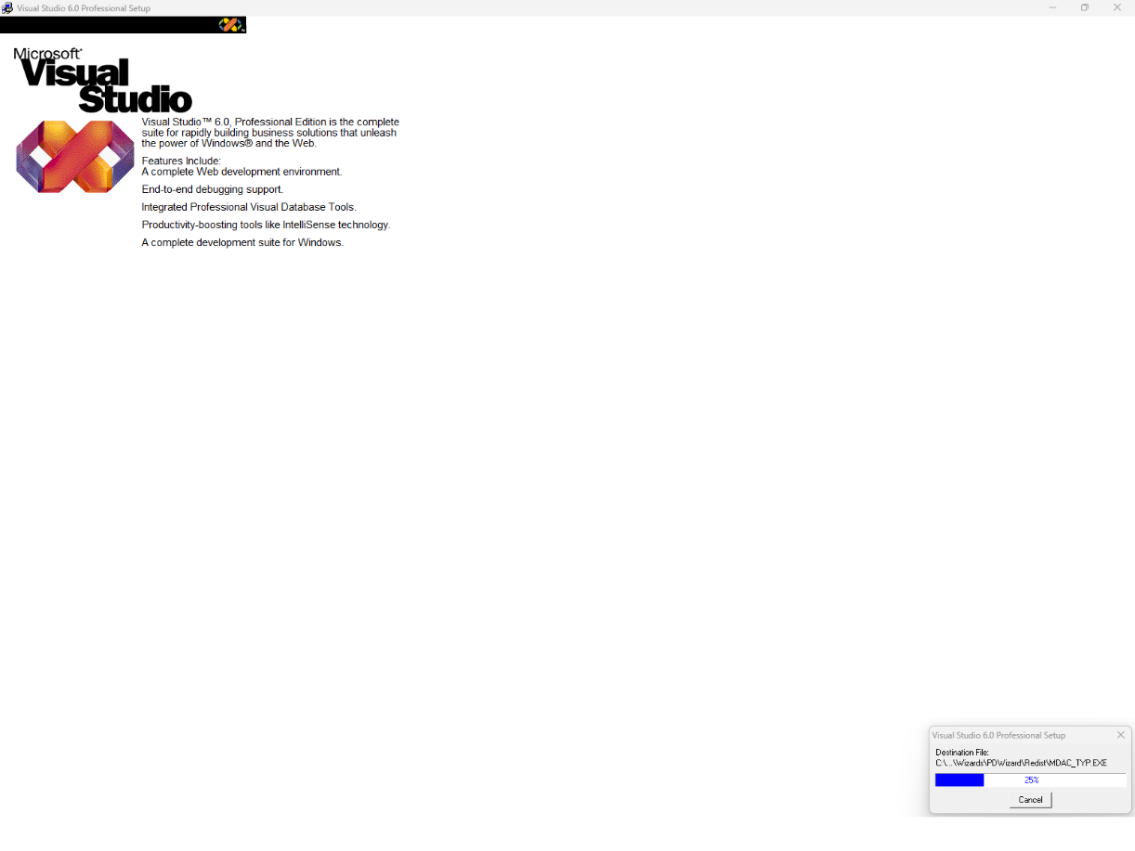
- Once it has completed the installation, a window will pop-up notifying you that you need to restart the PC to complete the installation. Go ahead and do this, now.
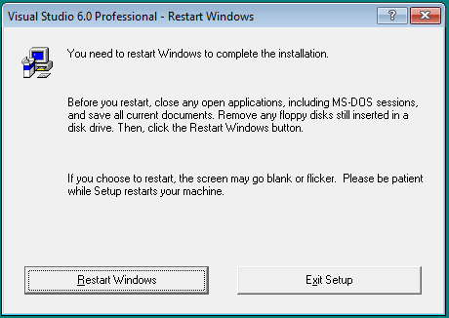

Post Install Clean-up
- Once your PC restarts, navigate to the Visual Basic 6.0 program folder on your PC, the path should be something like:
  - C:\Program Files (x86)\Microsoft Visual Studio\VB98
- Inside this folder, find the file VB6.EXE
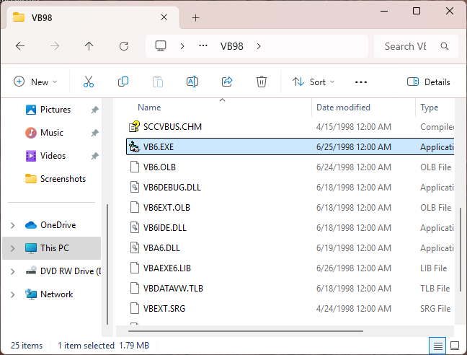
- Right-click the file, and in the pop-up menu select the “Properties” option
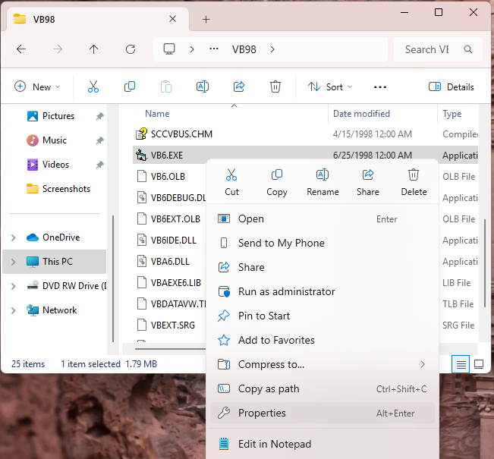
- In the “VB6.EXE Properties” window, select the “Compatibility” tab
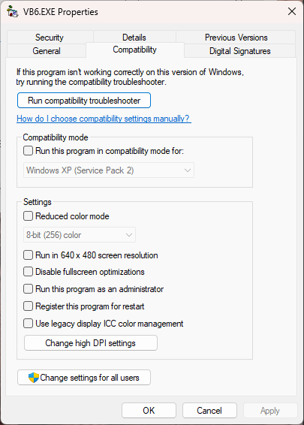
- Then click the button near the button of the window: “Change settings for all users”
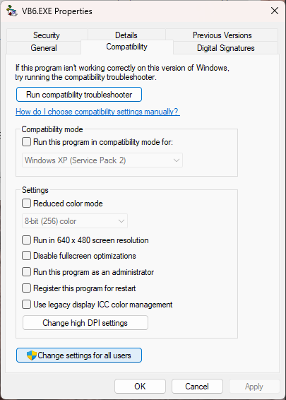

- In the new “Compatibility for all users” window, near the middle of the window check “Run this program in compatibility mode for:” and in the drop-down menu select: Windows XP (Service Pack 3)
  - In the bottom half of the window, check the option for: “Run this program as an administrator”
  - Then, finally, click the “OK” button
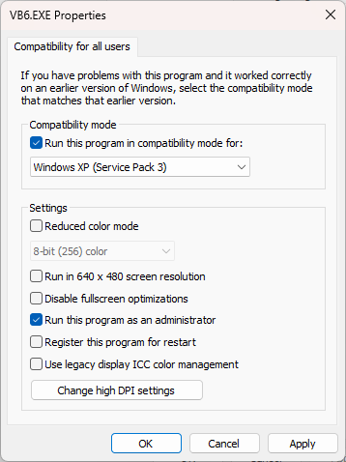
- Click “OK”, again, in the parent “VB6.EXE Properties” window
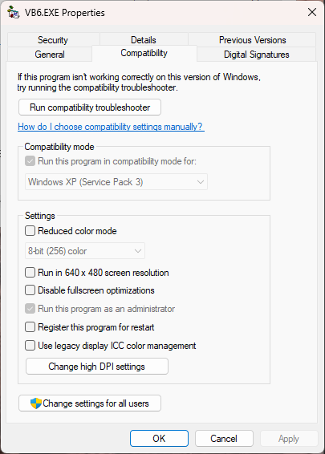

- Now Visual Basic 6.0 is ready to be run on your computer!!
- We can progress onto the next section to tweak the Paleomag VB6 project code so that it can run stably on your Windows 11 computer!

Configuring Paleomag VB6 code to run in Windows 11
- This section describes the steps needed to make changes to the Paleomag VB6 code from your old Windows OS system to run in VB6 under Windows 11.
- You might need to obtain an installer file: vb6cli.exe
  - As of May 2025, it can be found on an archived snap-shot of a Microsoft Downloads page: Wayback Machine: https://web.archive.org/web/20120507035918/http:/download.microsoft.com/download/vb60ent/Sample30/1/W9XNT4/EN-US/VB6CLI.EXE
  - If this link fails to work, I still have a copy of vb6cli.exe and can send it to you, if necessary.
  - Scan this file using a good anti-virus agent. Again, I suggest uploading it to VirusTotal.com

Run vb6cli.exe
- Running this installer before you open the Paleomag VB6 code will help reduce and simplify the number of weird cascading errors that you will get when you first open the Paleomag VB6 code in VB6.
- Before running vb6cli.exe, right-click the file, and from the pop-up menu select the “Properties” option
- In the vb6cli.exe Properties window, click the “Compatibility” tab, and then check the “Run this program in compatibility mode for:”, and then select “Windows XP (Service Pack 3)” option from the drop-down menu. Also check the option in the bottom half of the window to “Run this program as an administrator”. Finally, click the “OK” button to set the settings and close the window.
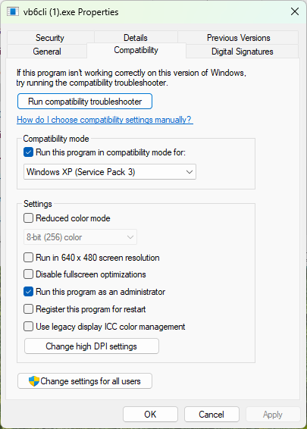
- In your Downloads folder create a new folder named vb6cli
  - Open the folder and then copy the full folder path. For instance, the folder path for the Lowenstam system at Caltech is: C:\Users\lab\Downloads\vb6cli
  - You will need this path when running vb6cli.exe
- Double-click the vb6cli.exe file to run it. This will open a WinZip Self-Extractor window. In this window, paste the full path to the vb6cli folder in the Downloads folder.
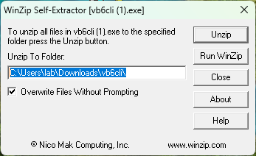
- Click the “Unzip” button
- In the Downloads\vb6cli folder, five new files will be created. Navigate to this folder and then right-click the file VBC6.exe.
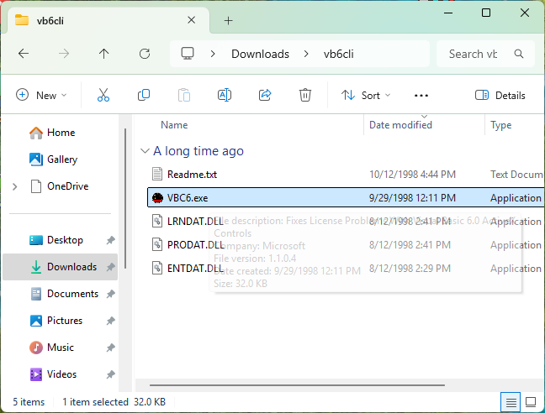
- In the pop-up menu, select the “Properties” option to open the VBC6.exe Properties window. In this window, select the “Compatibility” tab, and then check the option for “Run this program in compatibility mode for:”, and then select: “Windows XP (Service Pack 3)” from the drop-down menu.
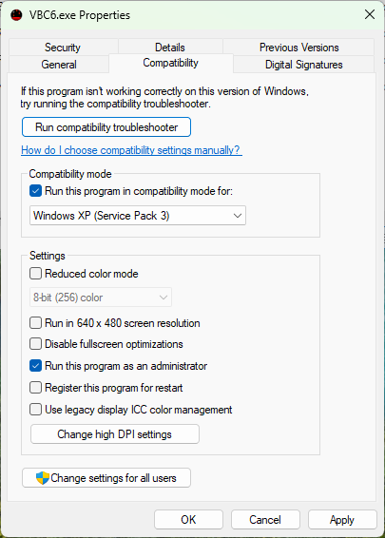
- Now, double-click VBC6.exe to run it
- If all has worked well, moments after you run the file, a message box will pop-up saying that the install was successful.
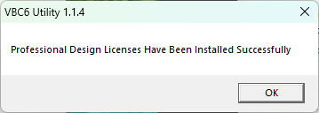

Copy Paleomag files, setting and code to Windows 11 PC
- From the backup of your Paleomag code and settings folder made from your prior system, copy over everything to a new folder
  - Some labs create a new folder on the Desktop
  - Some labs create a new folder under Documents
    - For the Caltech Lowenstam system, we create a folder called “Lowenstam” under our C:\Users\lab\Documents\ folder
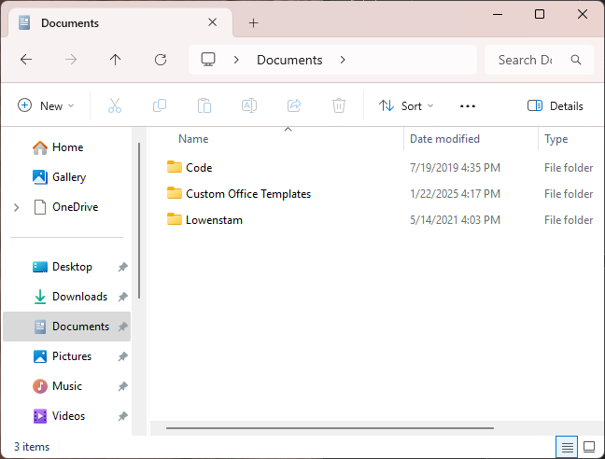
    - Inside the Lowenstam folder is all of the sub-folders containing the Paleomag XY code, all the settings and support files, etc. This may look different for your system, especially if you have a 2G built RAPID system.
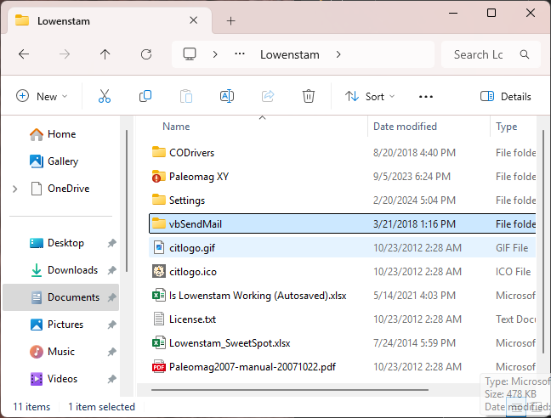

Register vbSendMail.dll
- Find the vbSendMail folder that you copied over from your old RAPID PC
- In the Windows search bar, type “cmd”. In the Best Match results, right-click “Command Prompt” and from the pop-up menu select the option to “Run as administrator”
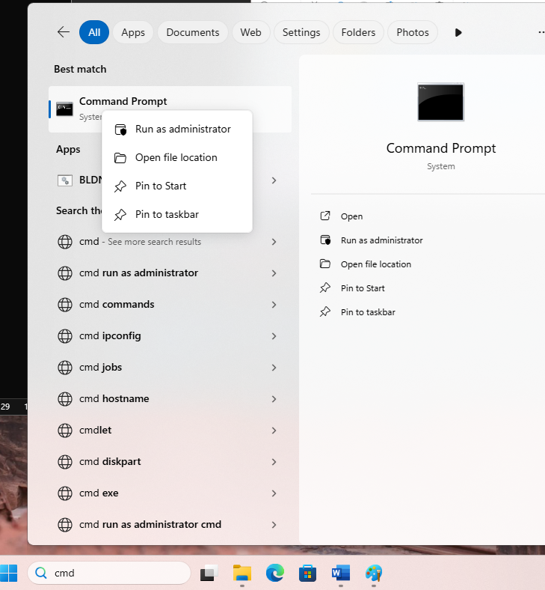
- In the Administrator: Command Prompt window, type in a command something like:
  - regsvr32 "[Path to vbSendMail folder]\vbSendMail.dll"
  - NOTE: [Path to vbSendMail folder] is not the actual text you should use, you will need to figure out the path to the vbSendMail folder in your Paleomag folder copied from your old RAPID system.
  - For the Caltech Lowenstam RAPID system, this command would be: regsvr32 "C:\Users\lab\Documents\Lowenstam\vbSendMail\vbSendMail.dll"
  - If we instead put the Lowenstam folder on the Desktop, this command would be: regsvr32 "C:\Users\lab\Desktop\Lowenstam\vbSendMail\vbSendMail.dll"
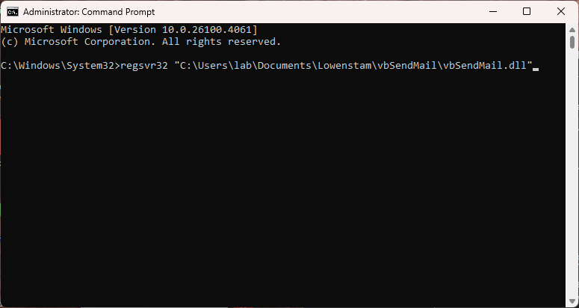
- Click enter to run the command, if all goes well, you should get a confirmation that vbSendMail has been registered successfully.
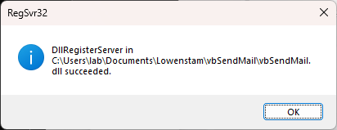

Create Desktop Shortcut to Paleomag VB6 code
- Navigate to the folder that contains your actual Paleomag VB6 code files
  - This folder should have at least one subfolder called “ADwin”
  - It should contain a bunch of code files ending in extensions like: .bas, .cls, .frm, .frx, .vbw, and .vbp
  - In this folder, we need to find the Paleomag VB6 project file, which will end with “.vbp”
    - This file should have a name like:
      - Paleomag v3.vbp (for the XY stage version of the RAPID system)
      - Paleomag v2.xx.vbp (for the snake chain version of the RAPID system)
  - Right-click the file and in the pop-up menu click the option “Send to” to expand a new pop-up sub-menu. In this sub-menu, select the option “Desktop (create shortcut)”
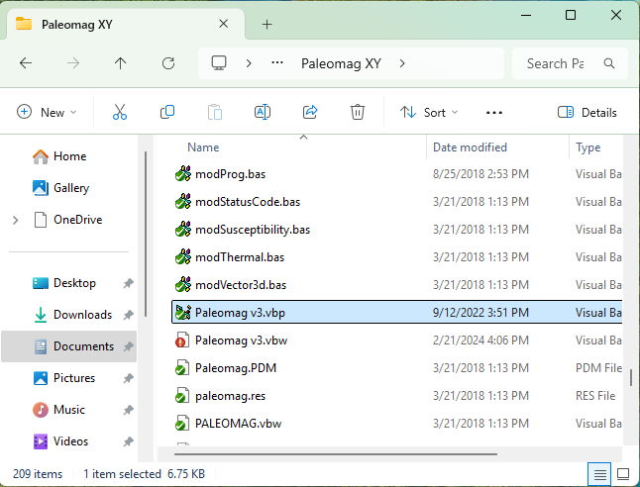
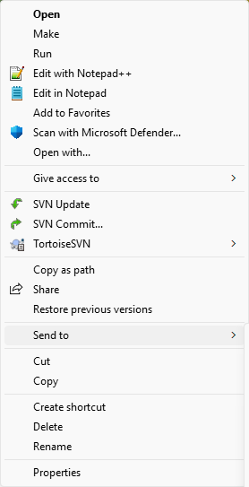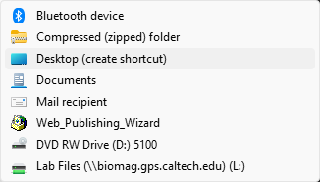

- Once you have read additional guidance, below, you can use this desktop shortcut to open the Paleomag code in Visual Basic 6.0

Opening the Paleomag VB6 code for the first time in VB6
- WARNING: Read the directions carefully. If you close the Paleomag VB6 code before all of the fixes for missing code references and components are complete, do NOT save changes to the Paleomag VB6 project. At some point in the directions, below, I will say when to save changes. If you do close the project without saving changes before all of the fixes are made, then you will have to go back and reimplement each fix. Please be careful what buttons you click.
- NOTE: Be careful about what you click after you first open the Paleomag VB6 code in Paleomag VB6. A number of error message boxes will pop-up. I suggest making a note of the error messages, in case they diverge from those that I have documented below. Several Forms in the Paleomag VB6 code will likely fail to fully load when you first open the code. These failures are usually do to certain .OCX ActiveX user-control components not being properly referenced within the Paleomag project work file (the file ending in .VBW) due to the upgrade to Windows 11. We should be able to fix these issues inside VB6.
- Double click the desktop-shortcut to the Paleomag .vbp project file to open the code in Visual Basic 6.0. You may get a security warning when doing this. I went ahead and unchecked the “Always ask before opening this file” option, as I’m fairly certain I know where it came from. Once you’ve satisfied yourself that the file is safe to open, go ahead and click the “Open” button.
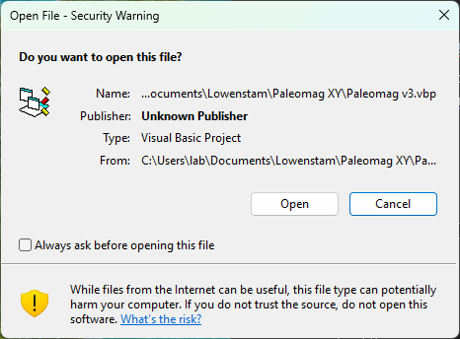
- You should get another window opening up, asking you to confirm that you want to allow Visual Basic 6.0 to open with Administrator privileges. Click “Yes” to authorize this.
- The VB6 environment will open up, and you will likely then immediately start to receive error Messages along the lines of: “C:\Users\lab\Documents\Lowenstam\Paleomag XY\MSCOMM32.OCX could not be loaded—Continue Loading Project?”
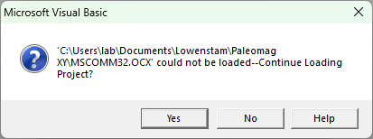
  - Write down the particular .OCX file referred to in the error.
  - IMPORTANT!!!!! Click “Yes”. After each of these error notifications, click “Yes” to continue loading the Paleomag project.
- The .OCX files that most often are not found / loaded when first opening the Paleomag VB6 code are:
  - MSCOMM32.OCX
  - COMCT332.OCX
  - COMCTL32.OCX
- Additional .OCX files may be missing / have load issues for your system. Here is the full list of the nine .OCX files that the Paleomag VB6 code relies upon:
  - MSCHRT20.OCX
  - COMDLG32.OCX
  - MSFLXGRD.OCX
  - MSHFLXGRD.OCX
  - RICHTX32.OCX
  - TABCTL32.OCX
  - COMCTL32.OCX
  - MSCOMM32.OCX
  - COMCT332.OCX
- For 2G RAPID systems all nine of the .OCX files should be provided inside of the Paleomag XY code folder.
  - If needed, the files can be COPIED to your C:\Windows\SysWOW64\ folder. If this step is needed, additional documentation on how to do this, is included, below. One .OCX file (COMCT332.OCX) was missing from the SysWOW64 folder on the Lowenstam RAPID PC, and I had to copy it over and register the file, manually.
- The errors messages will now change to simple message boxes that notify which Forms in the Paleomag VB6 code had errors during loading
  - For example: “Errors during load. Refer to ‘C:\Users\lab\Documents\Lowenstam\Paleomag XY\frmVacuum.log’ for details”
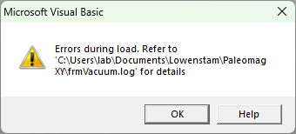
  - Click “OK” on these message boxes to proceed.
- The final error message box you will receive will say: “Errors occurred during load.” However, you may receive this error message MULTIPLE times more, interspersed with “Errors during load. Refer to…” messages.
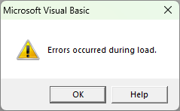
  - Click “OK” to exit out of this error message box.
- Once all the error message boxes have finished appearing (it will happen, eventually; 25 individual error message boxes of one type or another appeared when first opening the Paleomag XY code on the Lowenstam system at Caltech), then the Paleomag VB6 code will finally finish loading in the Visual Basic 6.0 development environment. We can now go about fixing all of the issues that were causing errors during the loading of the code.
  - The fixes come in two varieties:
    - Fixing missing / unloaded ActiveX (.OCX) Component files
    - Fixing missing References (e.g. to vbSendMail)

Fixing missing ActiveX (.OCX) Component Files
- We will now use the Project menu in VB6 to add back in the missing ActiveX (.OCX) controls that correspond to each missing / unloaded .OCX file
- Here is the full list of the .OCX files that the Paleomag VB6 code relies upon:
  - MSCHRT20.OCX
  - COMDLG32.OCX
  - MSFLXGRD.OCX
  - MSHFLXGRD.OCX
  - RICHTX32.OCX
  - TABCTL32.OCX
  - COMCTL32.OCX
  - MSCOMMCTL.OCX
  - MSCOMM32.OCX
  - COMCT332.OCX
- NOTE: For the Lowenstam RAPID XY stage system, the code was missing a copy of MSCOMM32.OCX, which was not an issue for the Yale RAPID snake-chain system. Not certain is this is a systematic difference between the components used in VB6 for the XY stage vs Snake-Chain versions of the RAPID sample changer.
- Hopefully, the missing ActiveX control (.OCX) files are present in your C:\Windows\SysWOW64 folder.
  - If you find that a .OCX file is missing, let me know. I think all 2G / RAPID Paleomag XY code folders contain copies of all 10 .OCX files needed by the Paleomag VB6 code. So any missing .OCX files can be found there or obtained from another RAPID consortium lab.
  - Another option is to download missing .OCX files from: www.ocxme.com. WARNING: this site has a lot of pop-up adds and misleading buttons and links to try and get you to install malware / bloat-ware instead of the actual .OCX file that you need. The correct download links / buttons are usually smaller, towards the bottom of the webpage, might require some form of CAPTCHA to activate, and will NOT cause a new window / tab in your browser to open. If you have an Adblocker for your web browser, I suggest using that as a means to defeat the horrible ads and layout on this web site.
    - WARNING: Always virus-scan any system files (e.g. .OCX, .DLL, etc.) that you download from the internet. Again, I suggest using the https://www.virustotal.com meta anti-virus agent scanner to upload and scan any installer or system file that you download on your computer. Even then, you might still end up infecting your PC.
  - Additional steps will be needed to register the .OCX files in the SysWOW64 folder, and are covered, below.
  - You want the Paleomag VB6 code to use the versions of the ActiveX .OCX files in the SysWOW64 folder, as this folder, though confusingly named, is the system folder reserved in Windows for 32-bit applications. Visual Basic 6.0, and thus the Paleomag VB6 code, is a 32-bit application. The System32 folder is reserved in Windows for 64-bit applications. I swear someone at Microsoft, at some point in time, is laughing uproariously at all of this, and at all of us.
- In the Paleomag VB6 project, in Visual Basic 6.0, click the “Project” menu near the upper left corner of the window.
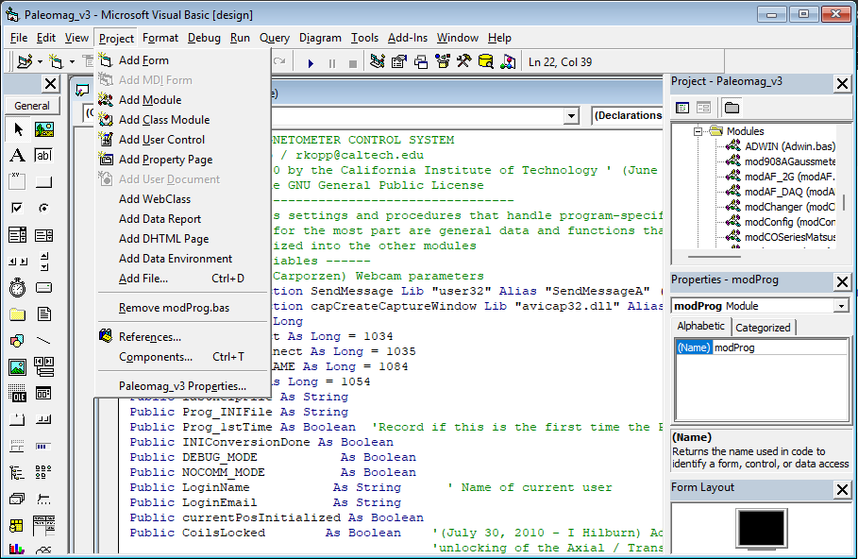
- Towards the bottom of the list of Project menu items, select the option: “Components…”
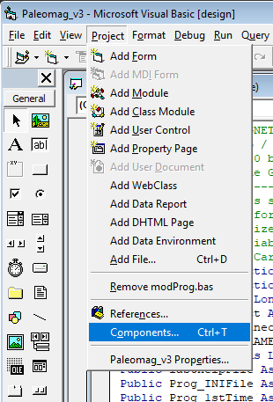
- This will open the project “Components” window. In this window, select the “Controls” tab in the upper left of the window, and then check the “Selected Items Only” check-box near the “Browse …” button on the lower middle right of the window. This will filter the list of Components to those already loaded in the Paleomag VB6 project.
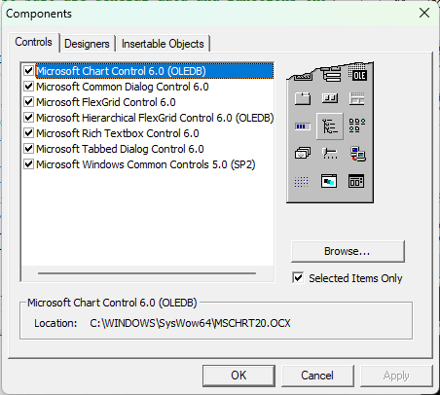
- In the example, above, seven of the ten needed .OCX files successfully loaded for the Paleomag VB6 code – only two .OCX files are missing. This is typical for the Paleomag XY version of the RAPID code (the XY stage version sold by 2G). For older versions that use the snake-chain changer, additional .OCX files may be missing. For instance, three .OCX files were missing / unloaded for the Yale Paleomag VB6 code when that system was transitioned to a Windows 11 PC.
- To re-add / load the missing .OCX file, click the “Browse…” button in the lower middle right of the “Components” window. This will open up an “Add ActiveX Control” file browser window.
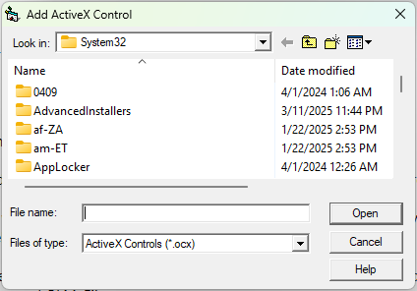
- The file dialog window will start in the C:\Windows\System32\ folder. We need to change the path using the “Look in:” drop-drown menu at the top of the window to look instead in the C:\Windows\SysWOW64\ folder
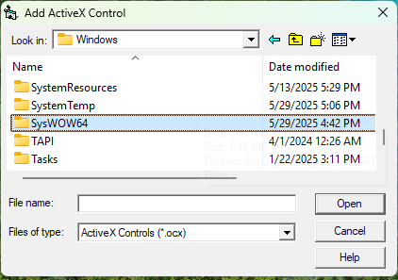
  - Once the Add ActiveX Control file dialog window is looking in the SysWOW64 folder, you can start typing in the name of the missing .OCX file in the “File name:” text-box near the bottom of the window (to the left of the “Open” button). A list of possible matches will appear as you continue to type. Select and click on the .OCX file in the list that matches the one you were looking for.
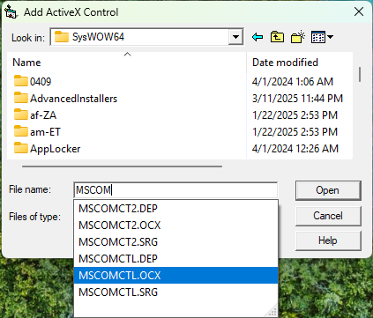
  - Click the “Open” button to add the .OCX file to the Paleomag VB6 project Components.
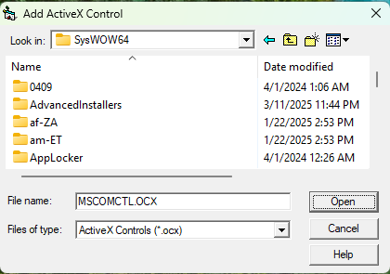
  - The newly added ActiveX control component will now be highlighted in the Components window
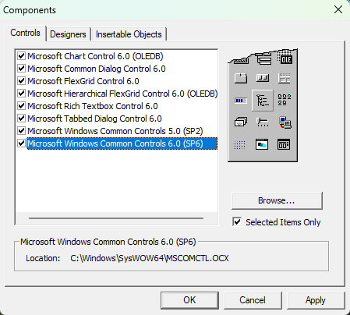
  - Continue using the “Browse…” button and the “Add ActiveX Control” window to add missing .OCX files from the SysWOW64 folder into the project, until all 9 ActiveX control components are listed in the Components window.
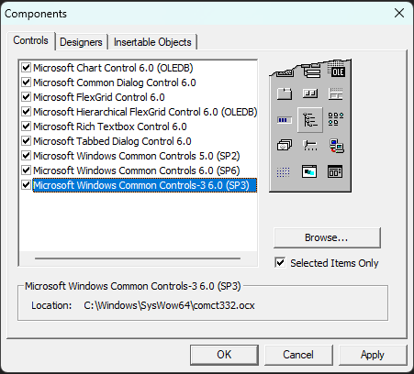

- If an .OCX file is not present in your SysWOW64 folder (e.g. COMCT332.OCX), additional steps are needed.
  - If you have a 2G built RAPID system, copies of all nine .OCX files should be present in your Paleomag XY code folder
  - If one or more are missing, you might be able to find a copy of the .OCX file in your C:\Windows\System32 folder
  - Failing that, you may need to go online to find the missing .OCX file, though I suggest getting a copy from another RAPID lab. Be careful what websites you visit to download the file. There are a number of scam download sites that target people trying to download .OCX files.
    - COMCT332.OCX can be hard to find, as online search engines assume you are searching for the more common COMCTL32.OCX file, instead. You may need to use quotation marks in your search browser to force it to search for COMCT332.OCX, specifically.
  - Once you download the file, I STRONGLY suggest using an online antivirus meta-screening tool like Virustotal.com to scan the downloaded .OCX file before opening it.
  - After you have virus-scanned the missing .OCX file, copy the file (e.g. by highlighting the file and clicking Control-C, or by right-clicking the file and selecting “Copy” from the pop-up menu), and paste a new copy of the file into your C:\Windows\SysWOW64\ folder.
    - A message box should pop-up asking you to provide administrator permission to copy the .OCX file to the SysWOW64 folder
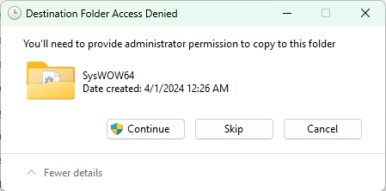
  - In the windows search bar, type in “cmd”, then under Best Match, right-click the “Command Prompt” search match. In the pop-up menu, select the option to “Run as administrator”
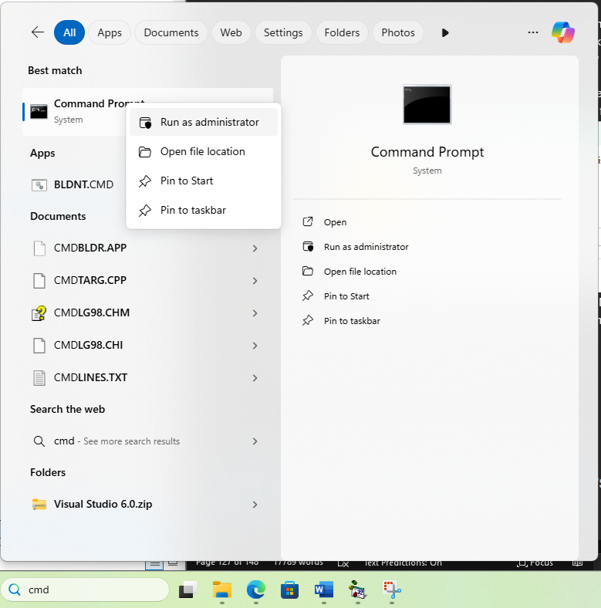
  - This will open an “Adminstrator: Command Prompt” terminal window
  - In this window, type the following command: cd C:\Windows\SysWOW64
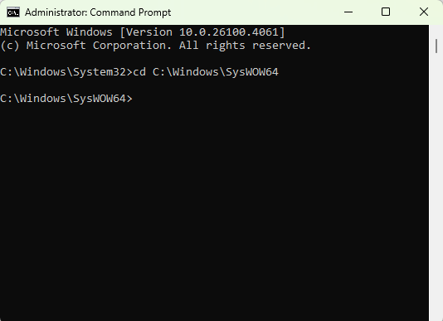
  - Now type the following command: regsvr32 [name of the .OCX file that we just copied over to the SysWOW64 folder].OCX
    - For the Lowenstam system at Caltech, in which the missing file was COMCT332.OCX, the command would be: regsvr32 comct332.ocx
      - You can use the tab key to autocomplete the .OCX file name – just make sure that it is the correct .OCX file – several of them have almost identical file names (e.g. COMCTL32.OCX, COMCT232.OCX, etc., etc.)
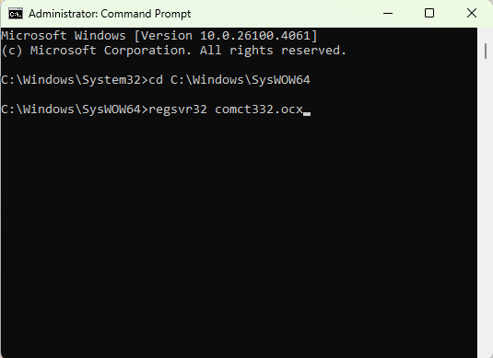
    - If all went well, you should receive a successful file registration message box
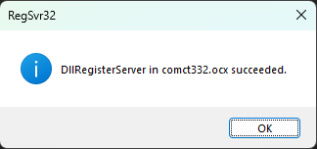
  - You can now go back to the Project -> Components windows in Visual Basic 6.0 and add the newly registered .OCX file as a component in the Paleomag VB6 code project.
- Once you have all 10 ActiveX controls added as Components to the Paleomag VB6 project, click the “OK” button to confirm the newly added components and close the Components window.
- Now, I strongly recommend saving the Paleomag VB6 project code. You can do this via the File menu, and then click the “Save Project” menu option
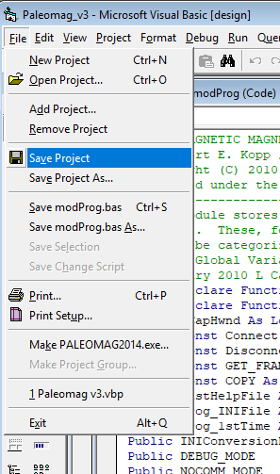

Fixing Missing References in Paleomag VB6 Project
- References in VB6 are compiled code files (usually .DLL files) that a project in VB6 relies on to handle some functionality.
- In addition to a list of more generic references, the Paleomag VB6 code project relies on a reference to vbSendMail, a 3rd party, open-source VB6 project that should be included as a subfolder amidst your various Paleomag folders / files. vbSendMail handles sending emails from within VB6. This is for sending notification emails about the status of your RAPID system.
  - In order for the Paleomag VB6 code to run, it must include a reference to a compiled version of vbSendMail. The directions for locating and registering the compiled library file, vbSendMail.dll, with the Windows 11 system are located here: Register vbSendMail.dll
  - If you do not have a folder containing the vbSendMail VB6 project, nor the compiled vbSendMail.dll file, you will need to request a copy from another RAPID lab, as I haven’t been able to find a download link for vbSendMail that still works. (I can’t even find the original vbSendMail on sourceforge.com).
- To add in a missing reference in the Paleomag VB6 project, either go to the project already open in VB6 (if you haven’t closed it yet), or use the desktop shortcut to open the Paleomag VB6 project in VB6.
  - Then, open the Project menu in VB6 and select the menu option for References
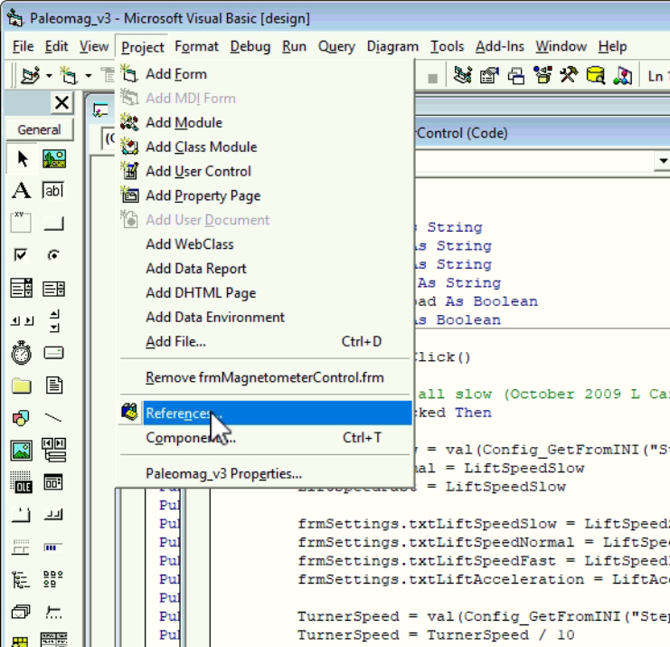
  - This will open the References window, which will list all of the selected references for the Paleomag VB6 project, followed by all available references.
  - Check to see if any of the references start with the label: “MISSING”. This denotes that VB6 can no longer resolve the path to the .dll file that is referenced.
  - For the Lowenstam Paleomag VB6 project, because I kept the folder path on the Windows 11 OS to the Lowenstam code the same as the path on the Windows 10 OS version, the Lowenstam Paleomag VB6 code was able to locate and access the reference to vbSendMail.dll
    - Because we went ahead and used regsvr32 to register this copy of vbSendMail.dll with Windows 11 further back in this guide, this .dll file will function without any issues
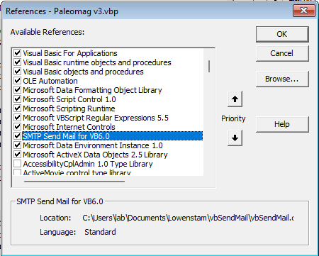
  - However, for your upgrade, especially if you are upgrading from 32-bit Windows 7 to Windows 11, your reference to vbSendMail may be labelled as “MISSING”, or may be absent entirely from the list of checked references.
  - To fix this problem, either highlight the “MISSING” reference (if there is one) and click the “Browse…” button, or just click the “Browse…” button in the upper right corner of the References window.
  - This will open a file-browser window to locate and open a .DLL file corresponding to the missing project reference.
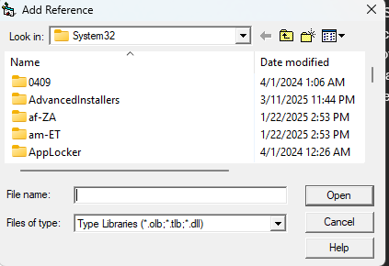
  - The file browser usually starts searching for the missing reference in C:\Windows\System32. However, for any missing standard references (Not vbSendMail.dll), you will want to instead search for missing references in C:\Windows\SysWOW64. This folder contains all of the system files for 32-bit applications, like Visual Basic 6.0. VB6 was create by Microsoft before Microsoft developed 64-bit versions of Windows, so it doesn’t know that it needs to start all of it’s searches in the SysWOW64 folder.
  - Navigate to the folder that contains the vbSendMail VB6 project. For the Lowenstam system, this folder is contained within the main folder that contains all of the Paleomag subfolders (Settings, Paleomag XY, etc.). The equivalent folder on your RAPID PC is where I suggest you keep your vbSendMail folder, and thus where you would navigate to now.
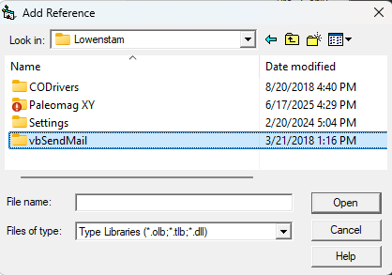
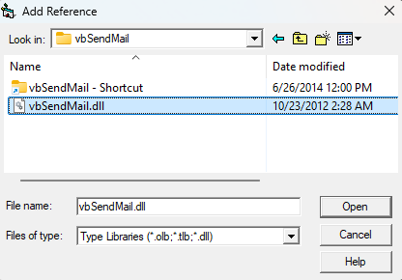
  - Once you have selected the vbSendMail.dll file that you registered with the windows OS in a previous step, click the “Open” button to re-add this reference to the Paleomag VB6 project file.
  - Then, click the “OK” button in the upper right corner of the References window to finish re-adding the reference to the Paleomag VB6 project.
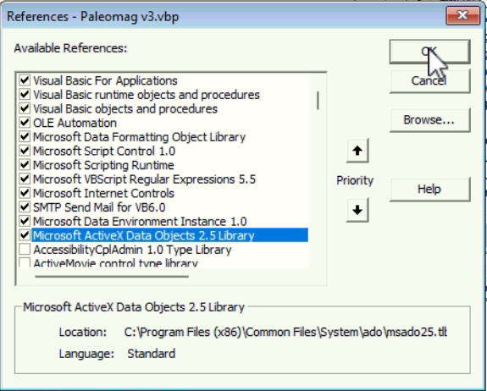
- Finally, make sure to save changes to the Paleomag VB6 project.

Running the Paleomag VB6
At this point, you should be able to run the Paleomag VB6 code.
- To run the code, inside the VB6 environment, press and hold the Control key, and then press the F5 function key on the keyboard. This will do a syntax / compile check on the Paleomag VB6 code prior to running the code. This is very useful to detect if inadvertent typos have been added to your code.
- When the code runs for the first time, it will open a file dialog box to ask you to select a settings .INI file. The code will very likely not be able to find the .INI file that it was expecting to use when running on your prior Windows OS. This is why the work we did prior to backup your old Paleomag VB6 related files and then the work we did after installing Windows 11 to create a new parent folder for your Paleomag code folder + settings folders + vbsendmail folder was important. Those steps make this part so much easier.
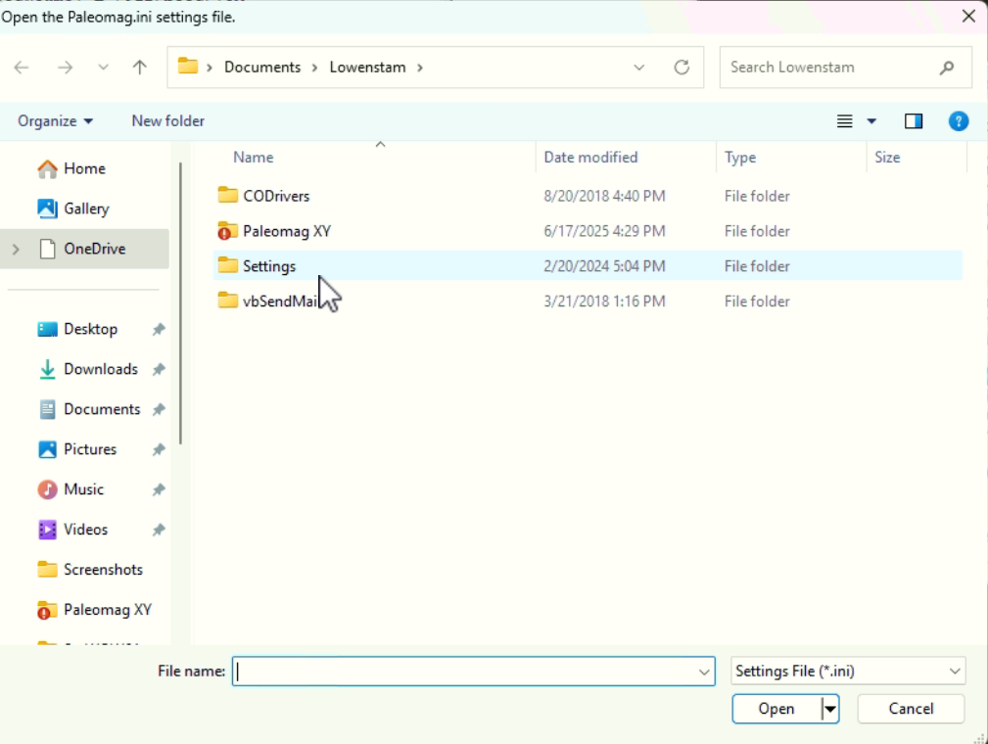
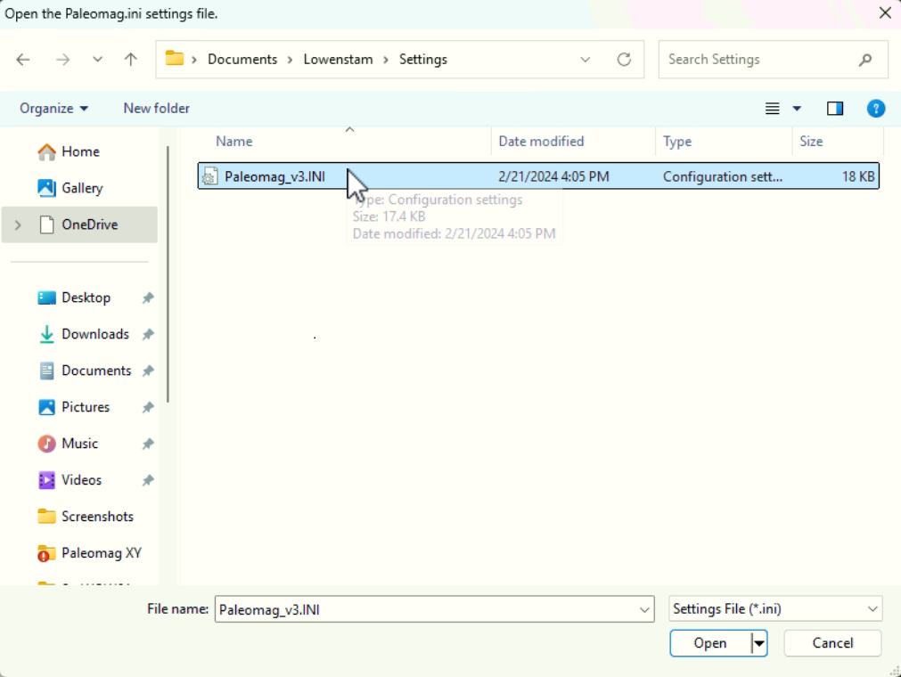
- Log in inside VB6 code with name and email address
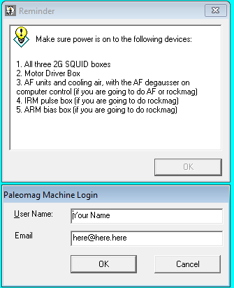

- Next, depending on the pathing and the settings for your system on your old Windows OS, the code may prompt you to locate and open your PaleoUse.DAT file.
  - This file stores the record of you logged into your system and used it over time
  - Best location for your .DAT paleo-use file is in the same Settings folder as your .INI file.
  - Paleomag code will guide you to locate and open the missing .DAT file. Worse comes to worse, you can create a new Paleouse.DAT file. It is simply a text file with the extension changed from .TXT to .DAT.

- Next, if your COM Port settings inside your Paleomag .INI file are no longer correct, you will get an Invalid Port error message.
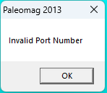
  - Click “OK” to get through the error message.
  - Then, a new message box will pop-up asking you if you want to turn on NO-COMM mode. Click “Yes” to turn ON no-comm mode
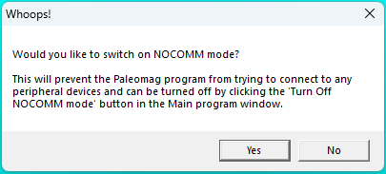
  - NO-COMM mode enables the code to continue to run without actually sending any commands to the various hardware. This allows the Paleomag VB6 app to “emulate” running your system, avoiding any communication errors. This also allows the program to continue running so that you can adjust the needed communication settings inside of the program.
  - If this is a comm port error – you can usually use the status messages at the bottom strip of the Paleomag VB6 main window to determine which hardware device the bad comm port settings are associated with. This most key information will be in the bottom left corner of the main window.
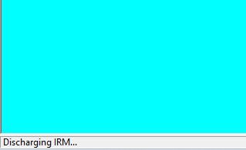
    - In this case, the issue is with the comm port used to communicate with the IRM hardware.
    - For this case, two settings need to be checked:
      - Which IRM system is set in View->Settings->IRM
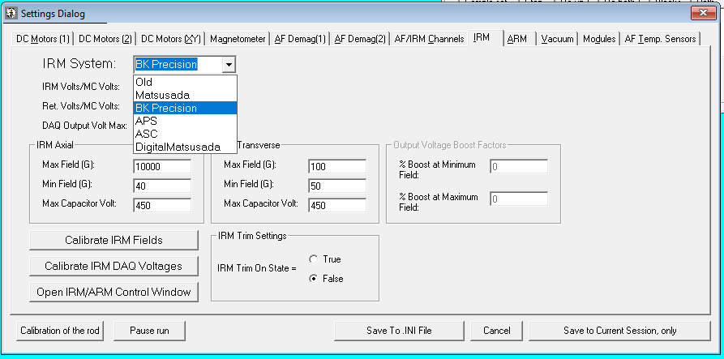
      - The IRM COM Port setting in View->Options->Comm ports
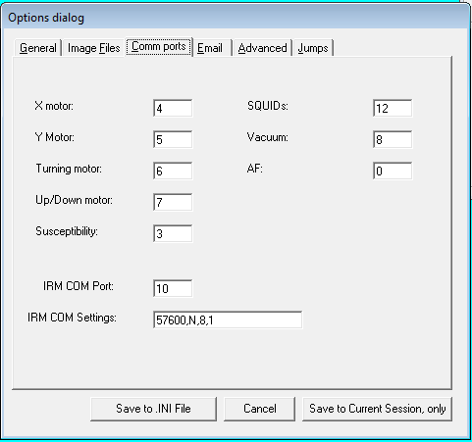
    - In this case, the IRM System setting is correct, the Lowenstam RAPID System at Caltech uses the B&K Precision DC power supplied variant of the Caltech/ASC IRM hardware system.
    - However, if we check the Ports (COM & LPT) tab of the Windows Device Manager – we learn that we have the incorrect COM Port assignment for the IRM Com Port. It should be COM Port 14 not 10
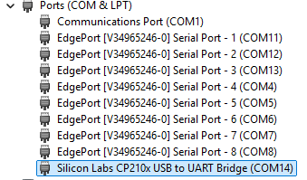
    - A quick change to the IRM COM Port options value inside View->Options->Comm ports in the Paleomag VB6 program should fix the issue.
  - When making changes to the Options or Settings in the Paleomag VB6 program View->Options, View->Settings, or View->Data File Save Settings windows, make sure to ALWAYS click the “OK” button (if you are using the Snake-chain version of the Paleomag VB6 code) or the “Save to .INI File” button (if you are using the XY Stage version of the Paleomag VB6 code). This will make sure that any changes that you make are saved to the settings .INI file and thus are remembered.
  - Finally, Quit and re-run the Paleomag VB6 program to refresh the new hardware settings.

- NOTE: I found errors with the Digital IRM code in the Lowenstam XY code.
  - These errors only affect systems that use the digitally controlled Matsusada or B&K Precision power supply variants of the Caltech / ASC IRM hardware system –AND– the XY stage version of the Paleomag VB6 code.
  - As far as I know, the Lowenstam RAPID system is the only system that meets these two criteria.
- May have ADWIN errors (if path settings to ADwin code folder are wrong). This error may trigger before the Invalid Port comm error. (It depends on which COM port has the incorrect settings). This can also happen if you have a USB connection error to the ADwin, or the power to the ADwin was not turned back on prior to starting up the Paleomag VB6 program.
  - To recreate the first version of this error, I manually changed the .INI setting file for the Lowenstam system, removing the full pathway to the ADWINBinFolderPath setting in the [AF] block of settings. This should block the Paleomag VB6 code from being able to locate the ADwin9.btl boot loader file needed to boot the ADwin-light-16 DAQ device in the Paleomag VB6 code.
  - When the ADWIN Boot Error window pops-up, click “OK” to continue
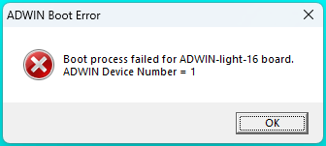

  - You may then need to also manually turn on the NO-COMM mode by clicking the “Turn on NOCOMM Mode” button on the top button strip in the main Paleomag window. It is next to the red “Quit & EXIT” button.
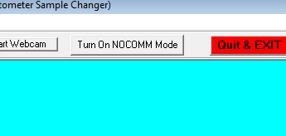

  - To Fix the ADwin folder path error, go to View->Data File Save Settings to open the Data File Save Settings window
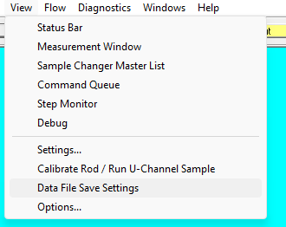
  - In that window, you’ll want to adjust the folder path for the ADWIN AF Boot / Prog. Folder Path setting, at the top of the window. Click the “…” button to the right of the folder path text box
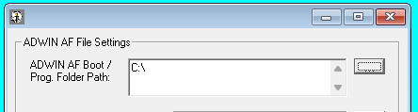

  - This will open a folder browser window asking you to locate and select the file directory that contains the ADwin boot file and program files.
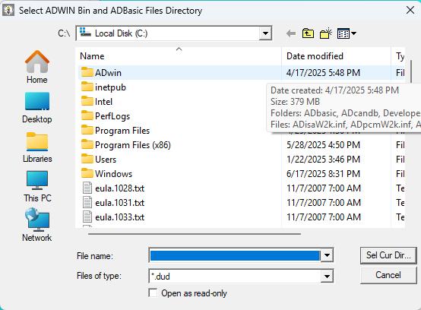

  - For –ALL– RAPID systems, this folder is located inside of the folder than contains the VB6 coding files for the Paleomag VB6 program. For the Lowenstam system, this path is: C:\User\lab\Documents\Lowenstam\Paleomag XY\ADwin\
  - This Path may be more convoluted for your system (though I suggest reorganizing your Paleomag folders and files to simplify the path.
  - Once you have SELECTED the adwin folder in your Paleomag code folder, then click the “Sel Cur Dir …” button to copy the path of this folder into the ADWIN AF Boot / Prog. Folder Path setting text-box in the Data File Save Settings window. (Note: I had to click the Sel Cur Dir… button twice – once to open the C:\User\...\Paleomag XY\ADwin\ folder, and a second time once that folder was open to choose it.
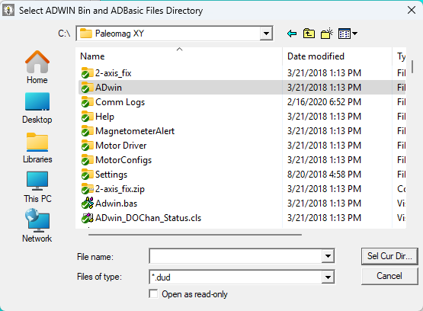
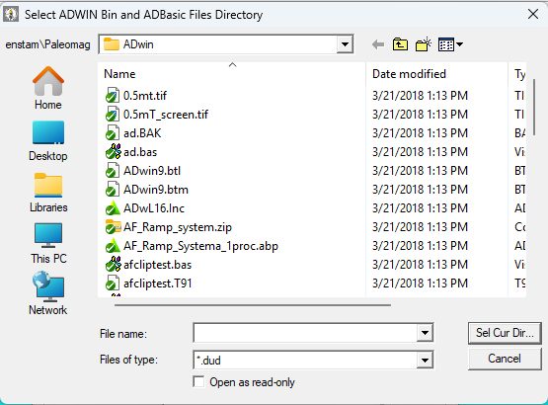

  - Click the “OK” button in the Data File Save Settings window to store the settings change to your settings .INI file.
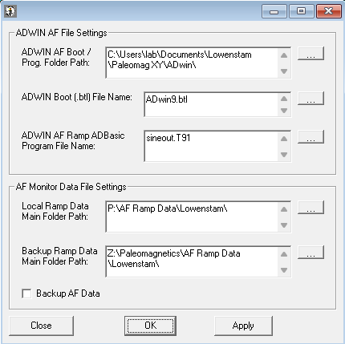
  - When you do this, a notification window will pop-up asking you to confirm that you want to make this settings change. Click “Yes” to confirm the change.
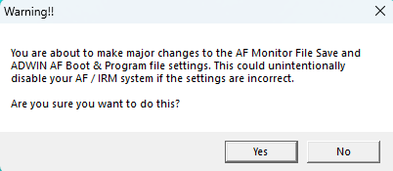
  - Finally, Quit and re-run the Paleomag VB6 program to refresh the new hardware settings.

- MSWINSCK.OCX error!! For sending encrypted emails – this is new – took screen shot
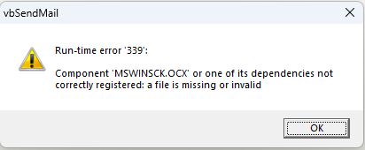

- Next up on the list of hardware to have issues would be Measurement Computing DAQ – not gone this far, yet.

APPENDIX A – Notes for Upgrading to Windows 10 in place

These are old instructions for upgrading from Windows 7 to Windows 10 in place. These are included here for reference, and in that special case where someone needs to do a sequential update from Windows 7 to 10 and then on to 11. These notes also contain information / directions that may be useful for the upgrade to Windows 11.

Version 1.1
Isaac Hilburn
Original: December 30, 2019
Revised: v1.1, January 3, 2020

RAPID Consortium Email List:
rapid-consortium@caltech.edu

Steps:

Backup Image of Windows 7 OS first
  - If you do not have handy IT staff to reliably do this for you, then you can use one of the following Windows 7 drive clone software apps:
    - Clonezilla: https://clonezilla.org/
    - Macrium Reflect Free version: https://www.macrium.com/reflectfree
    - DriveImage XML: https://www.techrepublic.com/blog/five-apps/five-free-and-reliable-cloning-tools/
    - Runtime Live CD: http://www.runtime.org/data-recovery-live-cd.htm
    - Paragon Backup & Recovery Free Edition: https://www.paragon-software.com/free/br-free/#
  - Here is the website that I go to get more info on these 5 drive cloning software apps: https://www.techrepublic.com/blog/five-apps/five-free-and-reliable-cloning-tools/
  - Whichever backup option that you use, make sure to backup your ENTIRE COMPUTER drive (usually C: drive in the US). I suggest backing up any relevant data drives on your PC as well.
  - Alternatively, several of the options above can create a bootable image of your drive onto another drive / thumbdrive. This is the preferred method for backing up your Windows 7 RAPID PC. It will allow you to access files from the old Windows 7 install if the upgrade in place process fails and corrupts your original computer.

Hardware compatibility
  - Some USB to RS-232 serial port adapters that work with Windows 7 will not work with Windows 10. If you are using one of more of these adapters, then you will have to replace them before or after the Windows 10 upgrade in order to keep you RAPID system working.
  - Generally, any USB or PCI or PCIe to RS-232 serial port adapter that works with Windows 7 and uses the Prolific UART chipset will not be compatible with Windows 10
    - You need an adapter that uses the FTDI chipset: http://www.usconverters.com/index.php?main_page=page&id=62&chapter=0
    - The Quick Checklist:
      - Preferred processor chip: FTDI or Silabs (very reliable)
      - Preferred serial driver chip: Maxim, Exar, NI or other reputable brand
      - Minimum 5.0VDC output power at serial connector (ensures reliable data transmission)
      - Build-in electro-static protection for at least 600W (protects against static electricity)
      - LED lights for TX and RX activity (nice to have when troubleshooting)
  - The RAPID system needs at least 4 to 8, RS-232 serial ports to control and talk to the various hardware, including 3 com ports (snake-chain) or 4 com ports (XY stage) to talk to the QuickSilver Motor Controllers, 1 com port to talk to your 2G SQUID fluxmeter boxes, and possibly also: 1 com port to talk to your Bartington MS-2 susceptibility meter, 1 com port to talk to your IRM system (either older Caltech system or newer APS IRM system), 1 com port to talk to your 2G AF system (pre-ADwin), and 1 com ports to control your vacuum system (pre-2009 RAPID systems, only, and even then, most likely you don’t have this issue).
  - If you do need to upgrade your RS-232 serial adapter, document which com-port on your current system belongs to which device. Then, label your RS-232 cables accordingly. This will help you figure out which com-port is which once your upgrade to Windows 10.
    - Windows 10 has a habit of scrambling all of your com-port assignments during the upgrade
    - While annoying, if you properly document and label what RS-232 port and cable is what, you should be able to easily fix the issue using the Device Manager window in Windows 10 after the upgrade
    - This problem can be even worse if you buy a cheap Windows 10 compatible multi-port RS-232 adapter. The com ports under the Device Manager may be randomized vs the com ports sockets on the adapter. If the com port sockets on the adapter are not properly labelled or do not have channel specific Tx/Rx LED status lights, figure out which com port socket corresponds to which com port assignment in the Windows 10 Device Manager can be quite frustrating.

Backup ALL of Paleomag files
  - Paleomag VB6 Code folder
    - The file path to the Paleomag VB6 code folder can be found by:
      - Hovering the mouse cursor over the desktop short-cut to the RAPID code
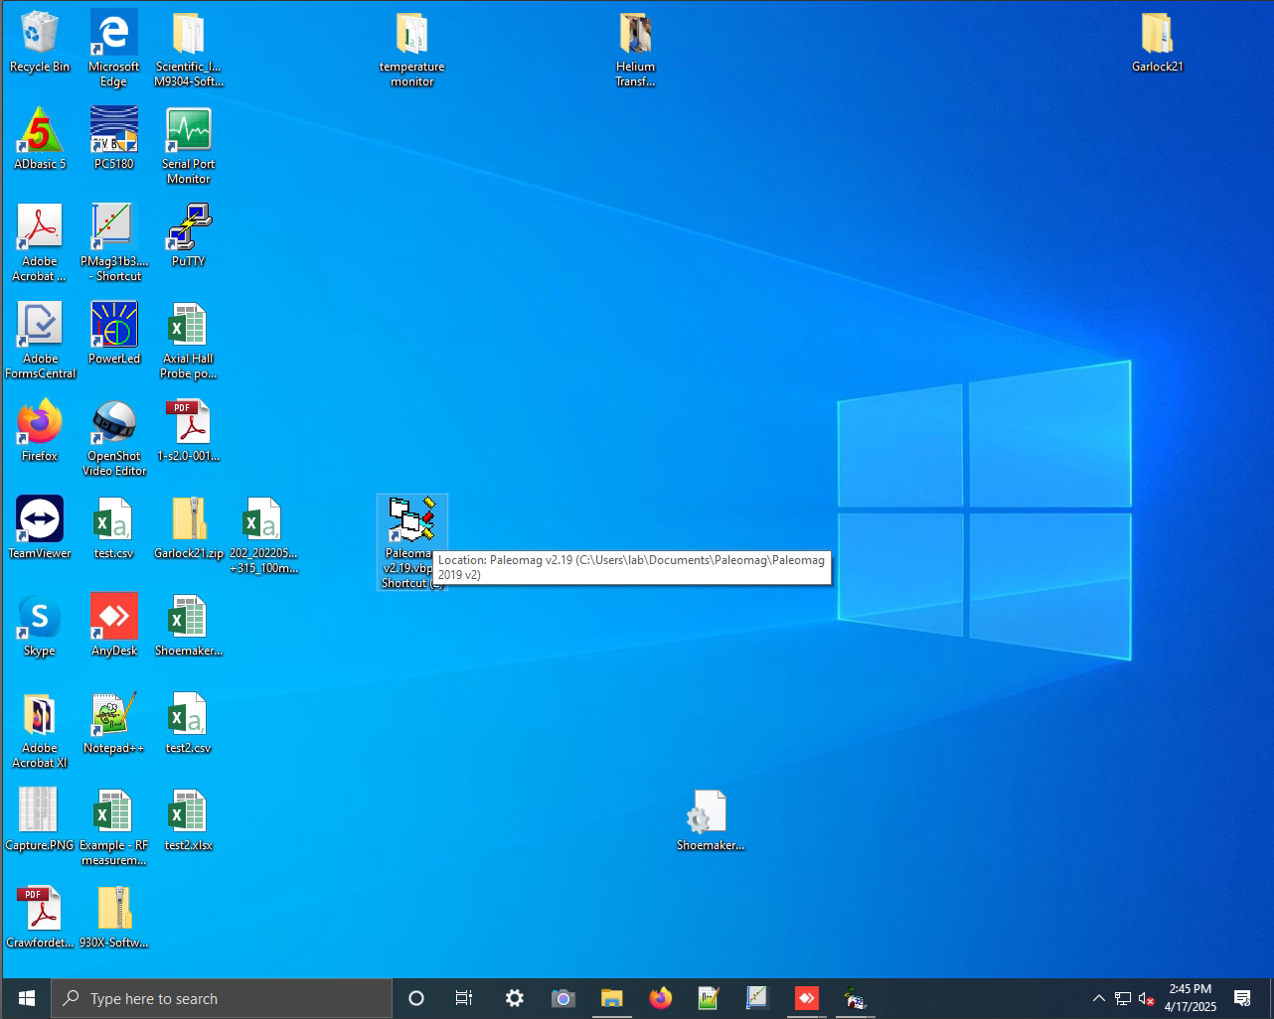

      - Right-clicking the desktop short-cut and selecting “Properties” at the bottom of the pop-up menu:

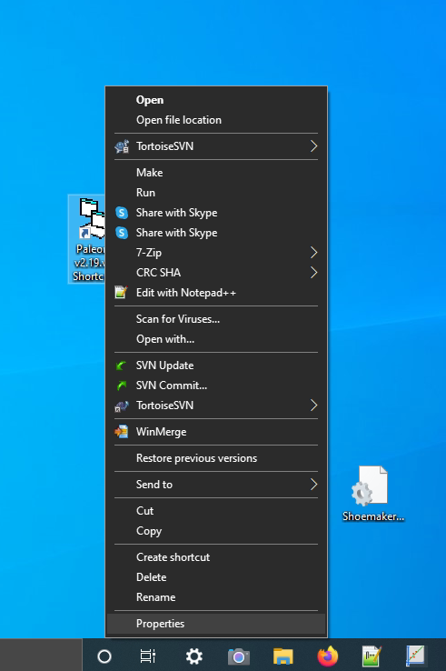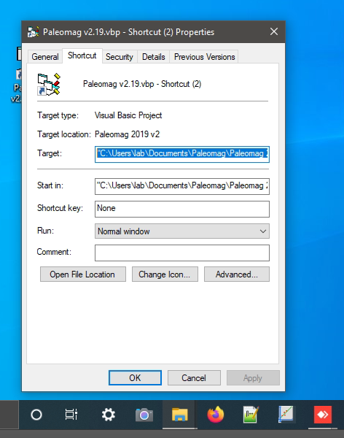

    - Use the path found above to navigate to the directory that contains the RAPID code, only.
      - In the example above, this path would be:
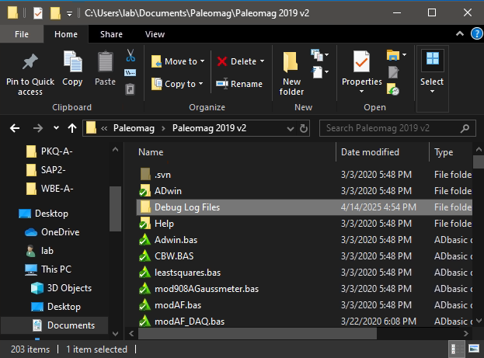
C:\Users\lab\Documents\Paleomag\Paleomag 2019 v2\
    - This folder contains all of the RAPID code files, and several important sub-folders:
      - ADwin/
        - Contains the binaries and related files necessary for the Paleomag code to control the ADwin-light-16 and run the AF demag process
      - Debug Log Files
        - These are serial communication log text files that the VB6 Paleomag code creates to help debug issues with controlling the RAPID system. If your system has been up and running for a few years, this folder could contain several gigabytes worth of text files.
        - When copying data from an old install to a new one, you may want to either compress or delete the majority of the log files in this sub-folder first. Copying over a large number of large text files can slow the file transfer process, especially if you are copying files over a network connection.
      - Help
        - This folder is no longer in use but may contain legacy help files. The default Help browser that VB6 uses is not supported in Windows 7 and later. We had to remove the Help browser from the Paleomag VB6 code due to this issue.

    - Including the ADbasic binary files used to program the ADwin-light-16 with the instructions needed to execute the AF demagnetization process.
  - Settings — including:
    - QuickSilver Control Motor Configuration (.qcp) files
    - The currently active copy of your Paleomag_v3.ini settings file. And all of the associated files in the same folder.
      - To find the location of your active Paleomag_v3.ini settings file, follow the following steps:
        - Start the Paleomag VB6 code
        - Go to the View Menu, then click on the Options sub-menu to open the Options Window
        - In the General tab (the first tab to the left) of the Options Window, several file paths are listed, including the “Ini File:” file path to your active Paleomag_v3.ini file. You can use this file path to find your active Paleomag_v3.ini and the folder in which it resides.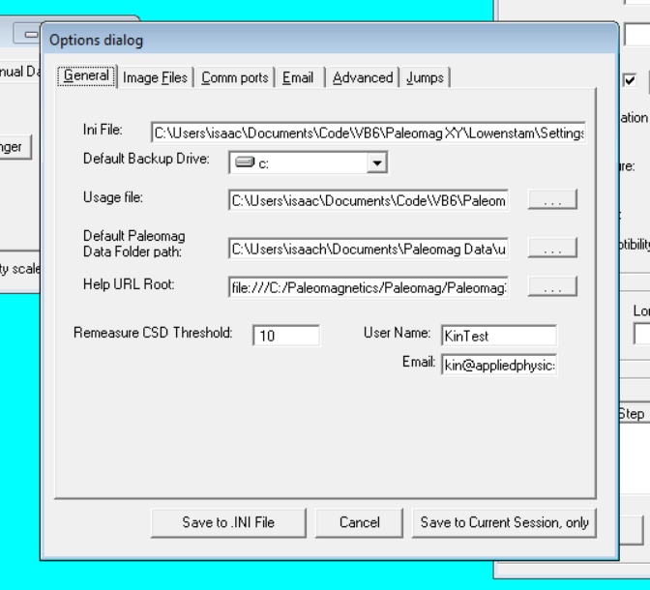
    - The location of you user login / Paleomag program usage file
      - Default name of this file (at Caltech) is: Paleouse.dat
      - The file may have been renamed when the RAPID system was installed in your lab (e.g. Perth.dat, Liverpool.dat, Lancaster.dat, etc.).
      - You can find the file-path to your .dat file in the “General” tab of the Options Window. Look at the file path in the “Usage File” setting in the General tab. This will allow you to locate your currently active usage .dat file and preserve a record of the email addresses and usernames of everyone who has logged into your RAPID system
    - Your actual Paleomag run data, including all of your user folders, sample group folders, sample files, rockmag data files (.rmg), UP files (.UP), Stat files (.STAT or .stat) and log files (various extensions, but usually: .log, .csv or .txt)
      - If you do not know the path to your Paleomag data folder, you can find the path in the General tab of the Options Window. You can find the file path under the “Default Paleomag Data Folder path:” settings in the General tab.
    - Your AF & IRM data, including the calibration data for your system. These files are usually stored in a folder called either: “AF Data”, “AF and IRM data, “AF & IRM Data”, or something similar.
      - You can locate this folder by:
        - Opening the Paleomag VB6 code
        - Opening the View menu and clicking on the Data File Save Settings sub-menu to open the ADWIn AF File Settings Window.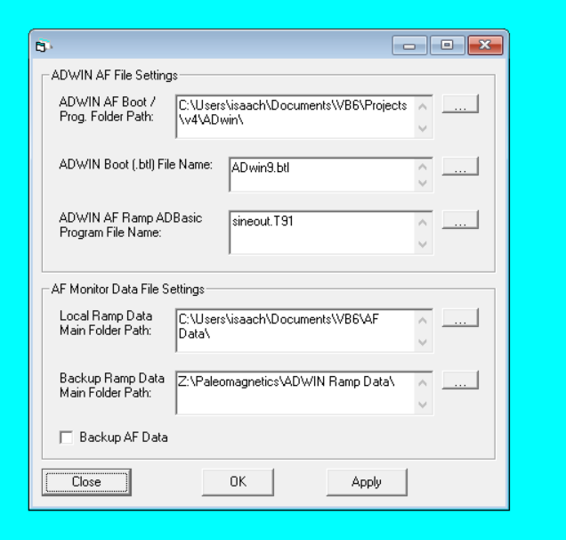
        - This window has several settings and is grouped into two halves that are split by a horizontal line in the Window.
        - The Upper Half contains the settings for your ADwin program folder that contains all of the ADbasic code files to run your ADwin system
        - The Lower Half contains the settings for the path to the main AF & IRM Data folder and the back-up folder and the check-box setting to store backed up copies of these files. (I suggest leaving the back-up check-mark unchecked as writing the raw AF & IRM Data files over the network can be quite slow, depending on the AF and IRM ramp file size, the network location of your backup, and the bandwidth of your RAPID PC’s network connection).
        - The first of these Lower settings gives the path to your AF & IRM data folder
      - The AF & IRM data folder is structured in a peculiar way (sorry about this):
        - The folder may be filled with data folders containing the raw data of individual AF ramps that were conducting when your system was installed or pre-installation when your AF system was being tested. Some of these AF ramp data folders may pre-date your system and be raw AF ramp data from prior systems. This is especially true for any RAPID systems that were installed by 2G.
          - You do not need to keep all of these data folders. I suggest only keeping the most recent ones that you know were created by your AF system. (Both 2G and Caltech have copies of the older AF ramp data folders. One of these days, Isaac plans to write some code to crawl through these files and search for any useful patterns in the data).
          - You can tell how old an AF ramp data folder is based on its folder name. The folder name should have the date that the folder and all the files in it were generated. The date structure may be different for older RAPID systems.
            - It may be: yyyy_MM_dd_HH_mm_ss, where yyyy = 4 digit year, MM = 2 digit month, dd = 2 digit day of the month, HH = 2 digit hour in 24 hour format, mm = 2 digit minute, and ss = 2 digit second.
            - OR, it may be a different datetime string variant.
            - You may want to keep folders that date to during and after your RAPID system was installed
          - However, these folders tend to be big in size and may contain ~1 - 25 MBytes of files, each.
        - Interspersed amongst these AF ramp data files, are two folders of definite importance:
          - Your AF Ramp Status logs [[check the name of this folder]]
          - Your Calibration folder (may be “Calibration Values” instead)
        - AF Ramp Status logs folder
          - Contains .xml logs files that store meta-data about every AF ramp that was run on your RAPID system
          - For 2G installed RAPID systems, this may contain .xml logs of every AF ramp that was ever run on any RAPID system developed at 2G since ~May, 2014. Though interesting, you may want to skip these log files to save space under your new Windows 10 OS.
          - Like the AF ramp data folders, these log files should have a date-time string in their file-names, allowing you to determine how old each file is and whether the pre- or post-date your system. I suggest keeping files that are at least one year older than the install date of your system. These files may contain important information of tests done on your AF system pre-install.
          - We are looking for any students, post-docs, etc. who may be interested in data mining information from these old AF ramp status files. There is likely quite a log of interesting information in these files about patterns in the behavior and reliability of the ADwin AF system at multiple laboratories. This may make an interesting mini-research project.
          - We strongly suggest saving these files to a remote location prior to upgrading your RAPID PC
        - Calibration folders
          - These folders contain the AF calibration data for your system prior to and after installation of your RAPID system
          - Depending on your IRM system type, this folder may also contain your IRM calibration data, as well
          - For systems installed by 2G, the Calibration folder may contain Calibration data from every RAPID system every developed by 2G.
          - Each calibration data file is labelled by type (AfAxial, AfTrans or AfTransverse, IRMAxial) and by the datetime string of the date and time that the calibration was performed.
          - This calibration folder may contain calibration data for AF calibrations done by 2G on your RAPID system prior to the installation of your RAPID system.
          - Again, we strongly suggest backing up this folder.
          - Again, we are also looking for any individuals or groups that might be interested in mining this data.
    - The vbSendMail folder
      - This folder contains source code and a compile .dll of the vbSendMail VB6 app. This app is what your RAPID system uses to send unencrypted status emails to notify system users and admins about the state of each sample run, any code red errors, etc. Some of the newer RAPID systems use an encrypted email code-set, but the old unencrypted code is still present in the overall Paleomag VB6 software.
      - Thus, you will need to preserve a copy of your vbSendMail folder before doing your upgrade to Windows 10.
      - Post install, you may need to re-register the vbSendMail.dll file with Windows 10. The process for doing this will be discussed in a later section of this documentation.
    - The RaPMS code and support folders
      - For newer RAPID systems manufactured by 2G / APS, the RaPMS code is written in C# and used to configure and calibrate the new generation of APS manufactured IRM boxes.
      - This code should be located directly on the “C:\” drive of your PC. There are two folders, one called “C:\RaPMS\” and the other named something like “C:\RaPMS Files\”
      - You will want to copy these folders to preserve the ability to calibrate your APS IRM device (if you have one) in the future. The \RaPMS Files\ folder contains the actual data file that store the DC pulse magnetic field calibration data for your APS IRM device.

Download / Acquire Windows 10 installation media
  - I suggest asking your University or Institution for assistance with this. They likely have installation media and can help you through the process.
  - If you do go with your IT people, make sure that they do an upgrade in place rather than a clean install.
  - If they insist on doing a clean install, then the process of getting the new Windows 10 system setup is much more involved. It will require assistance from someone who has done the upgrade on their own system. In particular, installing Visual Studio 6.0 on Windows 10 is quite tricky. Fixing a botched install is very time consuming and may require am additional clean reinstall of Windows 10 to fully fix.
  - That said, if you are doing the Windows 10 upgrade in place, then you can find comprehensive instructions for this from this Microsoft documentation web-link: https://docs.microsoft.com/en-us/microsoft-365/enterprise/windows-7-to-windows-10-upgrade-manual

Post-Upgrade clean-up

Com Ports
    - Please see section 3) above. Your com-port assignments in Windows 10 may have been scrambled.
    - If you have this issue, please let the RAPID Consortium email list know and one of us can help you.

ADwin-light-16 no longer recognized
    - Open ADConfig3.exe
      - If you don’t know where this app is, you can search for it using the Cortana search bar in Windows 10
    - If the list of compatible ADwin devices is empty then:
      - Check the power on your ADwin-light-16 device. If should have4 a green LED light that is on, near the device power toggle switch.
      - Check the USB cable connecting the ADwin-light-16 to your PC. Make sure it is connected.
      - In ADConfig, click the “Add USB” device option in the row of menu buttons, e.g. “Add Link”, etc.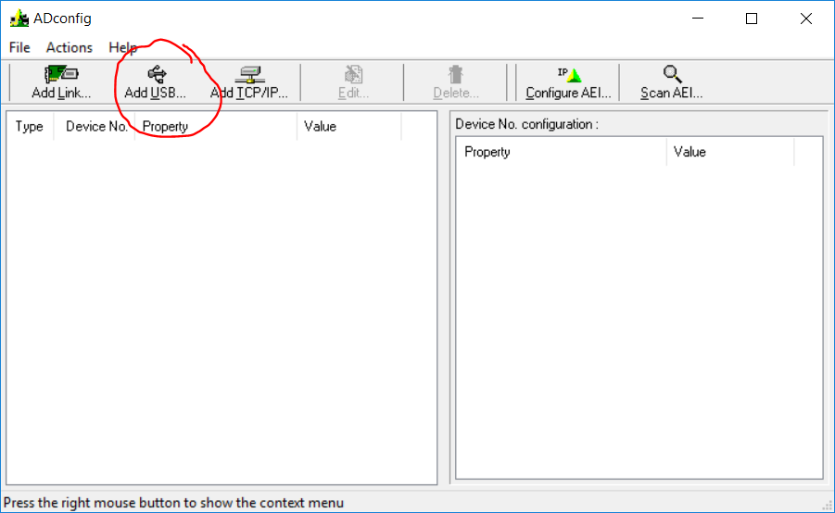

      - When you click “Add USB” a pop-up window should show that has two fields in it: “Device No.” and “USB Serial No.”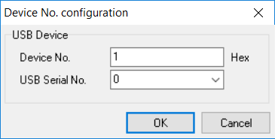
      - Click the “USB Serial No.” drop-down control, it should give you a non-zero option that is four digits long, like “3733”.
      - Click this option. AD Config should then configure your ADwin-light-16 device as Device No. 1. If your device is configured with a different Device No. than 1, please email the RAPID Consortium email list. Your .INI settings file will need to be modified to account for the different Device No. setting.
    - If this does not fix your ADwin issue, then please email the RAPID Consortium email list.

Measurement Computing DAQ device is missing when you try to startup up the VB6 Paleomag code
    - Open the InstaCal Measurement Computing app. You can find the app using the Windows 10 Cortana search bar.
    - If your Measurement Computing DAQ device does not show up in the PC Board List, then click the “+” button in the row of menu buttons to add a new device.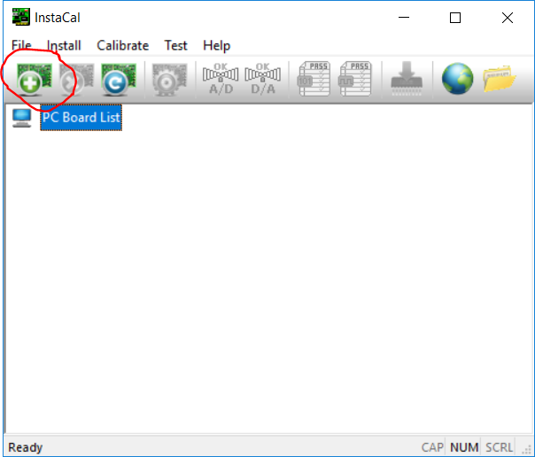
    - When you do this, the Board Selection List window search pop-up and show your Measurement Computing DAQ device in the list of devices. (Hopefully, there should only be one Measurement Computing DAQ device for your PC).
    - Select the desired DAQ device and click the “Add” button to add it to your Measurement Computing PC Board List.
    - If the Board Number corresponding to the device is not zero (0), then send an email to the RAPID Consortium email list, as your .INI settings file will need to be modified so that the VB6 code can access the DAQ device.

When you run your VB6 Paleomag code, the code crashes on load. When you click the “Debug” button, you get the following screen:

    - This is because, in Windows 10, the vbSendMail compiled program .dll file (vbSendMail.dll) is no longer registered with the new operating system.
    - Close and Quit both the Paleomag VB6 code and VB6 itself.
    - In the Cortana Windows 10 search bar, type: cmd
    - In the results, right click the “Command Prompt” option and select “Run an administrator” from the pop-up menu.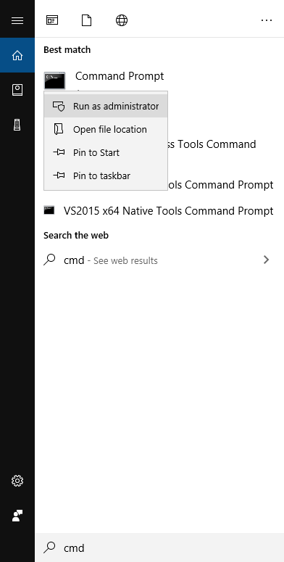
    - This should open up a new Command Console Window: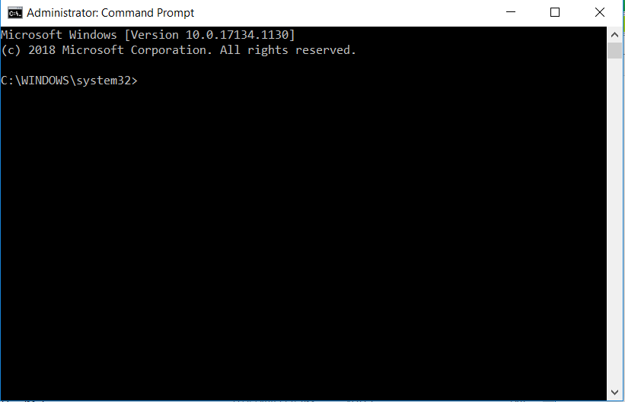
    - On your PC, open the Windows File Explorer and navigate to the folder that contains your VB6 Paleomag code.
      - It may be something like: C:\Paleomag\PaleomagXY\Paleomag2013\
      - Or:
      - C:\Users\{[your lab username]}\Paleomag\PaleomagXY\Paleomag2014]\
      - Or some other path. You want to search for a folder that contains the file: vbSendMail.dll
    - Once you have found vbSendMail.dll, copy the folder path in the path bar in Windows 10 File Explorer:
    - 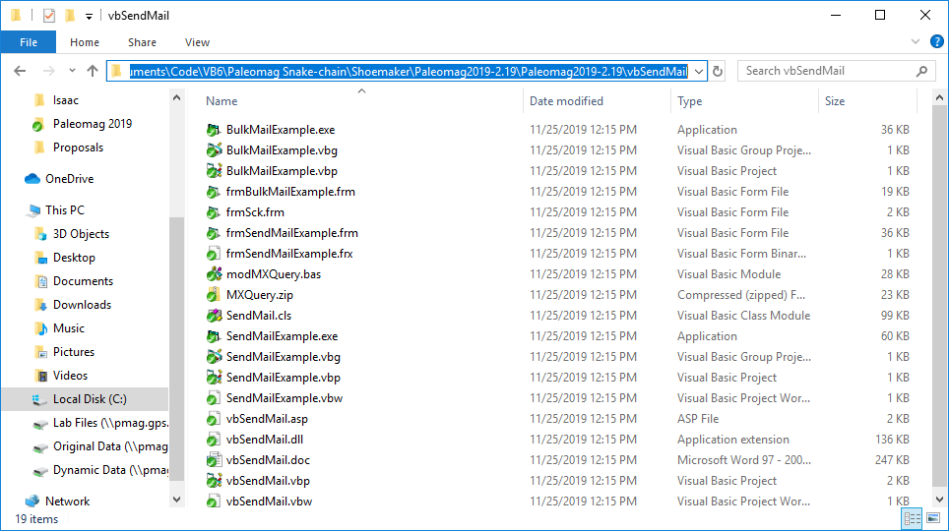Then type in: regsvr32 “
    - Right click after the “ to insert the folder-path to the vbSendMail folder
    - Then, type in: \vbSendMail.dll”
    - 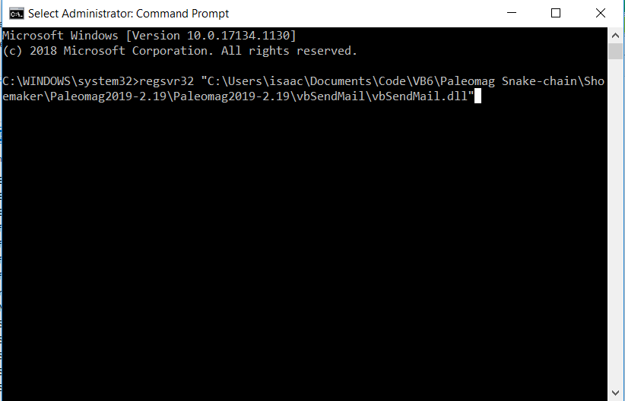Finally, click Enter to run the command.
    - You should get the following pop-up box: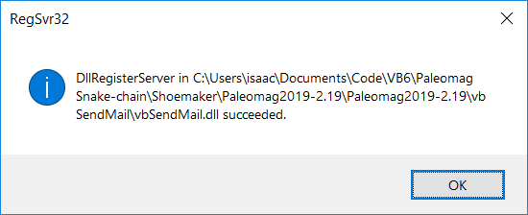
    - If you don’t get the pop-box above, but rather an error box, please email the RAPID Consortium email list, and we can provide assistance.

Your Windows 10 RAPID PC should now be fully functional.
  - If it is not, or you have run into some unforeseen error, please email the RAPID Consortium email list to post your error(s) and get assistance.
  - Thank you!

Addendum

Comments from Yiming Zhang at Berkeley post-upgrade
Happy last day of 2019! I just successfully upgraded our lab computer from windows 7 to windows 10. Your instructions were very helpful! Here is what I did:
- I backed up the entire disk as image using Macrium Reflect Free version, and made additional copies of Paleomag VB6 code and magnetometer data files.
- Then I used the windows "media creation tool" to do the in-place upgrade.
- During the upgrade I noticed that the vacuum in pick-up rod and air for inline AF coils was somehow turned on (control lost? They were off prior to the upgrade), so I turned off all the control box during later upgrade process
- After the upgrade the computer was very slow, likely due to a lack of optimizations. So I turned off these services:
  - Connected User Experiences and Telemetry
  - Diagnostic Execution Service
  - Diagnostic Policy Service
  - Diagnostic Service Host
  - Diagnostic System Host
- Running the VB6 Paleomag code, windows automatically configured Microsoft Office Professional Plus 2013.
- Encountered ADWIN Boot Error after logging in. I followed the instructions in Isaac's notes and the issue was solved.

